Summary
At the June 10, 2010, Portland Plan Advisory Group meeting attendees, in small groups, brainstormed potential strategy clusters for the Portland Plan. At the end of the meeting, each group presented their ideas and the large group briefly discussed benefits, drawbacks and other issues of concern. Strategy clusters general fell into two groups: complete/20-minute neighborhoods and broaden prosperity/build a stronger economy, although one of the small groups developed an equity-focused cluster. Attendees noted that sustainability and natural environment related ideas were not explicitly discussed. The strategy clusters and a list of some of the issues discussed are provided below.

Broaden Prosperity/Build a Stronger Economy Clusters and Notes

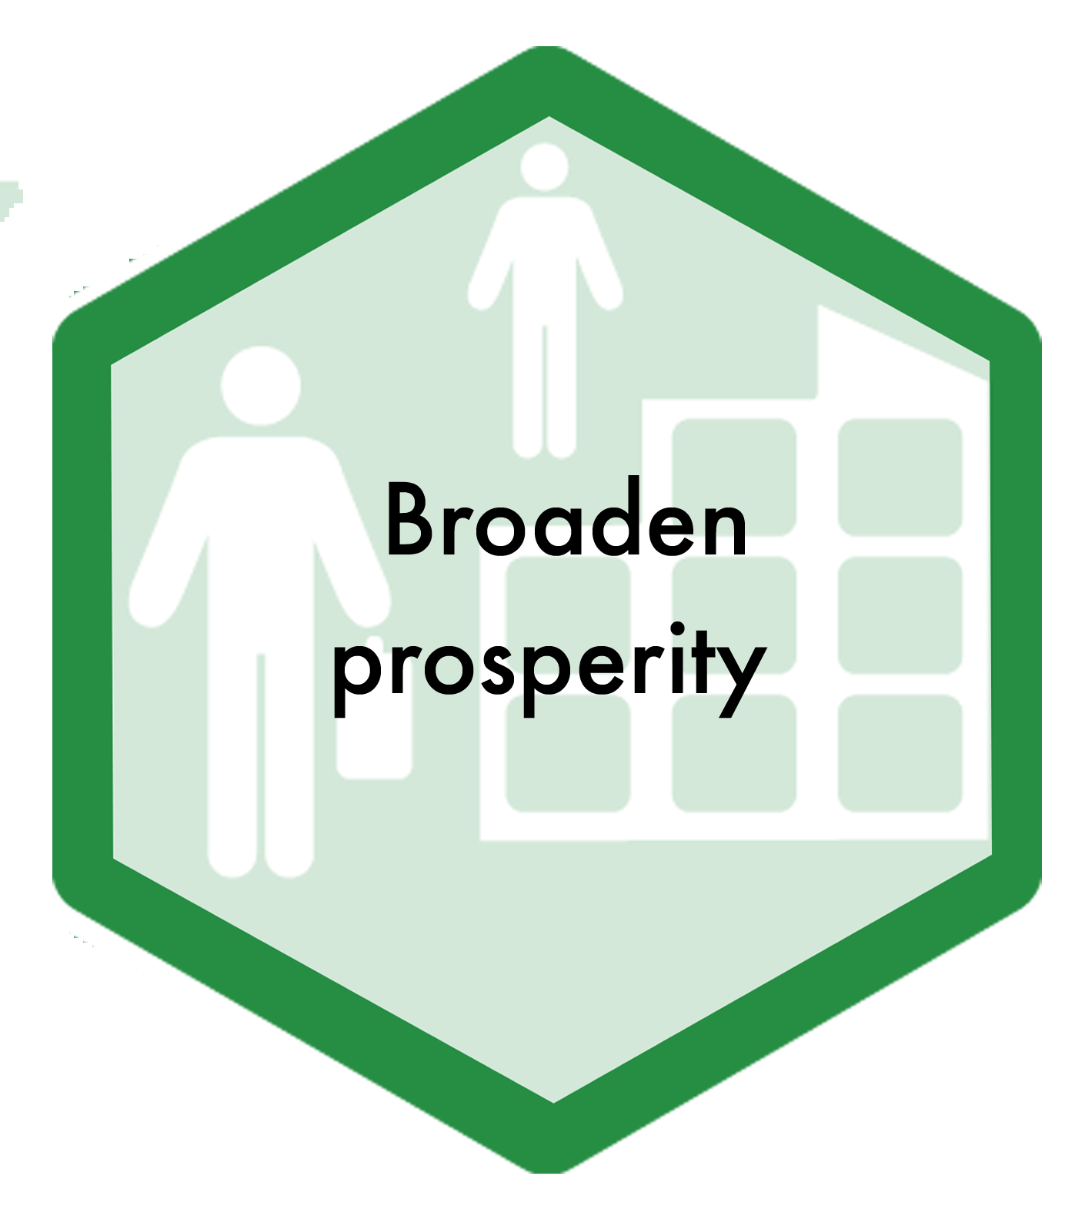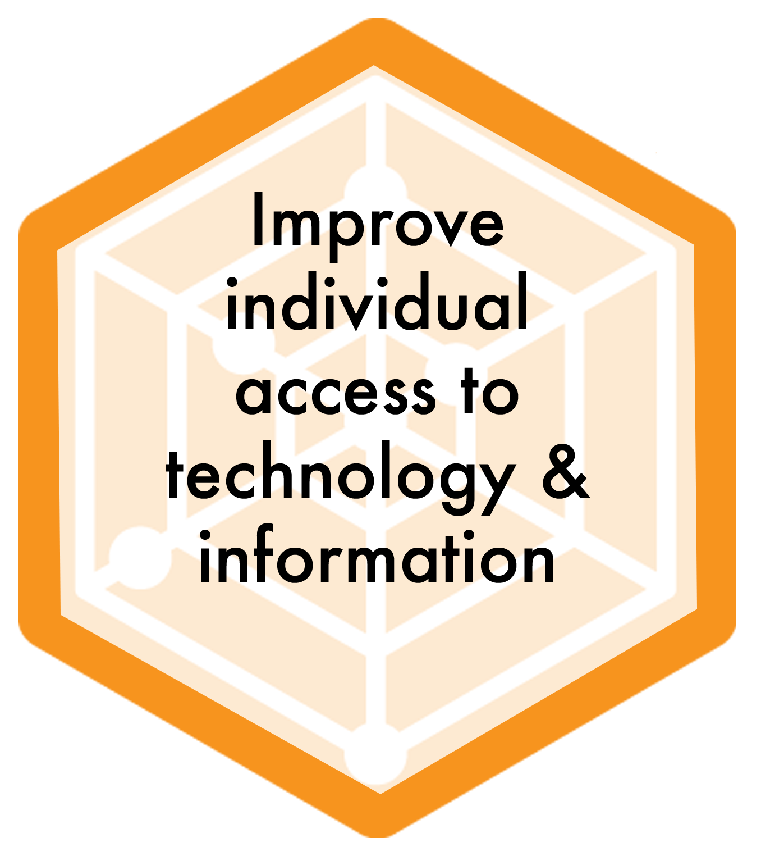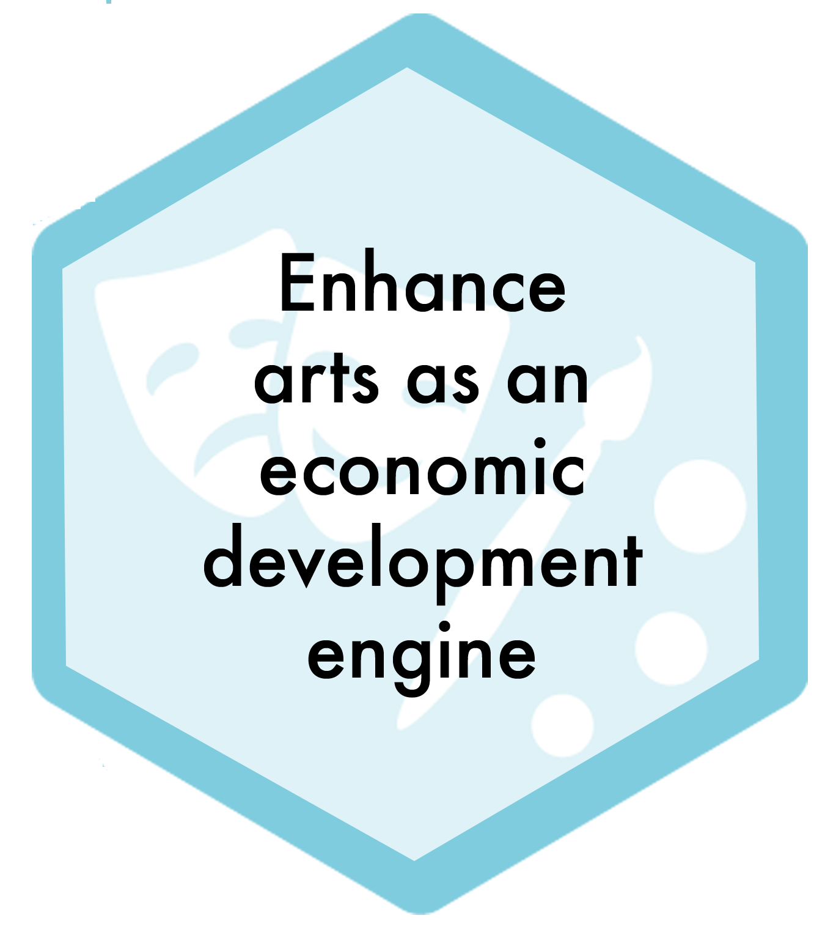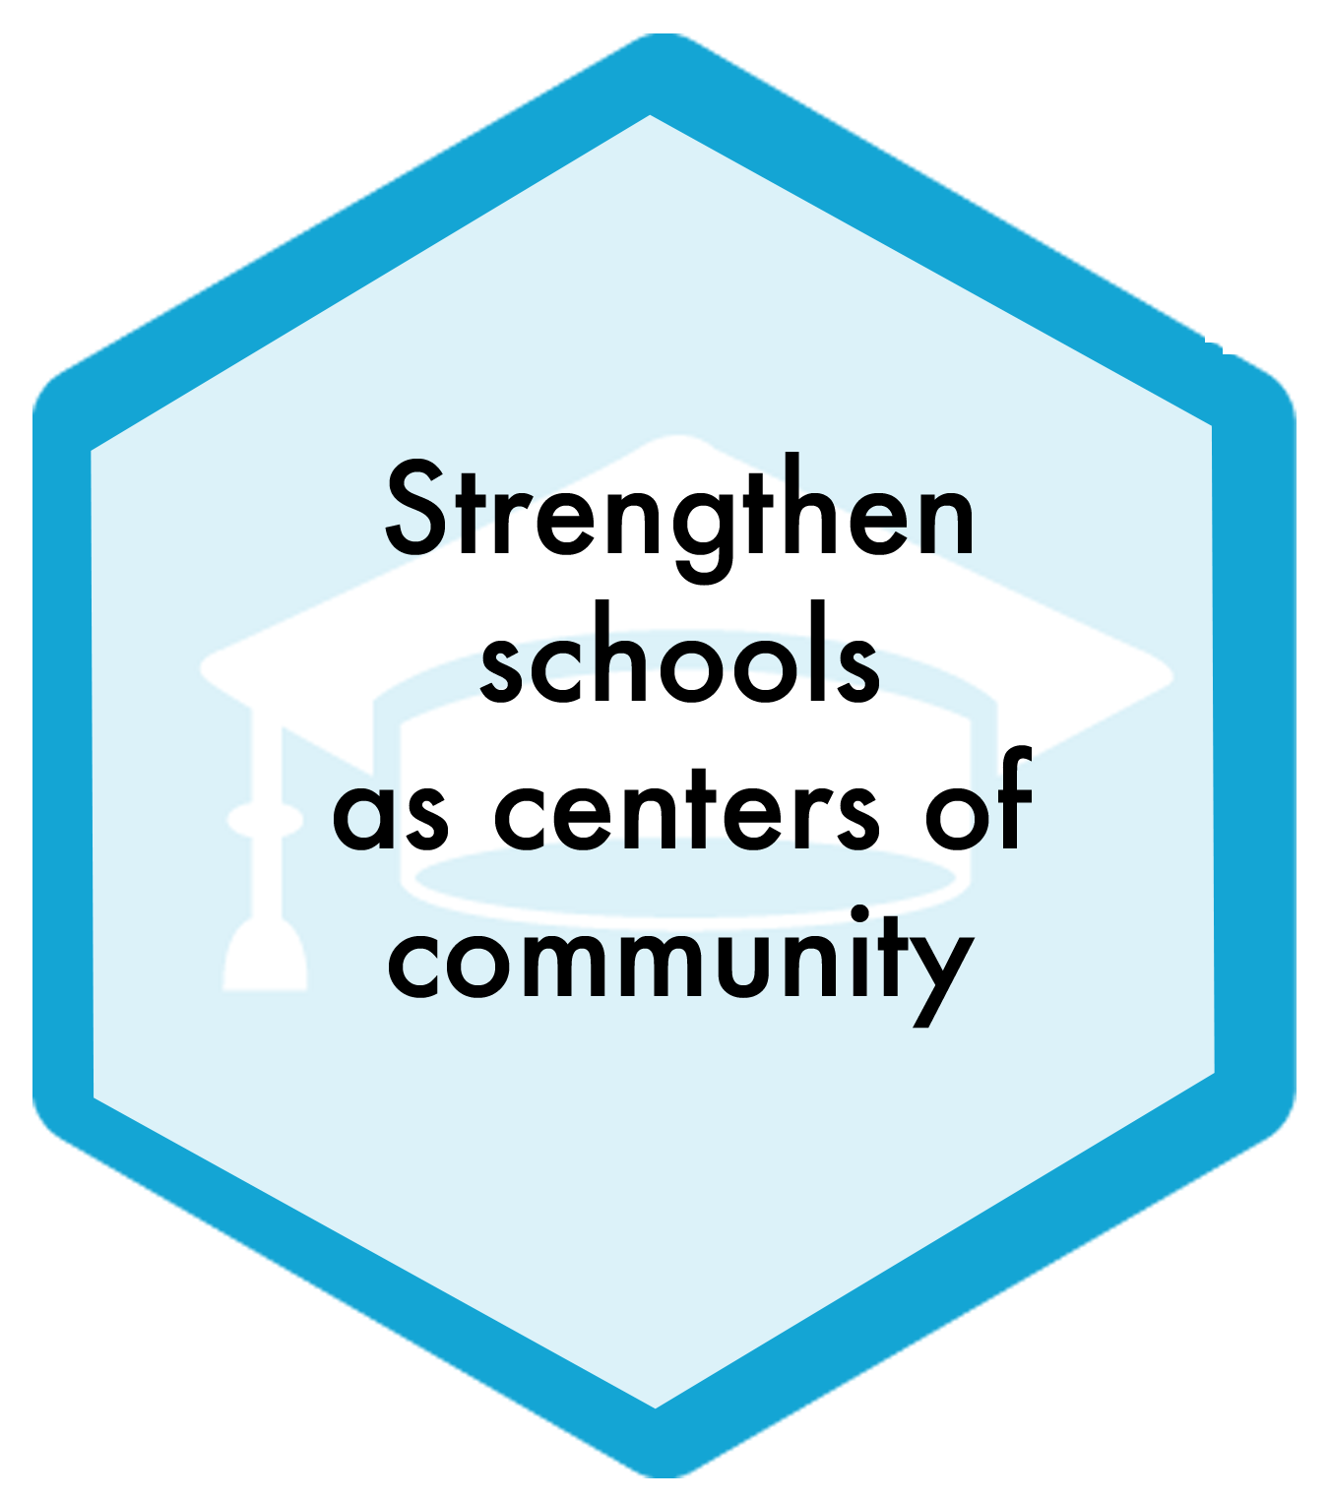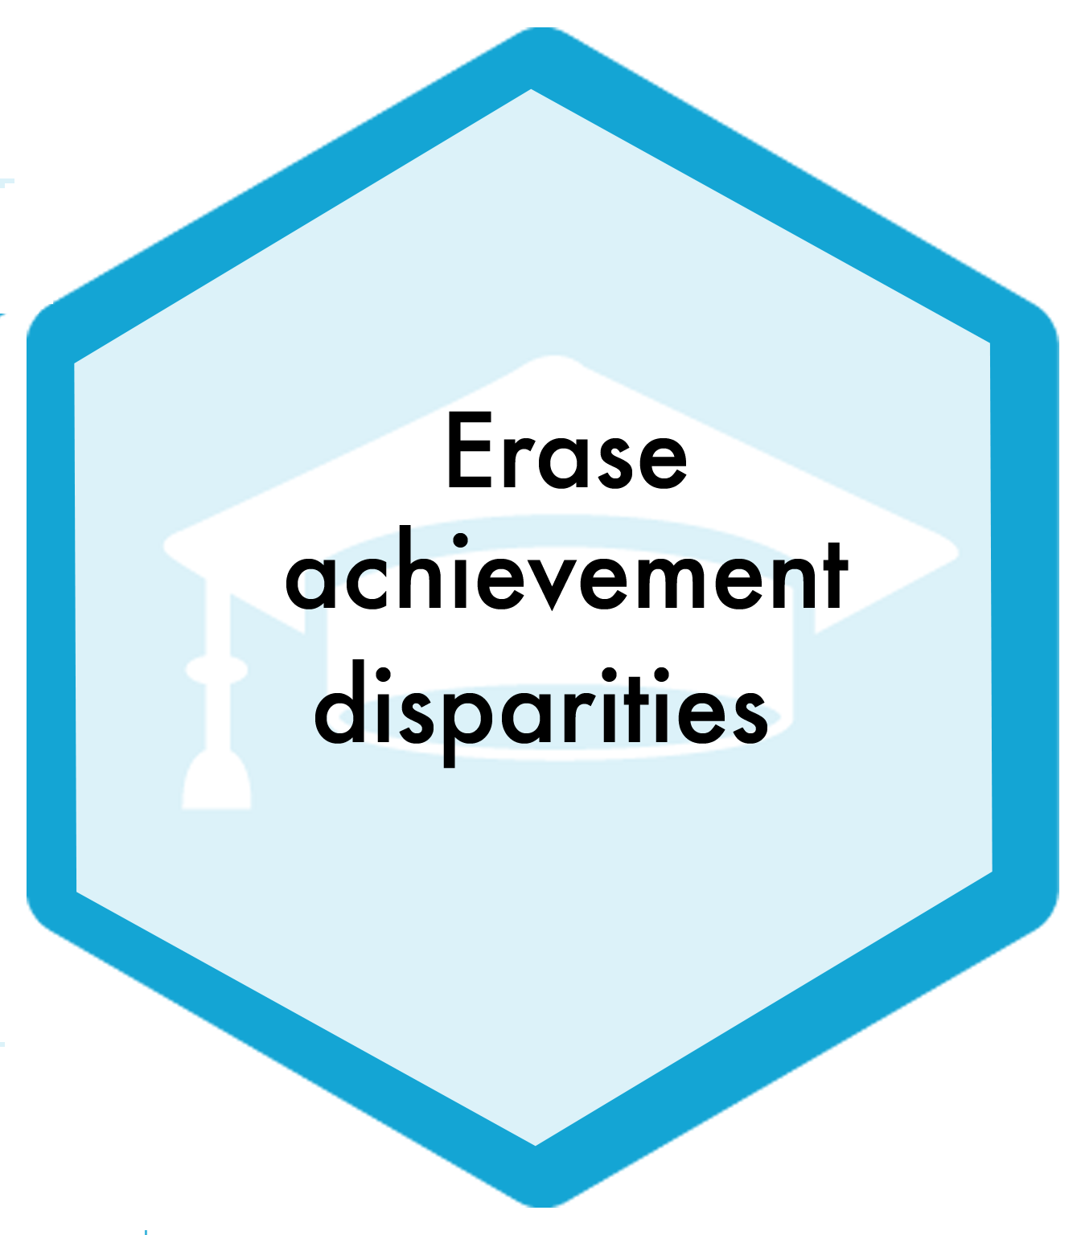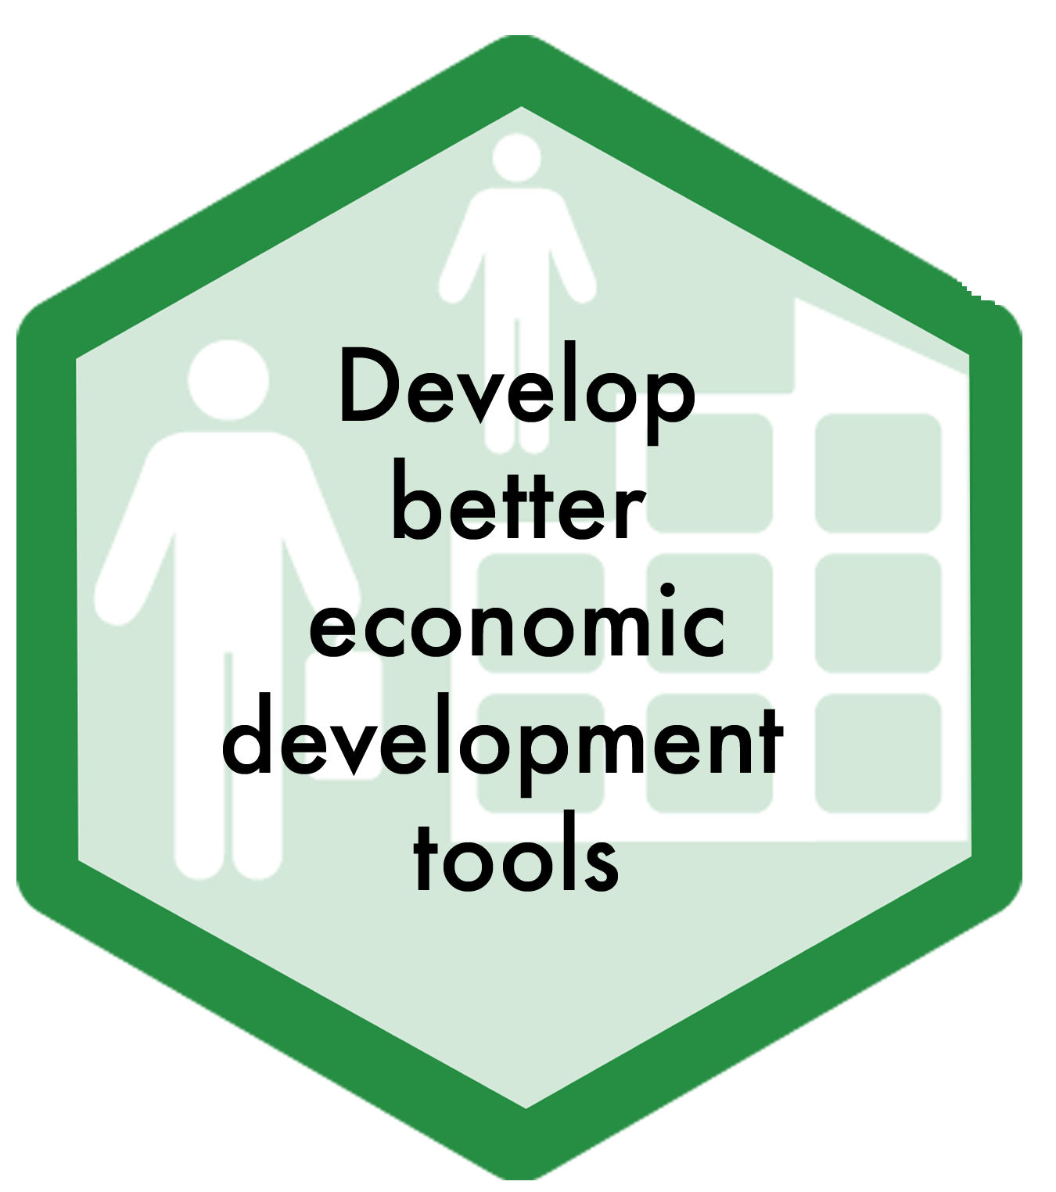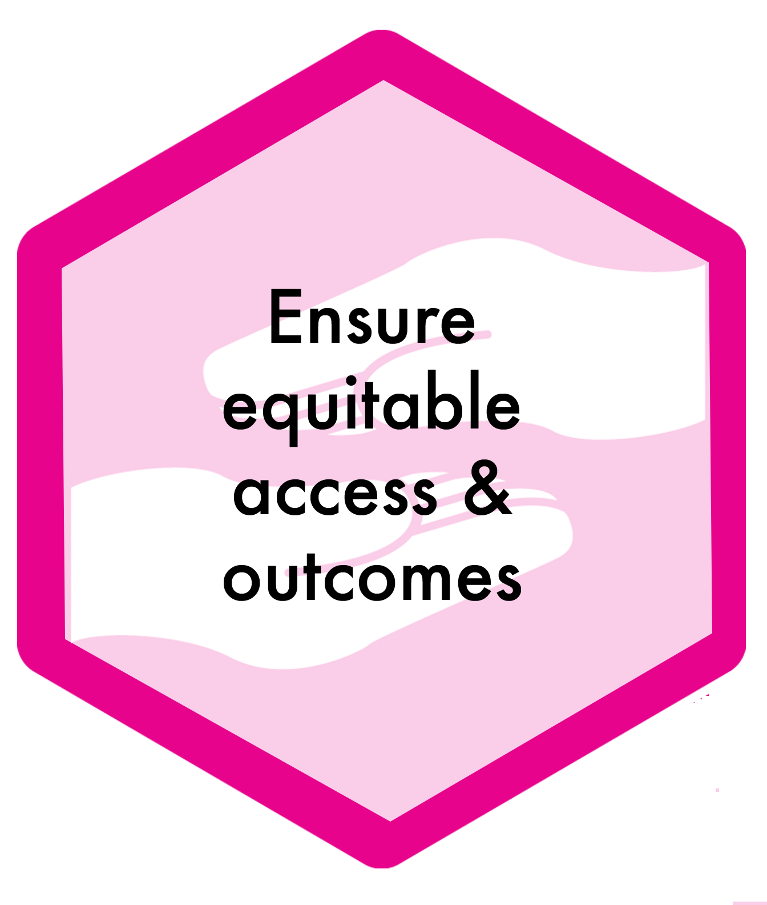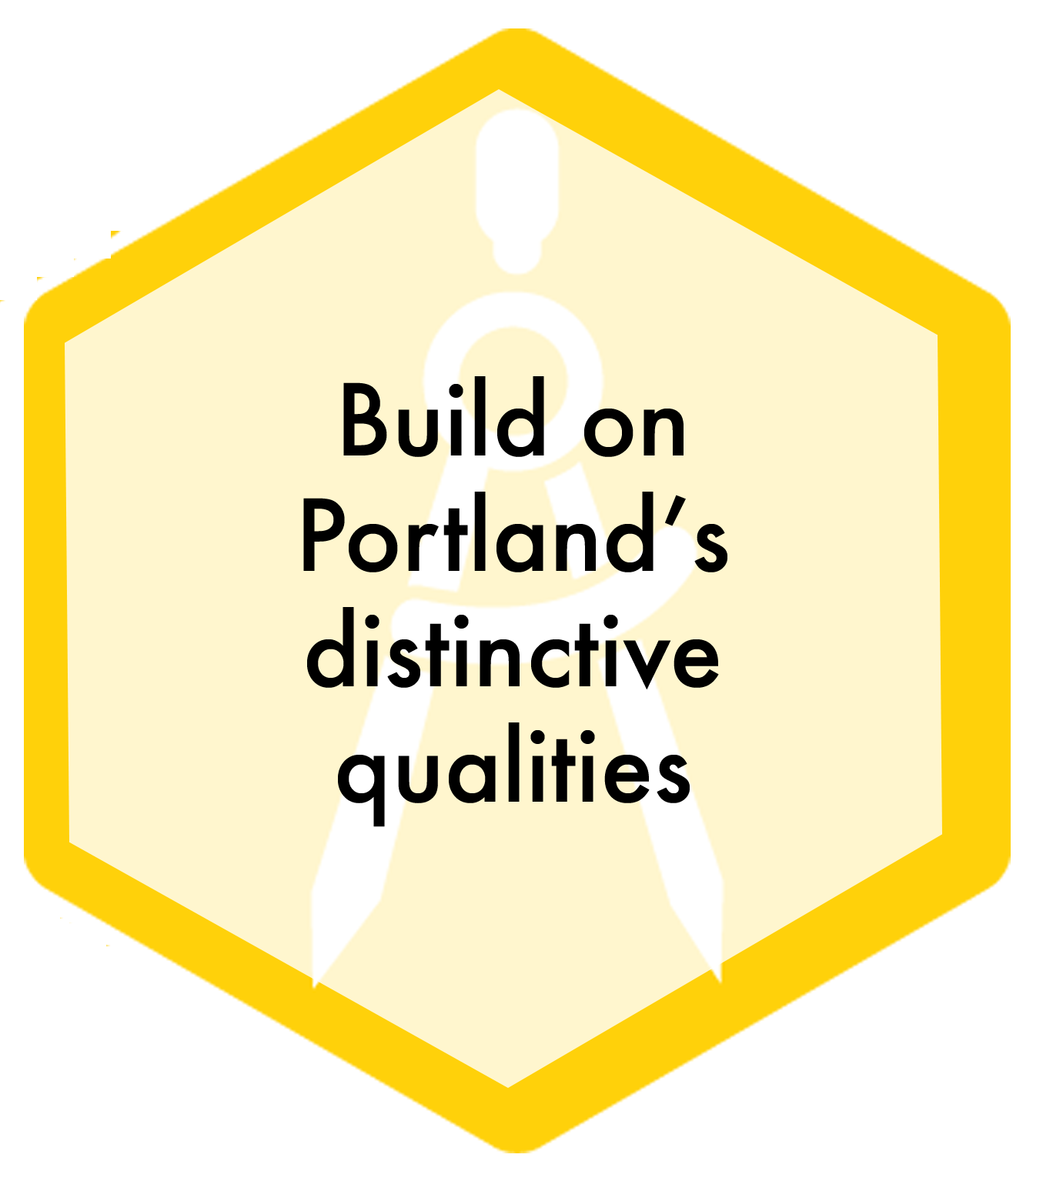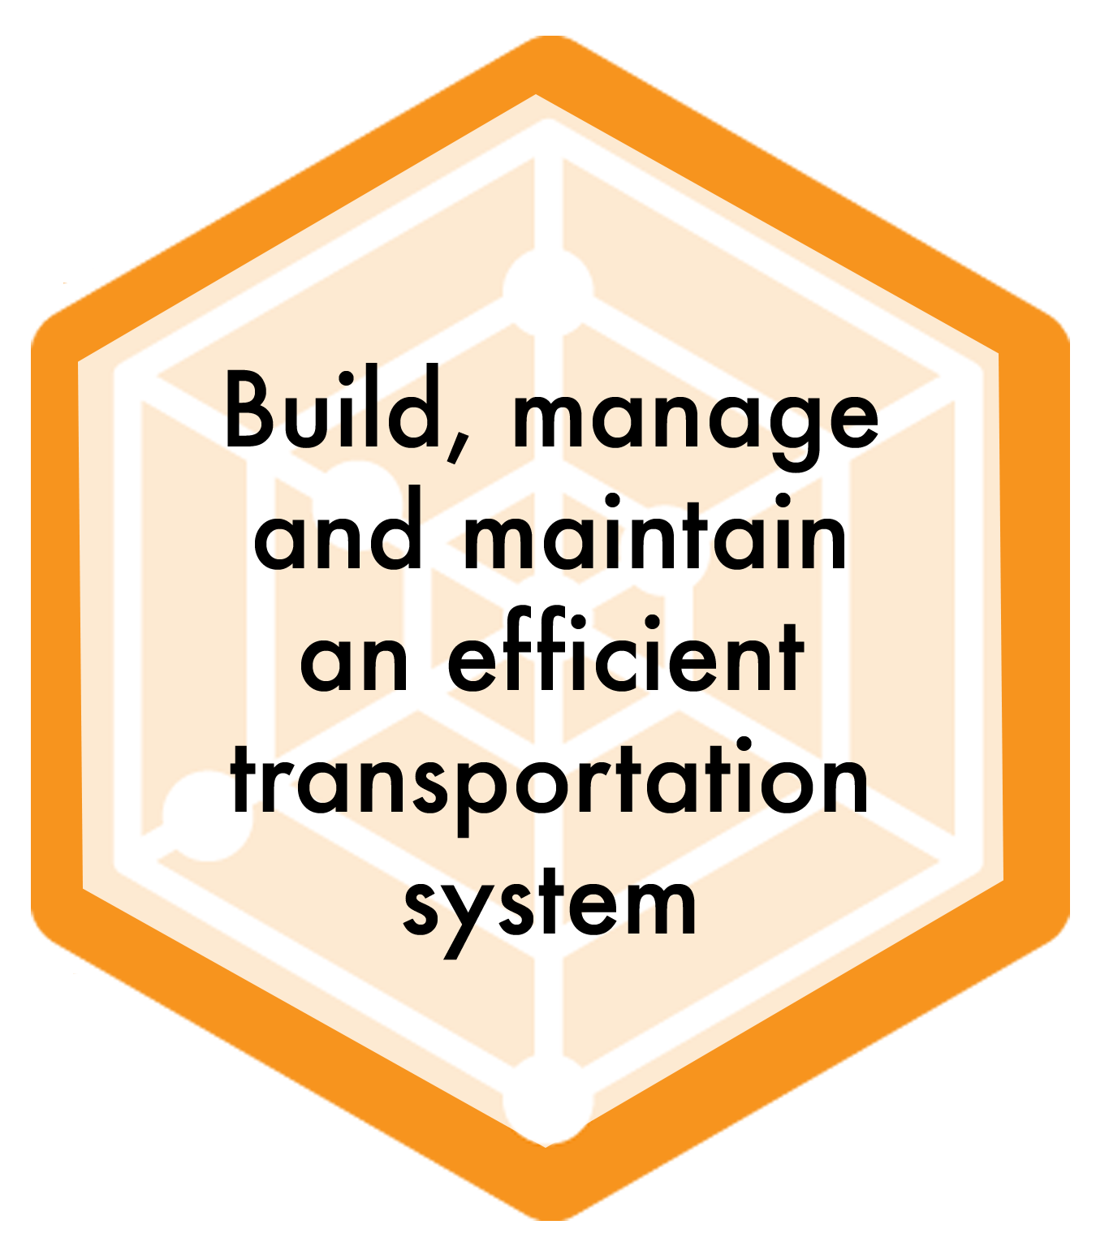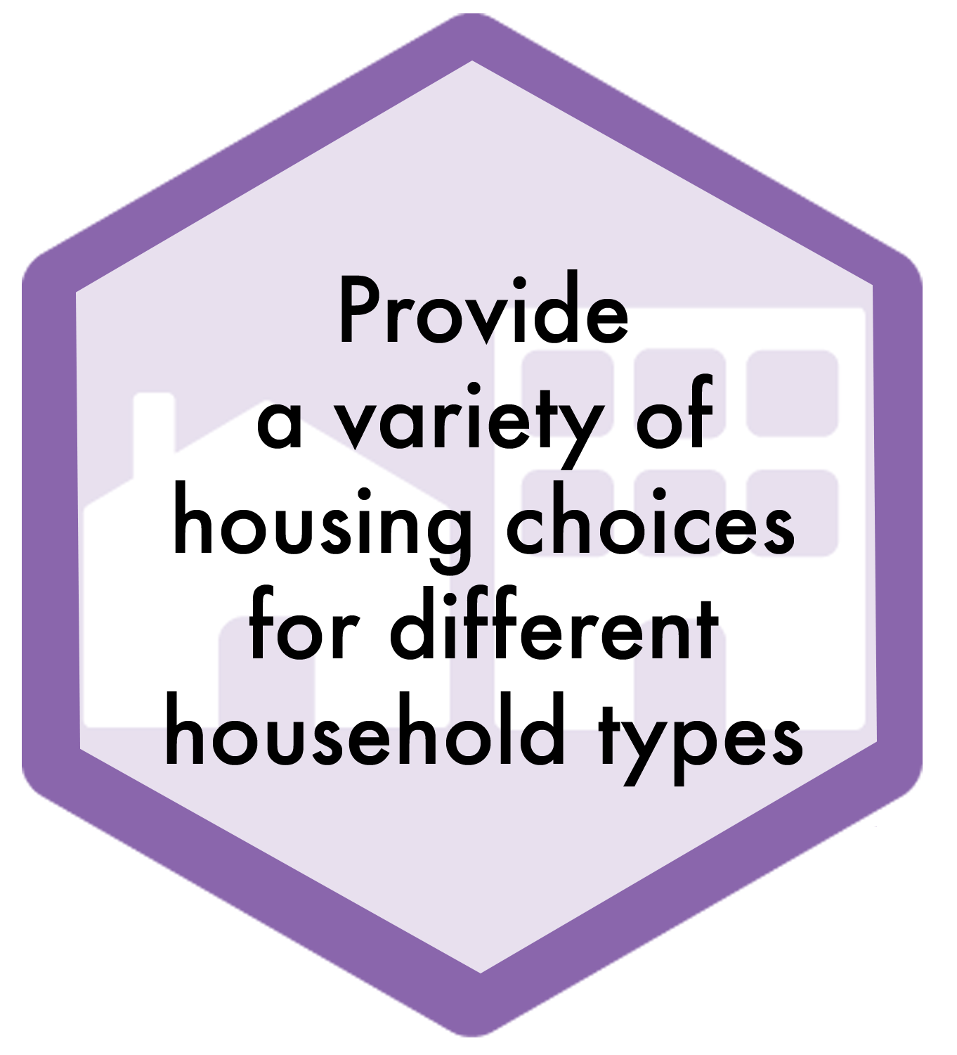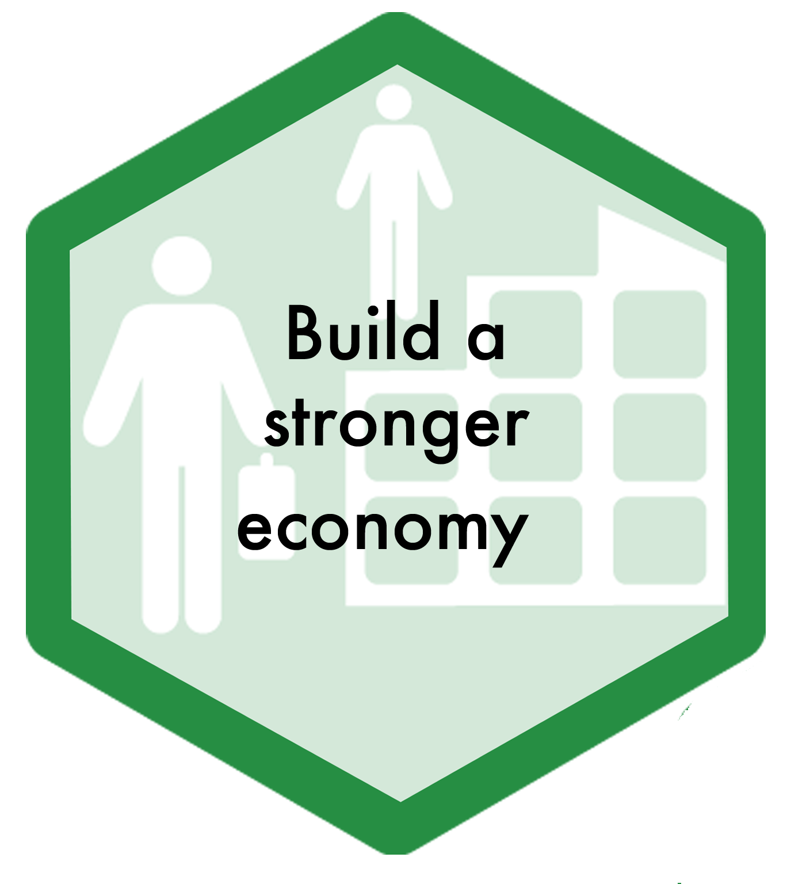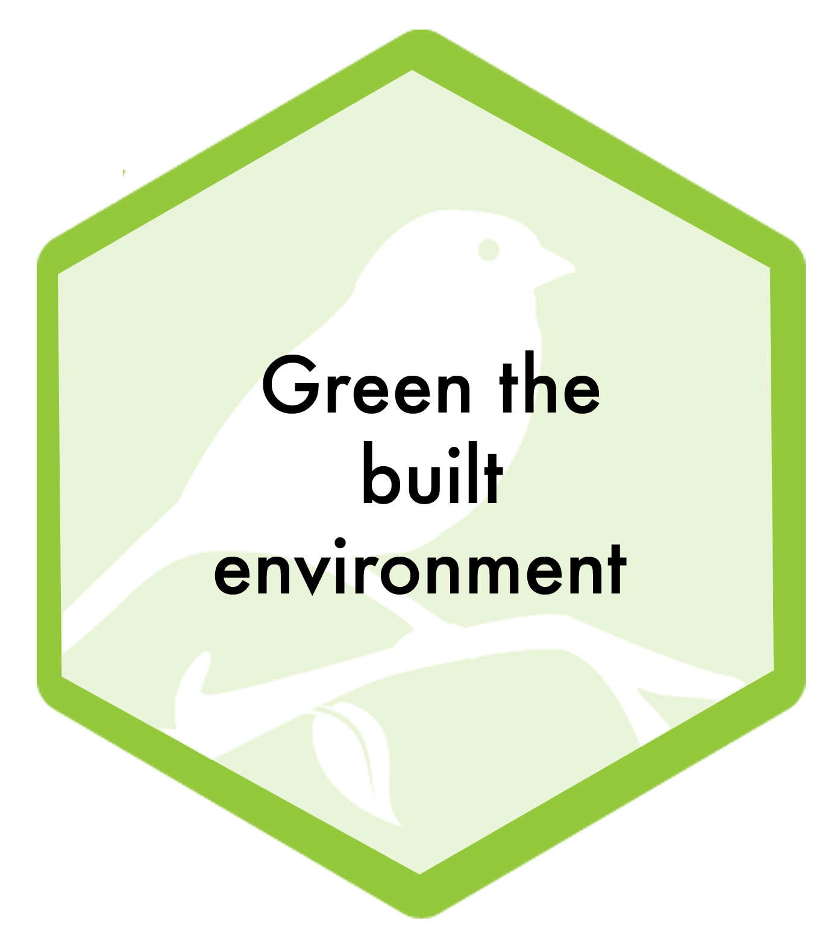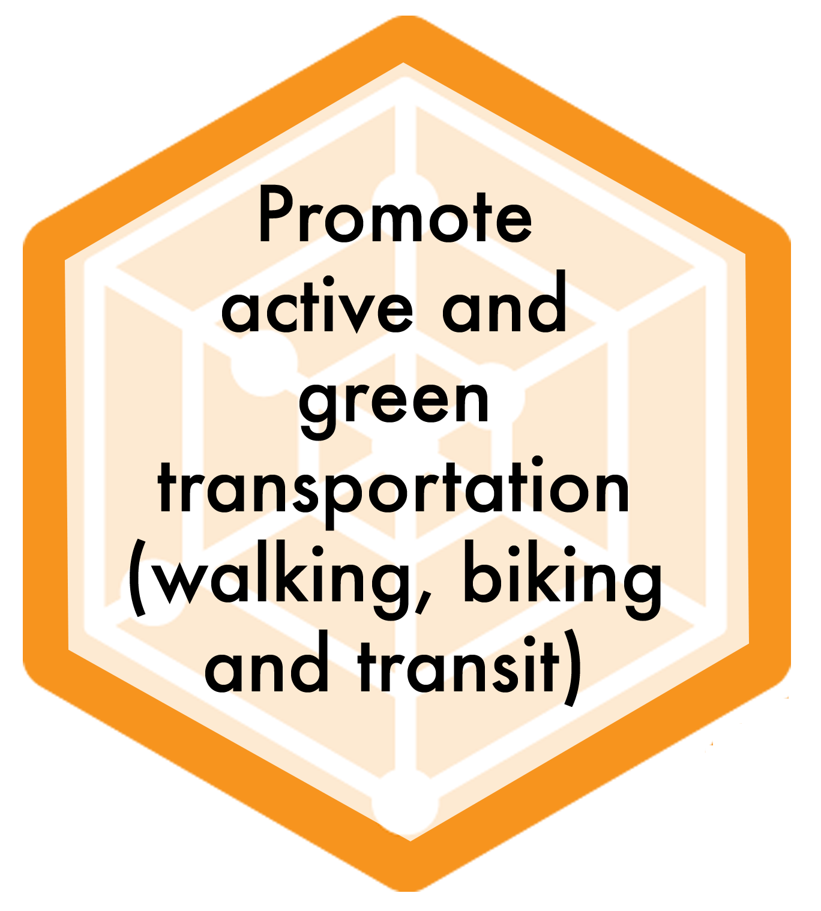
Equitable access and opportunities, for neediest in our community. Measure progress toward closing the gap

• Broader prosperity is the engine needed to affect all change.
• If we do not strengthen the economy and have more money, we will not be able to accomplish any of our goals.
• Investing in a strategy that aims to broaden prosperity will affect all areas.
• Caution: Many people come to Portland for its quality of life and the economy only becomes an issue when it is an obstacle to quality of life. How do you get people to focus on economic development over the long-term and not just during times of crisis?
• If people do not have jobs, we will not have a strong economy and we will have less money to invest in things like education.
Many people in Portland who are poor want a method to get out of poverty but we lack methods to help them get out of poverty.
Complete Neighborhoods/20-minute Neighborhoods

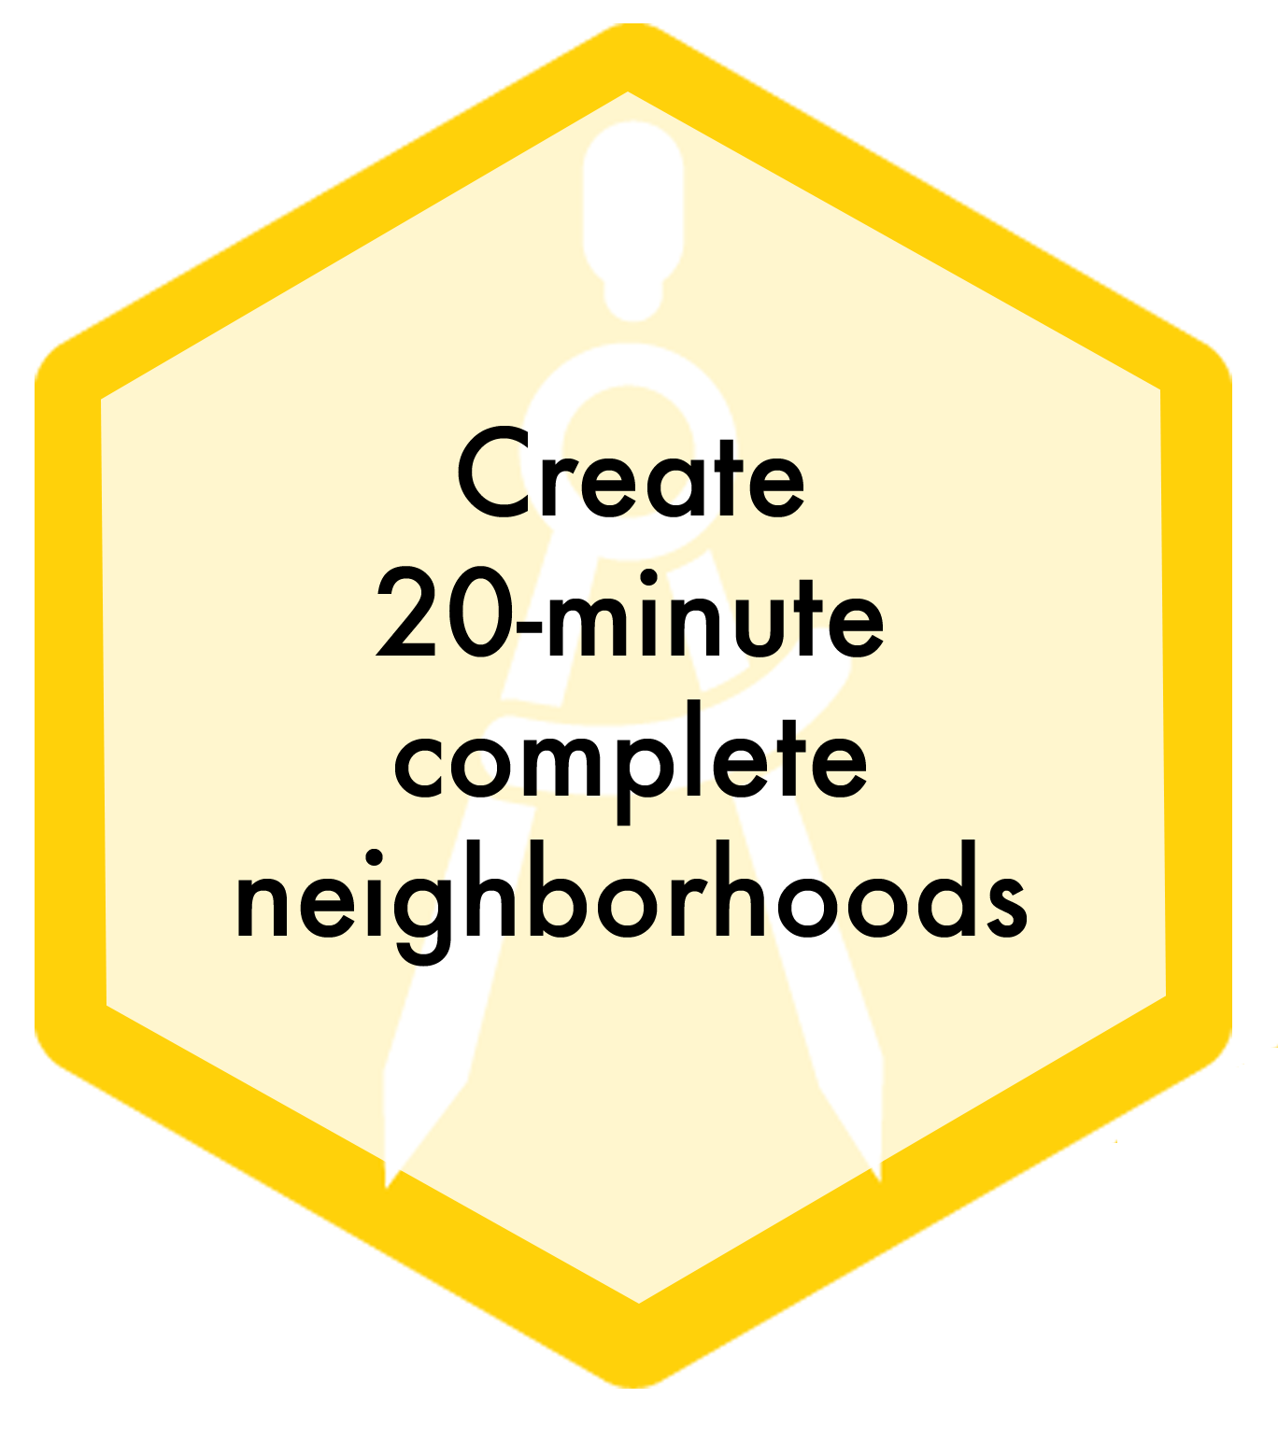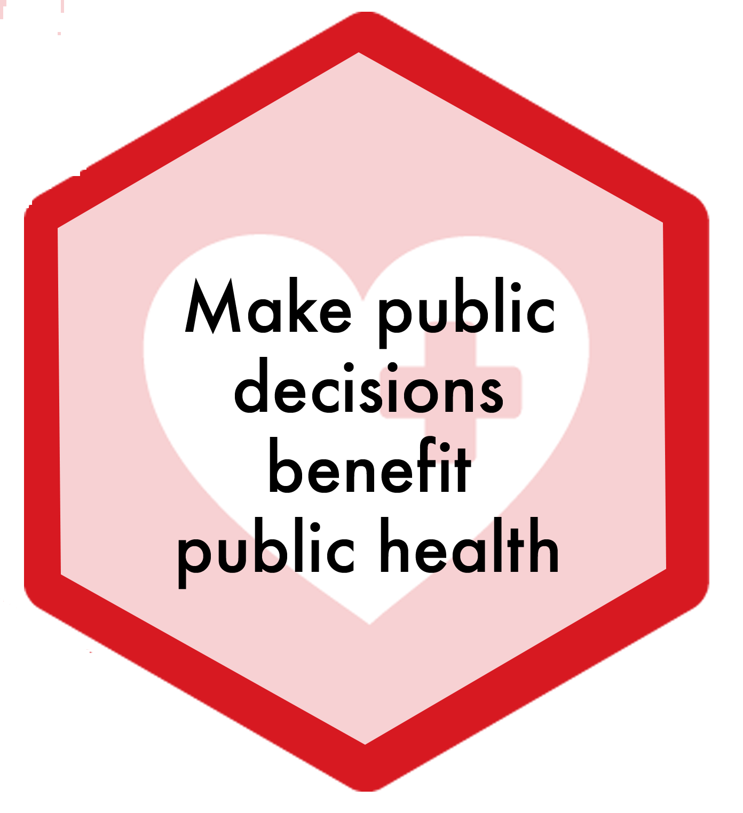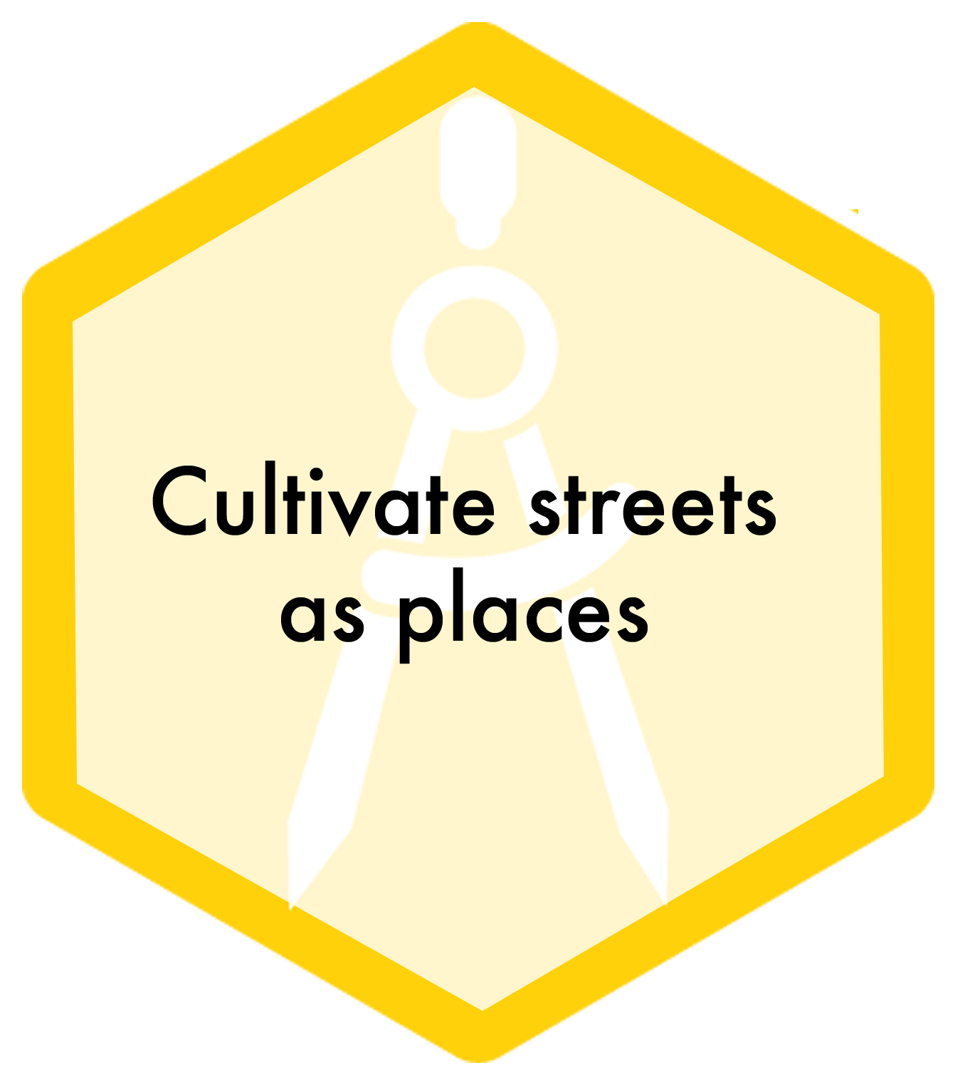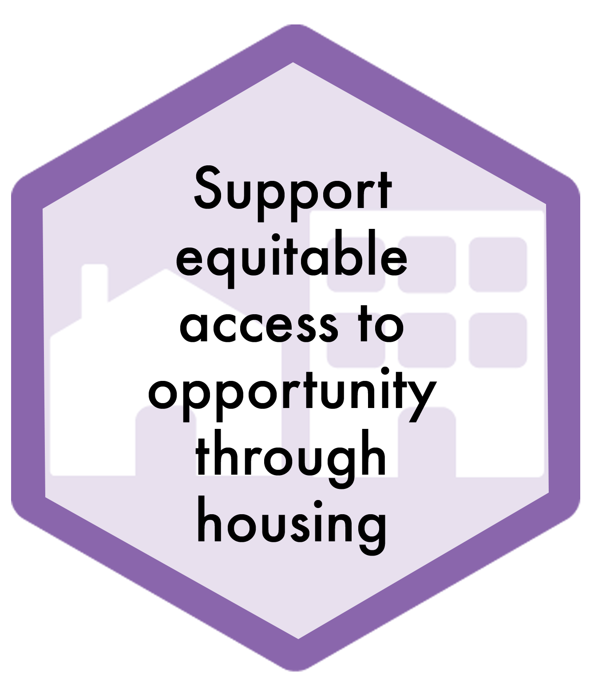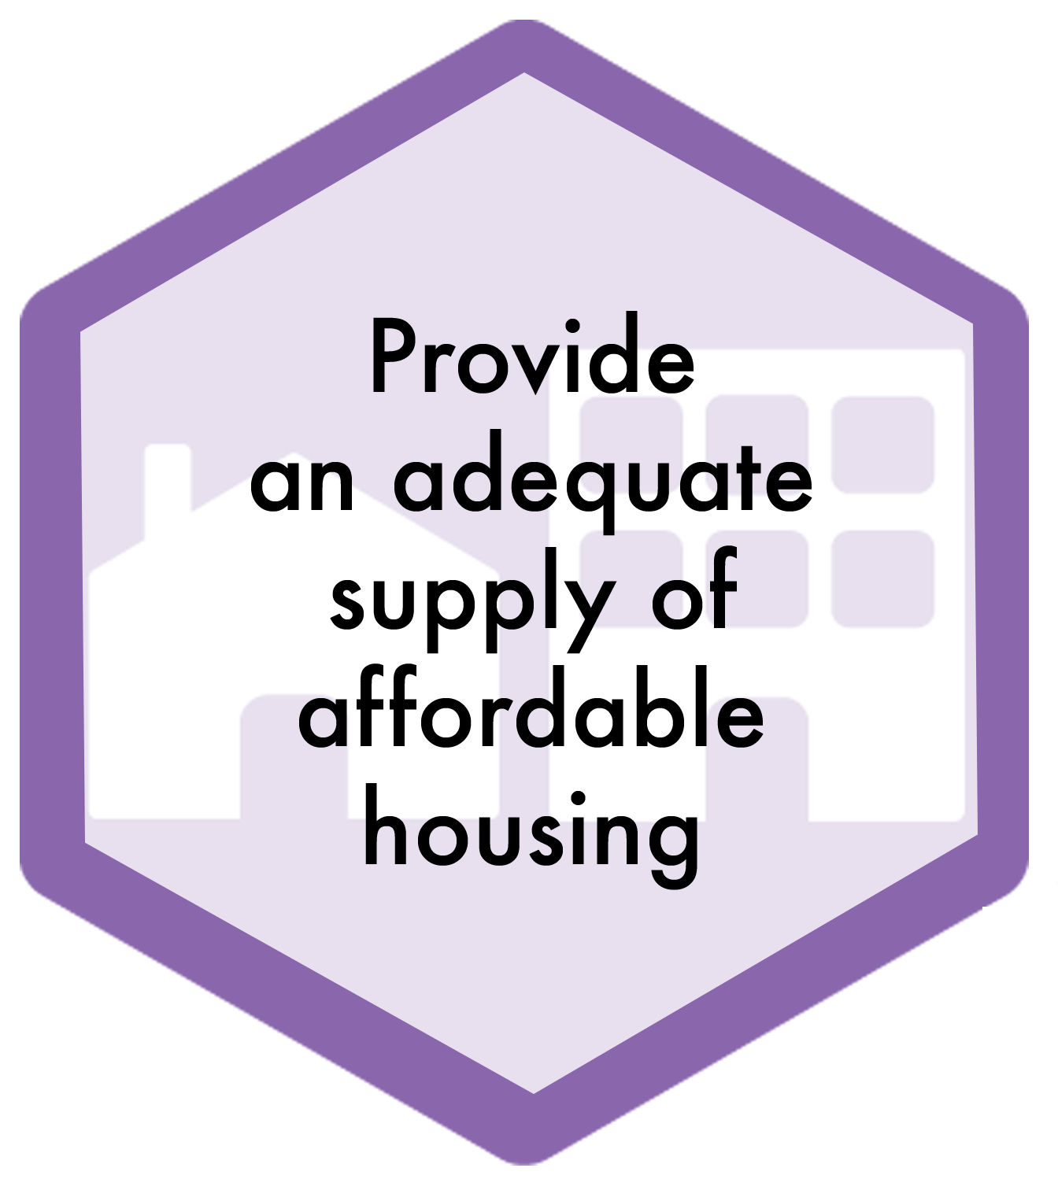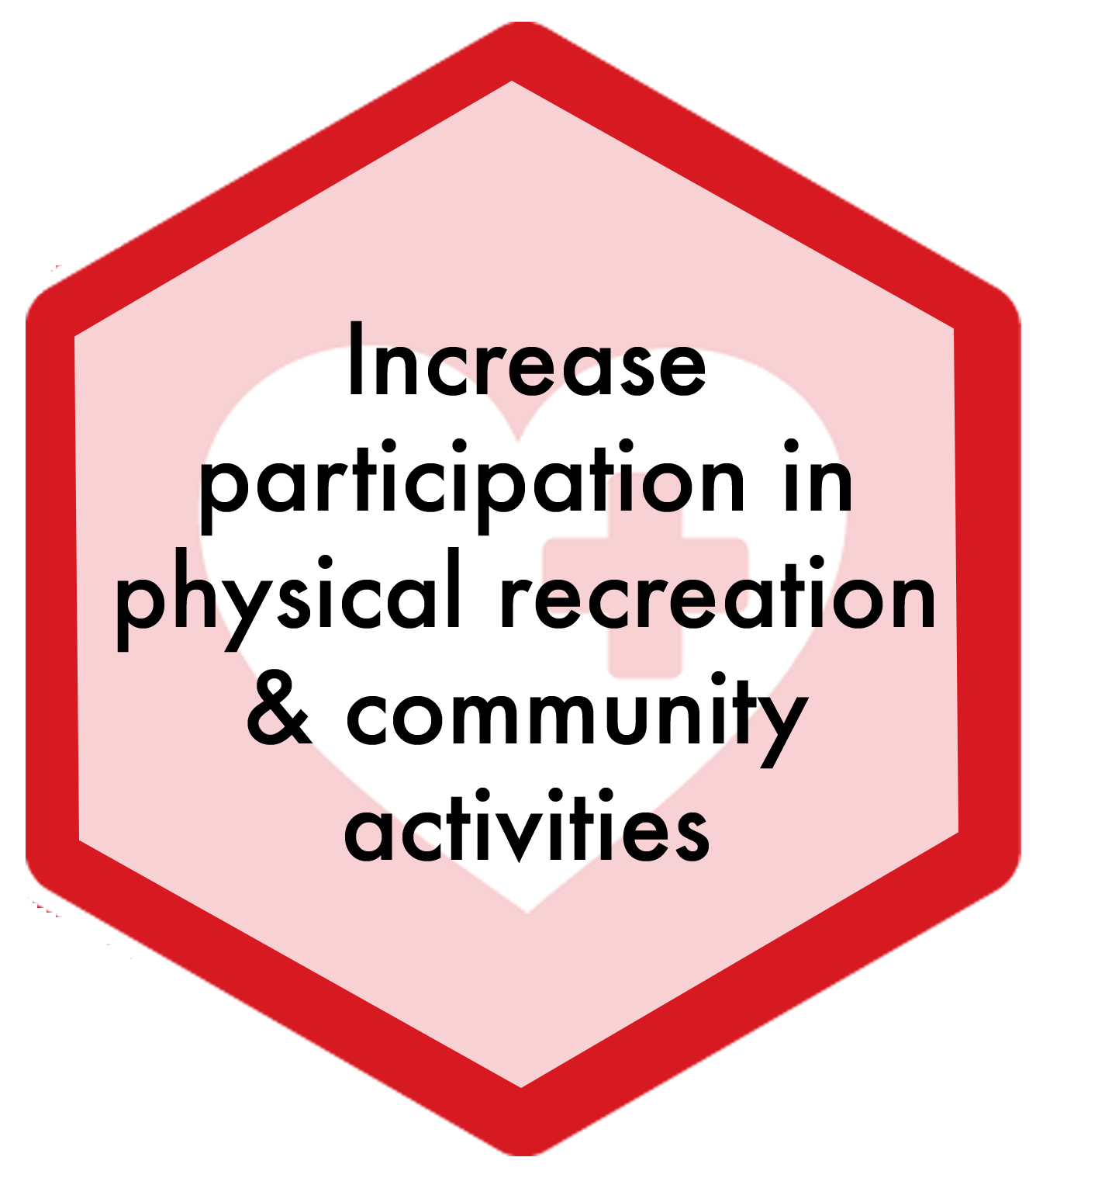

• Consider using the term “complete communities/neighborhoods” and moving away from a time-based definition of this concept. Reasons for moving away from a time-based concept included the following: time needs are different for different people; and while most neighborhoods can become complete neighborhoods, fewer can become 20-minute neighborhoods, (ex. Skyline).
• Use complete/20-minute neighborhoods as a way to focus on local community building
• It would be good to have service providers in neighborhoods
• This concept fosters inter-generational neighborhoods and allows people to age in neighborhoods/age in place.
• Add “multi-modal” to efficient transportation system
• Caution: we do not want to make neighborhoods that foster segregation; that is a risk with this concept.
• Often, new housing, particularly the new higher density housing seen in inner SE Portland, is very expensive. How do we ensure that affordable housing is available?
• Consider: we would need to support an array of complete communities. If a low-income family did not feel comfortable living in a generally upper-income neighborhood, we would not want to force them to live there.
• Changing the center from complete 20-minute neighborhoods to strengthen schools as centers of community brings in other social benefits and we begin to look at schools as gathering places for communities and families, (ex. Trillium).

Ensure equitable access and outcomes

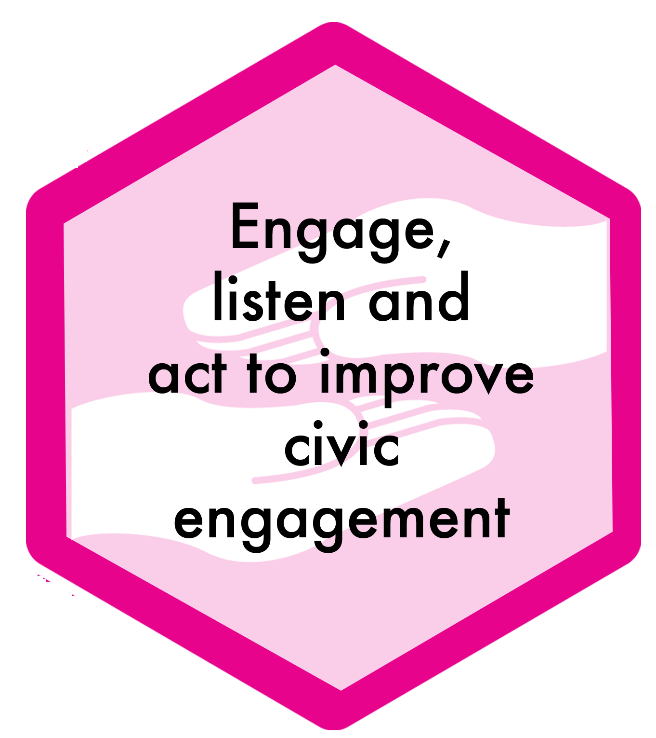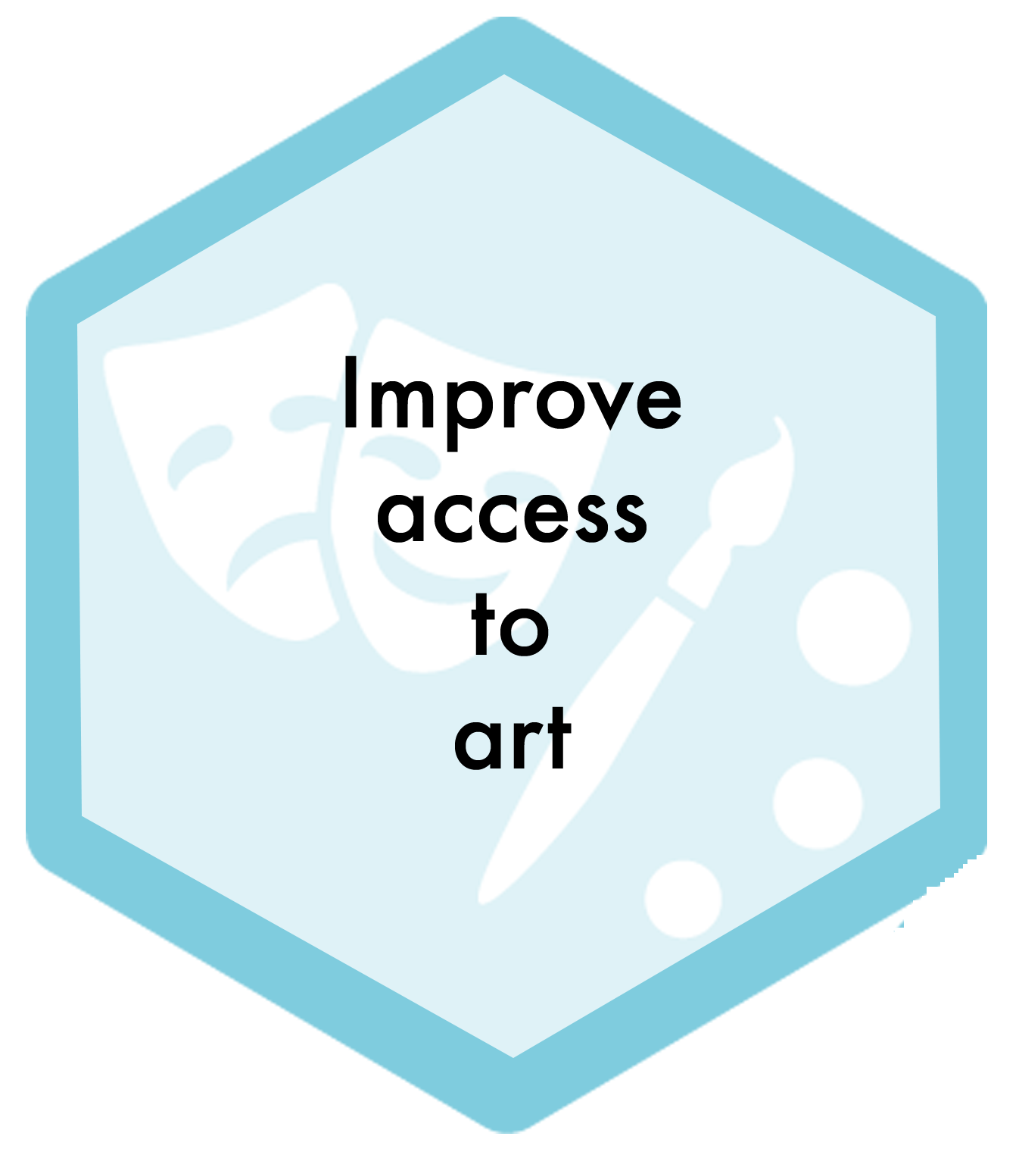

This idea was introduced at the close of the meeting and was not discussed.

