GRANT DEED OF CONSERVATION EASEMENT

THIS GRANT DEED OF CONSERVATION EASEMENT ("Grant") is made
This day of , , by

Primary Grantor: Riverview Village Homeowners Association

Address: PO Box 23099, Tigard, OR 97281

Secondary Grantor: Pacific Western Homes Inc.

Address: 5530 NE 112nd Avenue, Portland, OR 97230

in favor of City of Portland, an Oregon Municipal Corporation, whose address is 1120 SW 5th Avenue, Suite 1000, Portland, OR (“Grantee").
WHEREAS, the Riverview Village Homeowners Association is currently 30% vested in the development, but when all lots in the development are sold will become the sole owner in fee simple of a parcel of land comprising approximately 2.2 acres of real property in Multnomah County, Oregon, more particularly described in Exhibit B attached hereto (the “Conservation Easement Area”). A map of the Property is attached as Exhibit A. Riverview Village Homeowners Association will be known herein as the “Primary Grantors”.
WHEREAS, Pacific Western Homes Inc. is currently 70% vested in the development, but will sell all lots and have no ownership of the Property. At such time Pacific Western Homes Inc. becomes 0% vested in the development, it relinquishes all rights and responsibilities covered in this Grant. Pacific Western Homes Inc. will be known herein as the “Secondary Grantor”.
WHEREAS, Primary and Secondary Grantors have agreed to donate to Grantee a conservation easement over the portion of the Property consisting of approximately 2.2 acres legally described in Exhibit B to preserve the Property’s Conservation Values as described below;

WHEREAS, ORS 271.715 et seq. permits the creation of conservation easements for the purposes of retaining or protecting natural, scenic, or open space values of real property, ensuring its availability for forest, recreational, or open space use, protecting natural resources, maintaining or enhancing air or water quality;
WHEREAS, the Property possesses natural, scenic and recreational values of great importance to Primary and Secondary Grantors, the people of Multnomah County and the people of the State of Oregon (collectively, “Conservation Values”); the most important of these values are water quality protection, natural habitat protection and enhancement for fish in Wilkes Creek, a tributary to the Columbia Slough;
WHEREAS, the Property is within the City of Portland designated environmental zone, which protects natural resource values in compliance with Oregon Statewide Planning Goal 5. This clearly delineated government policy sets forth the public benefit of preservation of land in the Columbia Slough watershed and within the environmental zones on the Columbia Slough and its tributaries;
WHEREAS, the Property provides habitat for cutthroat trout (Oncorhyncus clarki) and Congress has found that encouraging public and private conservation programs “is a key to meeting the Nation’s international commitments and to better safeguarding, for the benefit of all citizens, the Nation’s heritage of fish, wildlife, and plants” 16 U.S.C. 1531(a)(5). This government policy sets forth the basis for preserving land with this key habitat;

WHEREAS, the portion of the Property described in Exhibit B attached hereto (the “Conservation Easement Area”) is undeveloped riparian area existing in a relatively natural state. Tract C contains an existing mature tree canopy made up of western red cedar, Douglas fir, Big leaf maple, black cottonwood and red alder. The understory is mainly comprised of Himalayan blackberry, morning glory, and weedy grasses. There is a cold-water stream flowing through Tract C. Commonly known as Wilkes Creek, the stream is the last existing tributary to the Columbia Slough and contains cutthroat trout.
WHEREAS, the specific Conservation Values of the Property are further documented in an inventory of relevant features of the Property, dated June 2002, on file at the offices of Grantee and attached at Exhibit C (“Baseline Documentation”). The Baseline Documentation consists of reports, maps, photographs, and other documentation that provide, collectively, an accurate representation of the Property at the time of this grant and which is intended to serve as an objective information baseline for monitoring compliance with the terms of this grant;
WHEREAS, Primary and Secondary Grantors intend, as owners of the Conservation Easement Area, to convey to Grantee the right to preserve the Conservation Values of the Conservation Easement Area in perpetuity and Grantee is willing to honor such intentions and protect such values in perpetuity;
WHEREAS, Grantee is the City of Portland whose mission includes serving the Portland community by protecting public health, water quality and the environment and specifically protecting, enhancing and restoring natural waterways;
NOW, THEREFORE, in consideration of the above and the mutual terms, conditions, and restrictions contained herein, Primary and Secondary Grantors hereby grant and convey to Grantee a perpetual conservation easement on, over, and across the Conservation Easement Area of the nature and to the extent set forth in this Grant (“Conservation Easement”).
1. Purpose. It is the purpose of this Grant to assure that the Conservation Easement Area will be retained forever in its natural condition and to prevent any use of the Conservation Easement Area that will significantly impair or interfere with the conservation values of the Conservation Easement Area. Grantors intend that this Grant will confine the use of the Conservation Easement Area to activities that are consistent with such purposes.
2. Scope of Easement. The Conservation Easement Area may be used only for those purposes set forth in Section 3 hereof. The Conservation Easement shall include the right to enter (by motor vehicle, if reasonably necessary in the judgment of Grantee) the Conservation Easement Area to exercise all other rights granted to Grantee under this Grant.
3. Rights of Grantee. To accomplish the purpose of this Grant, Primary and Secondary Grantors hereby convey to Grantee the right:
(a) To preserve, protect and restore in perpetuity and to enhance by mutual agreement the Conservation Values of the Conservation Easement Area;
(b) To enter upon for purposes of inspection, protection, restoration and monitoring of the Conservation Easement Area as provided in Section 6;
(c) To prevent any activity on or use of the Conservation Easement Area that is inconsistent with the purpose of this Grant and to require the restoration of such areas or features of the Conservation Easement Area that may be damaged by any inconsistent activity or use, pursuant to Section 7;
(d) To restore the natural attributes of the Easement via a Restoration Plan mutually agreed upon by the Primary and Secondary Grantors and Grantee (“Restoration Plan”). The Easement provisions are the controlling authority. The Restoration Plan does not confer any rights not specifically set forth in the Easement agreement. Primary and Secondary Grantors and Grantee will develop the Restoration Plan that enhances the Conservation Values of the Conservation Easement Area by undertaking a variety of activities including, but not limited to, removal of invasive plant species, planting of native plant species, removal of rubbish, and to perform other restoration work. The Restoration Plan is subject to the right of entry provided in Section 3(b) and 6;
(e) To construct a pedestrian tail. The trail will be constructed in a way that will preserve the Conservation Values. The purpose of the trail will be to allow the Grantor passive recreation access to the Conservation Easement Area. The Grantor agrees to maintain the trail in perpetuity.
(f) Nothing in this document shall be construed to prohibit Grantee from exercising prior recorded sewer easement rights in Grantee’s favor.
(g) Rights conveyed to Grantee by this Grant do not constitute obligations that Grantee has a duty to perform. Whether to exercise the conveyed rights is subject to Grantee’s sole discretion, and no claim can be asserted against Grantee in connection with Grantee’s failure to exercise such rights.
4. Prohibited Uses. Any activity on or use of the Conservation Easement Area inconsistent with the purposes of this Grant is prohibited. Without limiting the generality of the foregoing, the following activities on or uses of the Conservation Easement Area are expressly prohibited (except to the extent permitted by Section 2):
- Legal or “de facto” division, subdivision, or partitioning;
- Agricultural, commercial, or industrial activity;
- The above ground installation of new utility systems of extensions of existing utility systems, including, without limitation, water, power, fuel, and communication lines and related facilities;
- The placement or construction of any buildings, structures, or other improvements of any kind (including, without limitation, pipelines, wells, septic systems, drain fields, fences, roads, and parking areas);
- Building new roads or any other rights of way or widening of existing roads;
- The alteration of the surface of the land, including, without limitation, the excavation, fill or removal of soil, sand, gravel, rock, peat or sod or changing the topography of the land; except with prior written approval from Grantee or pursuant to the Restoration Plan to preserve, protect or restore the Conservation Values of the Property;
- The draining, filling, dredging, ditching, or diking of riparian area, the alteration or manipulation of water courses, or the creation of new wetlands, water impoundments, or water courses; except with prior written approval from Grantee or pursuant to the Restoration Plan to preserve, protect, restore or enhance the Conservation Values of the Property;
- Any use or activity that causes or is likely to cause significant soil degradation or erosion or significant pollution of any surface or subsurface waters;
- The disposal or storage of rubbish, garbage, debris, vehicles, abandoned equipment, parts thereof, or other unsightly, offensive, or hazardous waste or material;
- The placement of mobile homes, commercial signs, billboards, or other advertising material;
- Hunting or trapping; except to the extent determined necessary by Grantee to preserve, protect or enhance the Conservation Values of the Property. Feral domestic mammals and individuals from the family Muridae of the order Rodentia (old world rats and mice) may be killed without approval of Grantee if done in a manner so as not to adversely impact native plants and animals;
- The exploration for, or development and extraction of, minerals and hydrocarbons on or below the surface of the Conservation Easement Area;
- The disruption of wildlife breeding, foraging and nesting activities;
- The keeping of domestic animals;
- The use of any herbicides or pesticides; except with prior written approval from Grantee or pursuant to the Restoration Plan to preserve, protect, restore or enhance the Conservation Values of the Property.
- The pruning, mowing, cutting down, or other destruction or removal of live and dead trees and other vegetation; except with prior written approval from Grantee or pursuant to the Restoration Plan to preserve, protect, restore or enhance the Conservation Values of the Property.
- The introduction of nonnative plants and nonnative invasive species;
- The operation of motorcycles, dune buggies, snow mobiles, all-terrain vehicles, or any other type of off-road motorized vehicles or the operation of other sources of excessive noise pollution.
5. Reserved Rights. Primary and Secondary Grantors reserve to themselves, and to their personal representatives, heirs, successors, and assigns, all rights not granted hereby, including the right to engage in or permit or invite others to engage in (a) all uses of the Property other than that within the Conservation Easement Area, and (b) all uses of the Conservation Easement Area that are not expressly prohibited herein or inconsistent with the purposes of this Grant.
6. Entry by Grantee. Grantee or its designee shall have the right to enter upon the Conservation Easement Area at any time for the purposes as set forth in Section 3.
7. Grantee's Remedies.
(a) Remedies. If Grantee determines that a violation of the terms of this Grant has occurred or is threatened, Grantee shall give written notice to Primary and Secondary Grantors of such violation and demand corrective action sufficient to cure the violation and, where the violation involves injury to the Conservation Easement Area resulting from any use or activity by or at the direction of Primary and Secondary Grantors inconsistent with the purposes of this Grant to restore the portion of the Conservation Easement Area so injured. If Primary and Secondary Grantors fail to cause the violation to be cured within 30 days after receipt of notice thereof from Grantee (or if the violation cannot reasonably be cured within a 30-day period, if Primary and Secondary Grantors fail to begin curing the violation within such period), or fail to continue diligently to cure such violation until finally cured, Grantee shall have the following rights and remedies, in addition to all other rights under this Grant:

(i) To bring an action at law or in equity in a court of competent jurisdiction to enforce the terms of this Grant;
(ii) To enjoin the violation, by action of the City, as necessary, by temporary or permanent injunction;
(iii) To recover any damages to which it may be entitled for violation of the terms of this Grant or injury to any of the Conservation Values; and
(iv) To require the restoration of the Conservation Easement Area to the condition that existed prior to any such injury.
Without limiting Primary and Secondary Grantors' liability therefor, Grantee, in its sole discretion, may apply any damages recovered to the cost of undertaking any corrective action on the Conservation Easement Area. Notwithstanding anything to the contrary in this Grant, if Grantee, in its sole discretion, determines that immediate action is required to prevent or mitigate significant damage to the Conservation Values, Grantee may pursue its remedies under this subsection (a) without prior notice to Primary and Secondary Grantors or without waiting for the cure period to expire. Grantee's rights under this section shall apply equally in the event of either actual or threatened violations of the terms of this Grant. Primary and Secondary Grantors acknowledge and agree that breach of this Grant will cause irreparable harm to Grantee and agree to the entry of a temporary restraining order and permanent injunction by any court of competent jurisdiction to prevent breach or further breach of this Grant, in addition to specific performance of the terms of this Grant, without the necessity of proving either actual damages or the inadequacy of otherwise available remedies, at law.
(b) Remedies Cumulative. All rights and remedies described in subsection 7(a) are cumulative and in addition to any other remedy Grantee may have by agreement, at law or in equity. Partial exercise of or forbearance by Grantee in exercising any right or remedy shall not limit or restrict Grantee's subsequent exercise of such right or remedy or contemporaneous or subsequent exercise of any other right or remedy, nor shall it be construed to be a waiver by Grantee of any term of this Grant.
(c) Costs of Enforcement. If any action or suit is instituted to enforce the terms of this Grant, the prevailing party shall be entitled to recover from the other party, in addition to any other rights and remedies it may have, all reasonable expenses and attorney fees at trial or on appeal, and all costs (including attorney fees) associated with any restoration required as a result of Primary and Secondary Grantors' violation of the terms of this Grant.
(d) Acts Beyond Primary and Secondary Grantors' Control. Nothing contained in this Grant shall be construed to entitle Grantee to bring any action against Primary and Secondary Grantors for (a) any injury to or change in the Conservation Easement Area resulting from causes beyond, Primary and Secondary Grantors' control, including, without limitation, fire, flood, storm, and earth movement, or from any prudent action taken by Primary and Secondary Grantors under emergency conditions to prevent, abate, or mitigate significant injury to the Conservation Easement Area resulting from such causes, or (b) any act or omission of a third party.
8. Access by the Public. The public shall be granted access to the Conservation Easement Area by way of a trail, once constructed.
9. Costs and Liabilities.
(a) Primary and Secondary Grantors retain all responsibilities for and shall bear all costs and liabilities of any kind related to the ownership, operation, upkeep, and maintenance of the portions of the Property which are not subject to this Grant, including the maintenance of adequate comprehensive general liability insurance coverage. Primary and Secondary Grantors shall keep the Conservation Easement Area free of any liens arising out of any work performed for, materials furnished to, or obligations incurred by Grantors.
(b) The Primary Grantor agrees to maintain the Conservation Values of the Conservation Easement Area in perpetuity according to the maintenance requirements agreed upon in the Restoration Plan. Maintenance will include, but not be limited to, removal of garbage, removal of invasive and nonnative plant species, replacement of native plant species that have died with native plants, and general maintenance of the pedestrian trail once constructed. Primary Grantor agrees to perform maintenance on an annual basis.
10. Taxes. Primary and Secondary Grantors shall pay before delinquency all governmental taxes, assessments, fees, and charges of whatever description levied on or assessed against the Property (including the Conservation Easement Area), including any taxes imposed upon, or incurred as a result of this Grant, and shall furnish Grantee with satisfactory evidence of payment upon request.
11. Extinguishment. If future circumstances render the purpose of this Grant impossible to accomplish, this Grant can only be terminated or extinguished, in whole or in part by judicial proceedings in a court of competent jurisdiction. The amount of the proceeds to which Grantee shall be entitled, after satisfaction of prior claims, from any sale, exchange, or involuntary conversion of all or any portion of the Conservation Easement Area subsequent to such termination or extinguishment, shall be determined, unless otherwise required by Oregon law at the time, by using the values which would be used to calculate the value of the deduction for federal income tax purposes allowable by means of such Grant pursuant to Section 170(h) of the Code, assuming such grant occurred on the date the easement is extinguished or terminated.
12. Condemnation. If all or any part of the Conservation Easement Area is taken by power of eminent domain, or is conveyed under threat of condemnation, Grantee shall be entitled to compensation in accordance with applicable law.
13. Assignment. Grantee may assign its rights and obligations under this Grant only to an organization that is a qualified organization at the time of transfer within the meaning of Section 170(h) of the Code (or any successor provision then applicable) and the applicable regulations promulgated thereunder and is authorized to acquire and hold conservation easements under ORS 271.715 et seq. (or any successor provision then applicable).

14. Subsequent Transfers. Primary and Secondary Grantors agree to incorporate the terms of this Grant in any deed or other legal instrument by which Primary and Secondary Grantors divest themselves of any interest in all or part of the Property, including without limitation, a leasehold interest. Primary and Secondary Grantors further agree to give written notice to Grantee of the transfer of any such interest at least 30 days prior to the date of transfer. The failure of Primary and Secondary Grantors to perform any act required by this section shall in no way impair the validity of this Grant or limit its enforceability.
15. Mutual Indemnities.
(a) Indemnification of Grantee. Primary and Secondary Grantors shall hold harmless, defend, and indemnify for public liability and property damage Grantee, and Grantee's officers, directors, agents, and employees, against all claims, demands, actions, and suits (including all attorneys fees and costs incurred through trial and on appeal) brought against any of them arising from the exercise of Grantor's rights or responsibilities hereunder. Primary and Secondary Grantors shall not be responsible under this Grant for the acts or omissions of third parties, other than Primary and Secondary Grantors’ agents, employees, contractors, or subcontractors.
(b) Indemnification of Primary and Secondary Grantors. Grantee shall hold harmless, defend, and indemnify for bodily injury and property damage Primary and Secondary Grantors, and Primary and Secondary Grantors’ agents and employees, against all claims, demands, actions, and suits (including all attorneys fees and costs incurred through trial and on appeal) brought against any of them arising from the exercise by Grantee of its rights or responsibilities hereunder. Grantee shall not be responsible under this Grant for the acts or omissions of third parties, other than Grantee's officers, directors, agents, employees, contractors, or subcontractors, except to the extent the acts or omissions of third parties area caused by the fault of Grantee or its officers, directors, agents, employees, contractors, or subcontractors
Grantee's obligations shall be subject to the limitations of the Oregon Constitution and the Oregon Tort Claims Act (ORS 30.260 to 30.300).
16. Subordination. At the time of execution of this agreement and grant of the Easement, the Property is subject to a deed of trust, the beneficiary of which has agreed by separate instrument to subordinate its rights in the Property to the extent necessary to permit Grantees to enforce the purposes of the Easement in perpetuity and to prevent any modification or extinguishment of the Easement by the exercise of any rights of the beneficiary.
17. Miscellaneous.
(a) Controlling Law. This Grant shall be governed by and construed in accordance with the laws of the state of Oregon.
(b) Notices. Any notice, demand, request, consent, approval, or other communication required or permitted hereunder shall be in writing and either served personally or sent by first class mail, postage prepaid, or certified mail, return receipt requested, addressed as follows:

To Primary Grantors: Riverview Village Homeowner’s Association
Address: PO Box 23099, Tigard, OR 97281

To Secondary Grantors: Pacific Western Homes, Inc.
Address: 5530 NE 112nd Avenue, Portland, OR 97230

To Grantee: City of Portland
Address: 1120 S.W. 5th Avenue, Room 1000, Portland, OR 97204
Or to such other address as either party from time to time shall designate by written notice to the other. Notices shall be deemed given when received, or four days from the date of mailing, whichever occurs first.
(c) Recordation. Grantee shall record this instrument in the official records of Multnomah County, Oregon, and may re-record it at any time as may be required to preserve its rights in this Grant.
(d) Liberal Construction. Any general rule of construction to the contrary notwithstanding, this Grant shall be liberally construed to effect the purpose of this Grant and the policies and purposes of ORS 271.715 et seq. Any provision in this Grant found to be ambiguous shall be interpreted consistent with the purpose of this Grant.
(e) Severability. If any provision of this Grant is found to be invalid, the remaining portion thereof and all other provisions of this Grant shall, nevertheless, remain in full force and effect.
(f) Entire Agreement. This Grant is the final and entire agreement of the parties with respect to the subject matter hereof and supersedes all prior or contemporaneous oral or written understandings or agreements between the parties.
(g) No Forfeiture. Nothing contained herein shall be construed to result in a forfeiture or reversion of Primary and Secondary Grantors ' title to the Property in any respect.
(h) Successors. The covenants, terms, conditions, and restrictions of this Grant shall be binding upon, and inure to the benefit of, the parties hereto and their respective personal representatives, heirs, successors, and permitted assigns and shall continue as a servitude running in perpetuity with the Property.
(i) Termination of Rights and Obligations. A party's rights and obligations under this Grant terminate upon transfer of such party's interest in the Property or the easements granted hereby, except that liability for acts or omissions occurring prior to transfer shall survive transfer.
(j) Joint and Several Obligations. All obligations, agreements, and promises of Primary and Secondary Grantors in this Grant shall be construed, and are hereby declared, to be joint and several and shall be fully binding upon and enforceable against either Grantor.
(k) Exhibits and Recitals. The exhibits and recitals are incorporated herein by this reference.

IN WITNESS WHEREOF, this Grant has been duly executed on the date first above written.

PRIMARY GRANTOR GRANTEE
Riverview Village Homeowner’s Association City of Portland, Oregon
By: By:

Dated: Dated:

SECONDARY GRANTOR

Pacific Western Homes, Inc.

By:

Dated:
STATE OF OREGON )
) ss.
County of Multnomah : )

This instrument was acknowledged before me on __________________________, 2002 by __________________________________________________ as ____________________________________________ of the City of Portland.

__________________________________
Notary Public for Oregon
My commission expires: _____________

This instrument was acknowledged before me on __________________________, 2002 by __________________________________________________ as ____________________________________________ of Riverview Village Homeowner’s Association.

__________________________________
Notary Public for Oregon
My commission expires: _____________

This instrument was acknowledged before me on __________________________, 2002 by __________________________________________________ as ____________________________________________ of Pacific Western Homes, Inc.

__________________________________
Notary Public for Oregon
My commission expires: _____________
Approved As to Form:

Deputy City Attorney
Exhibit A: Site Location and Aerial

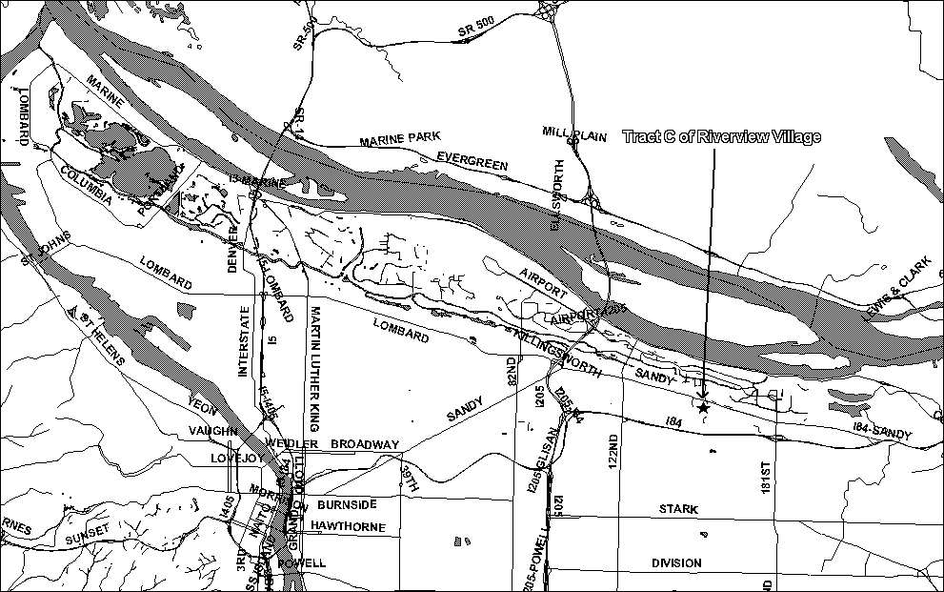
Exhibit B: Conservation Easement Area

Legal Description: Tract C of the Riverview Village Subdivision.

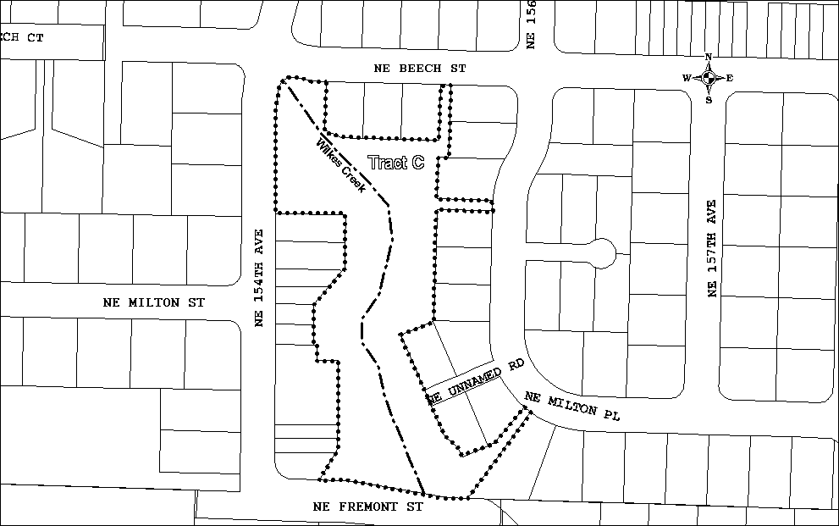
Exhibit C: Baseline Documentation Report

Conservation Easement
Baseline Documentation Report

Please complete to satisfy Section 1.170A-14(g)(5) of the federal tax regulations.

Donor Name:
Business/Oranization: Riverview Village Homeowner’s Association
Address: PO Box 23099, Tigard, OR 97281

Donor Name:
Business/Organization: Pacific Western Homes Incorporated
Address: 5530 NE 112nd Avenue, Portland, OR 97230

Donee Name:
Business/Organization: City of Portland, Environmental Services
Address: 1120 SW 5th Street Suite 1000, Portland, OR 97204

Property Location:
Address: NE 154th Street and NE Beech Street
Taxlot ID: 1N2R24DC –000OS

Land Types:

# Acres: 2.2_______
% Wetland: 0_____
% Forestland: 100__
% Farmland: 0
Buildings/Structures: 2 culverts
Open Stream: Wilkes Creek
Other: N/A_________

Project Summary:
The purpose of the conservation easement is to enhance and protect the conservation values of Tract C in Riverview Village. A second purpose is to allow access to the tract and at some time in the future construct a pedestrian trail to connect Tract C with Wilkes Park. The Grantee agrees to perform the initial enhancement of Tract C during 2002/2003 and to construct the pedestrian trail when funding becomes available. The Grantor agrees to perform annual maintenance, beginning in 2003, of Tract C based on the responsibilities agreed to in the Restoration Plan.

Legal Description:
Tract C of Riverview Village subdivision.

Conservation Values:
Tract C contains an existing mature tree canopy made up of western red cedar, Douglas fir, Big leaf maple, black cottonwood and red alder. Some of the trees are up to two feet in diameter (2’ dbh). The understory is mainly comprised of himalayan blackberry, morning glory, and weedy grasses. These invasive, non-native species have crowded out any native shrubs and groundcover. The non-natives are also preventing regeneration of the trees.

There is a cold-water stream flowing through Tract C. Commonly known as Wilkes Creek, the stream is the last existing tributary to the Columbia Slough. The water quality of Wilkes Creek appears to be good, although no official testing has been completed. The water was relatively cold and flowing at the time of the site visit. Downstream for Tract C, cutthroat trout have been documented using the stream. Wilkes Creek flows from Tract C under NE 154th, across Tract A and a private property, then under Sandy Blvd. and to the Columbia Slough. The stream is a cold water input to the Slough, which has a TMDL for temperature.

In compliance with Section 1.170A-14(g)(5) of federal tax regulations this natural resources inventory is an accurate representation of the property at the time of the conservation easement donation.

Donor:_______________________________
Date:________________________________

Donor:_______________________________
Date:________________________________

Donee:_______________________________
Date:________________________________

Attachments: USGS topographic map

Map of existing conditions
Property lines, roads, buildings, fences, vegetation
Aerial photography
On-site photographs

Attachment A: USGS Topographic Map

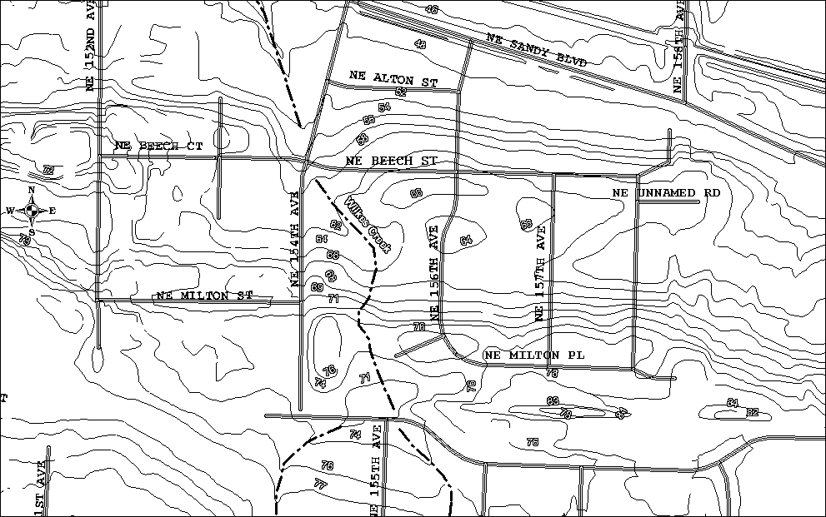
Figure 1: Riverview Village Topography

Attachment B: Existing Conditions Map

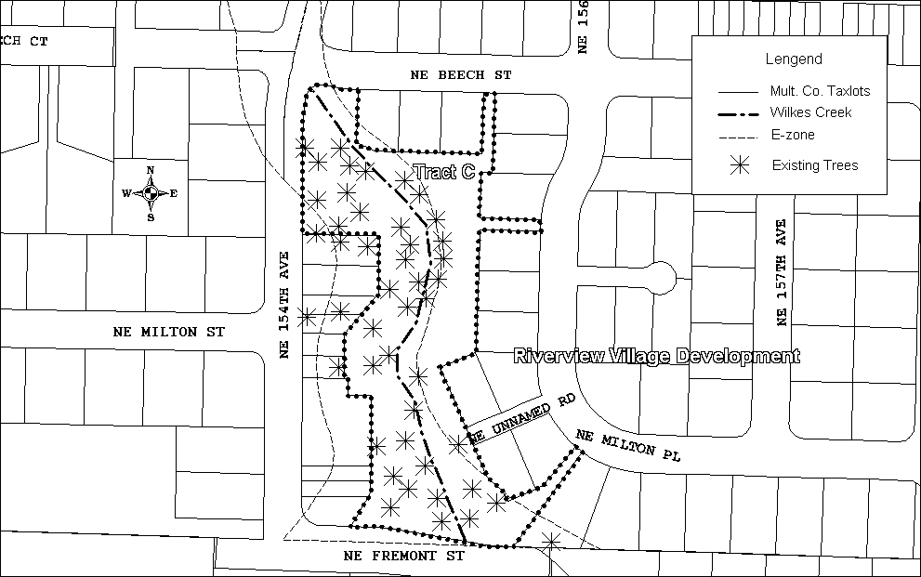
Figure 2: Riverview Village Existing Conditions

Attachment C: Aerial Map

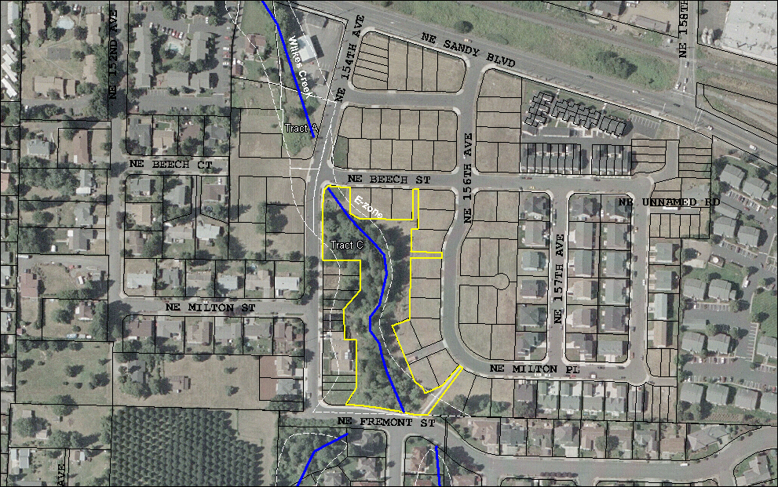
Figure 3: Riverview Village Aerial

Attachment D: Photographs July 2002

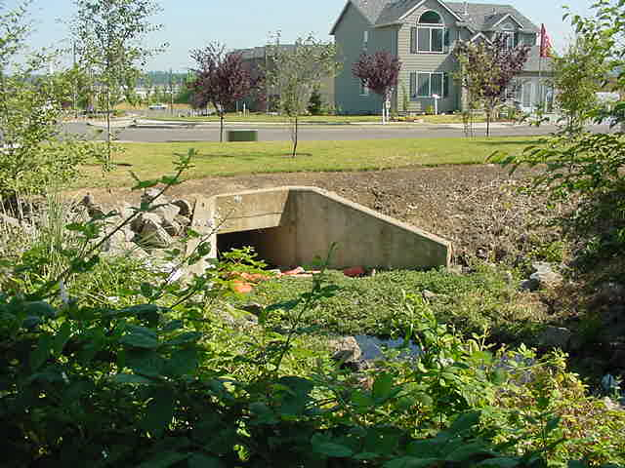
Figure 4: Downstream Culvert

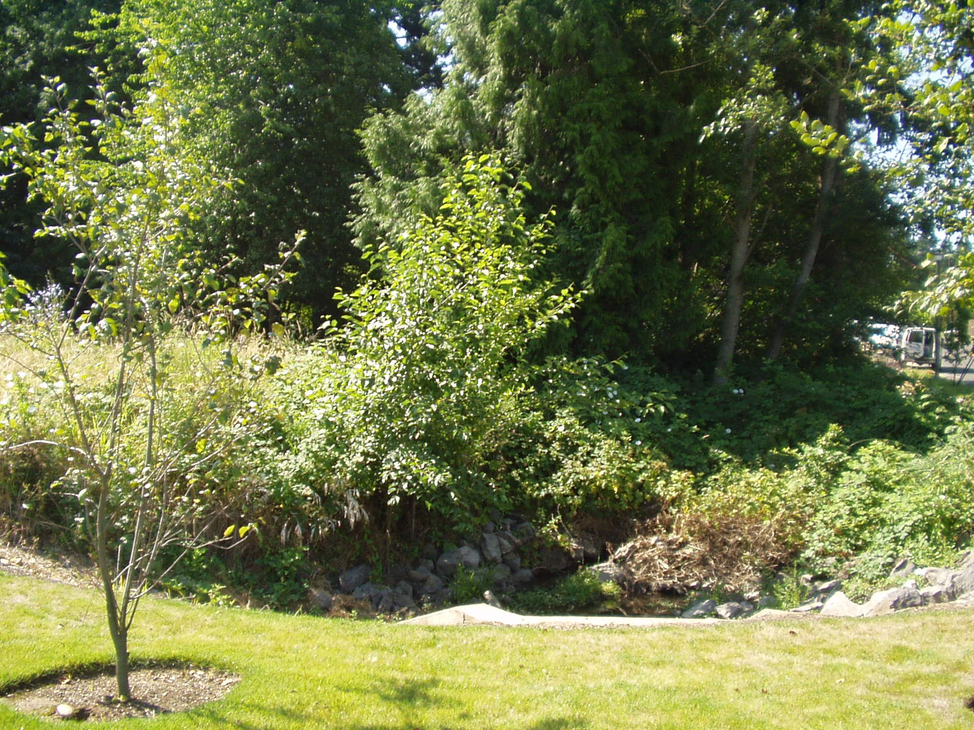
Figure 5: North Side Tract C
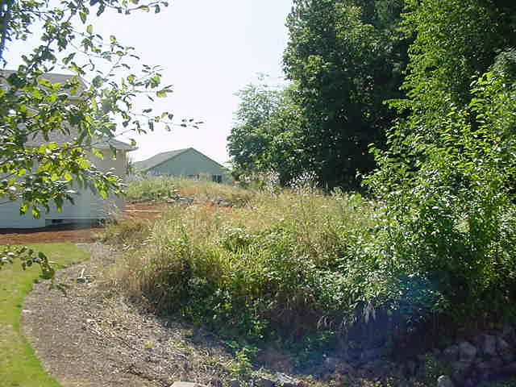
Figure 6: Northeast Side Tract C

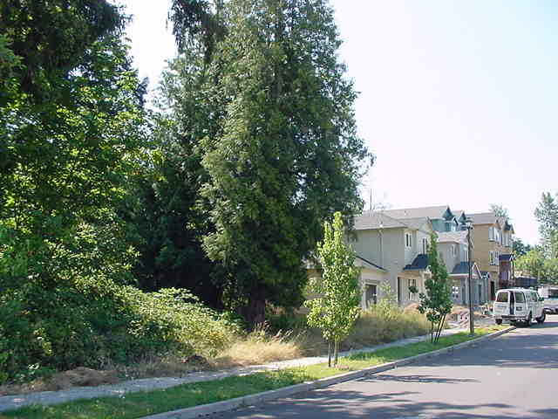
Figure 7: Northwest Side Tract C
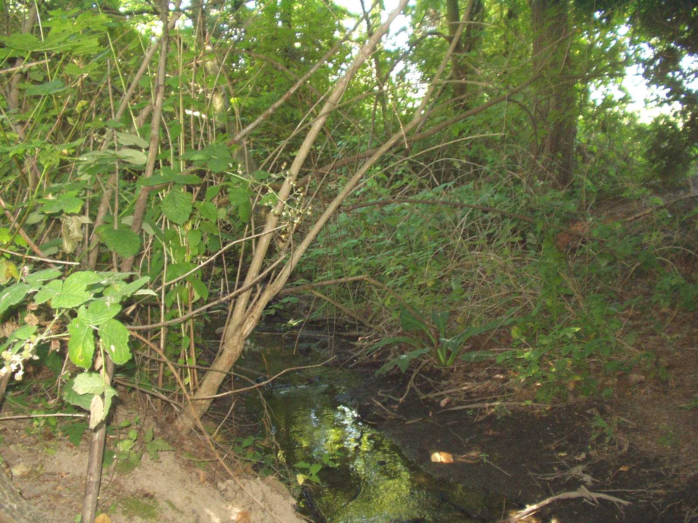
Figure 8: Wilkes Creek

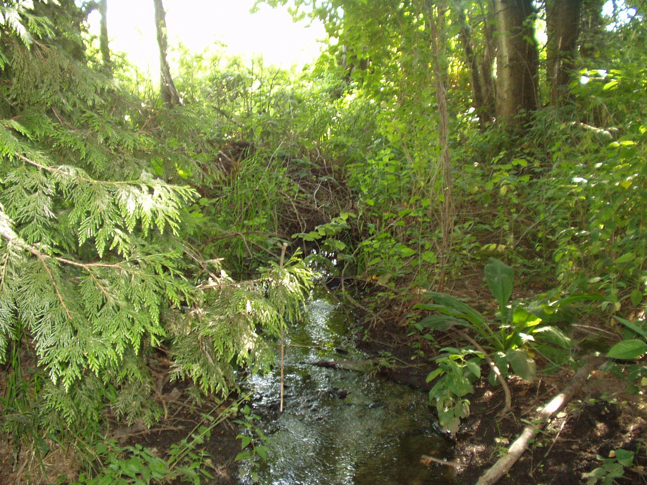
Figure 9: Wilkes Creek
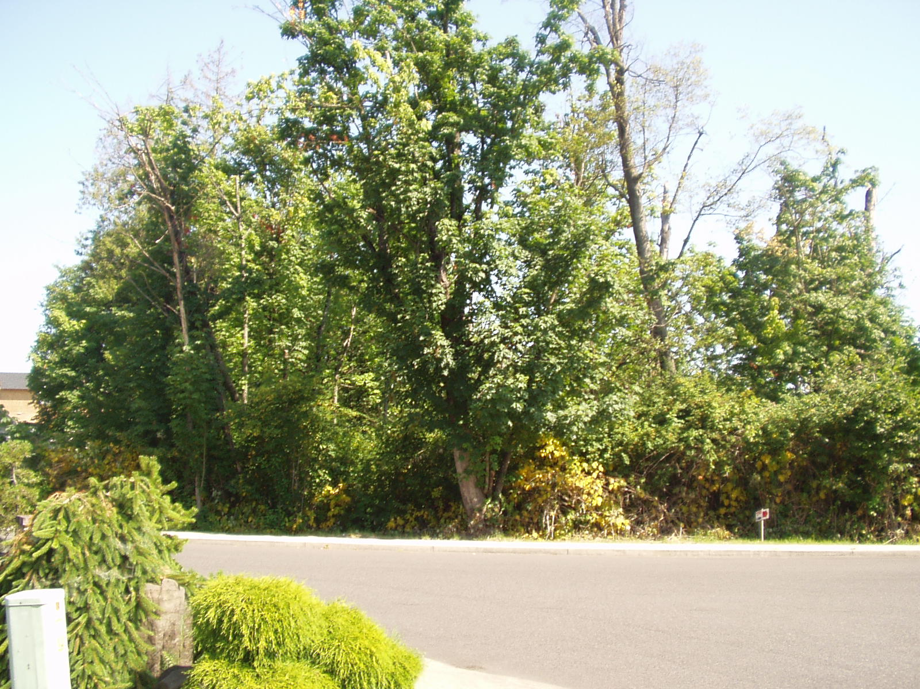
Figure 10: South Side Tract C

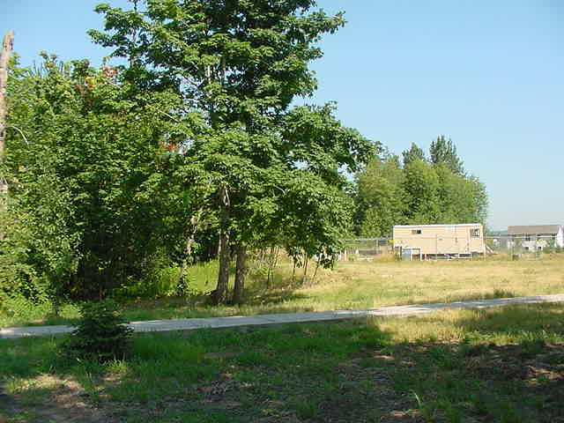
Figure 11: Southeast Side Tract C
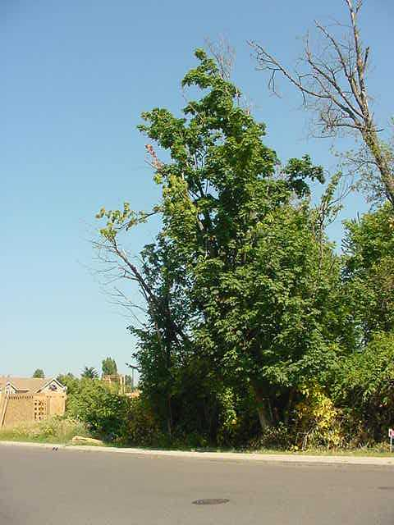
Figure 12: Southwest Side Tract C

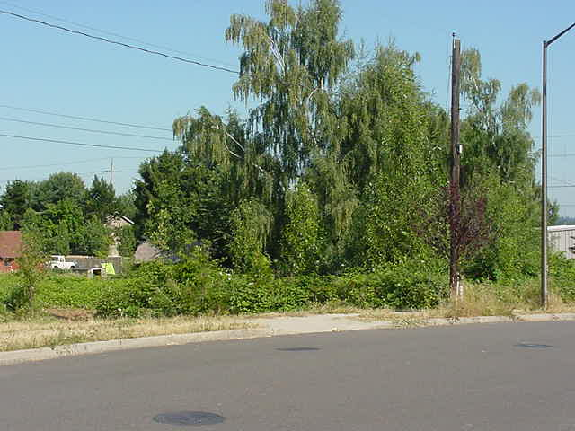
Figure 13: Tract A

Exhibit D: Restoration Plan

Long Term Vision Goal: The goal of this project is to remove non-native species that are dominating the understory of this reach and allow native plants to regenerate. Native planting will include shrubs to diversify the understory vegetation as well as deciduous and coniferous trees. The Riverview Village Homeowner’s Association will be responsible for maintenance of the site. During the first three (3) years, BES will contract with SOLV to organize homeowner involvement in the restoration and maintenance of the site. Tract C will be monitored in perpetuity by BES and will be maintained in perpetuity by the Riverview Village Homeowner’s Association.

Initial Restoration: 2002-2003
- Removal of Himilayan blackberry and English Ivy on site. Approximately 10 tons.
- Removal of any trash on site. Approximately 50 lbs.
- Planting approximately 700 native trees and shrubs. Species to be planted include:
Big Leaf Maple
Red Alder
Douglas Fir
Western Red Cedar
Red Elderberry
Snowberry
Pacific Ninebark
Indian Plum
Vine Maple
Red Osier Dogwood
Pacific Willow
Spirea (Hardhack)
Swamp Rose
Sword Fern
Salmonberry
- Target number of volunteers: 100

Initial Maintenance: 2003-2005
- Completion of Monitoring Form (Exhibit E) on an annual basis. The completed form will be mailed to Riverview Village Homeowner’s Association.
- Photo and vegetation monitoring two (2) times a year, in the spring and fall. To be performed by SOLV.
- Replacing any native plants that have died with the same species of native plant.
- Removal of non-native and invasive species two (2) times a year, in the early and late summer.
- During the first year of native plant growth, some watering may be needed. Summer watering should be done by hand in the early morning or late evening.
- Removal of trash and other debris if necessary.
- Target number of volunteers: 30

Long-term Maintenance
- Completion of Monitoring Form (Exhibit E) on an annual basis. The completed form will be mailed to Riverview Village Homeowner’s Association.
- Removal of non-native and invasive species at a minimum of once a year, in the early summer, until the understory is established. Establishment will be determined by BES.
- Replacing native understory plants that have died with native plants.
- Removal of trash and other debris at a minimum of once a year.

Exhibit E: Monitoring Inspection Form

Conservation Easement
Monitoring Inspection Form

Site Name: Tract C of Riverview Village
Address: NE 154th and Beech Street

Current Owner: Riverview Village Homeowner’s Association

Address: PO Box 23099, Tigard, OR 97281
Phone:

Inspector Name: City of Portland, Bureau of Environmental Services
Address: 1120 S.W. 5th Avenue, Room 1000, Portland, OR 97204
Phone:
Inspection Date:

General Conditions of Protected Features

Plant Survival of Original Planting

Water Quality as Compared to Baseline Report

Condition of Trail

Possible Violations of Terms of Conservation Easement

I, _________________________________________, grantor of the above property, agree that the description prepared by _____________________________________ is an accurate representation of the physical condition of the property as of _____________________, ________.

___________________________________________
Owner Signature
___________
Date

___________________________________________
Inspector Signature
_____________
Date

Attachments: Photographs (if necessary)

