Bylaws of the BRIDGETON Neighborhood Association
Portland, Oregon
October 20, 2020

ARTICLE I NAME OF ORGANIZATION

The name of the organization is BRIDGETON NEIGHBORHOOD ASSOCIATION

ARTICLE II PURPOSE

The BRIDGETON NEIGHBORHOOD ASSOCIATION does not provide services, but is an asset driven organization that works to engage neighbors in cooperative self-directed community building, civic improvement, social connection, and mutual assistance.

ARTICLE III BOUNDARIES

In Portland, Oregon, roughly defined as starting on the west at I-5, north from N. Marine Drive to the center of the North Portland Channel. to the intersection of Bridgeton Road and N. Marine Drive including the Portland Yacht Club on the east.

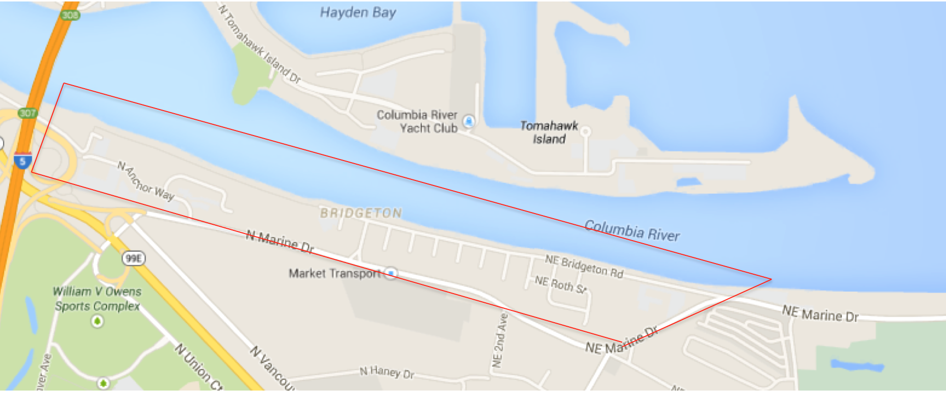

ARTICLE IV GOVERNANCE

Section 1 Standards, Practices, and Law: BRIDGETON NEIGHBORHOOD ASSOCIATION is an officially recognized neighborhood association of the City of Portland, a Non-Profit Corporation of the State of Oregon, a federal tax-exempt organization under the Internal Revenue Service 501(c)(3) tax code, and one of eleven neighborhood associations of North Portland Neighborhood Services, managed by the Portland City Office of Community & Civic Life (OCCL). BRIDGETON NEIGHBORHOOD ASSOCIATION will follow the City of Portland Office of Neighborhood Involvement Standards for Neighborhood System https://www.portlandoregon.gov/civic/40260 (ONI Standards), the State of Oregon laws for Non-Profit Corporations, U.S. Internal Revenue Service laws and requirements, and participate in North Portland Neighborhood Services actions and activities.

Section 2 Bylaws Review and Amendment: These bylaws will be reviewed annually by the Board of Directors. Amendments to these bylaws may be proposed by the General Membership or the Board for consideration and vote by the General Membership.

Section 3 Governance Procedures: Robert’s Rules of Order shall govern formal votes on issues and elections, and may be invoked as needed by any member to govern discussions.

ARTICLE V GENERAL MEMBERSHIP

Section 1 Qualifications: Membership is open to any person above the age of 18 who is a resident, property owner, or holder of a business license located within the BRIDGETON NEIGHBORHOOD ASSOCIATION neighborhood boundaries.

Section 2 Voting: All members shall have one vote each to be cast during attendance at any General or special meeting. One representative from each business shall have the same privilege as other members. Unless otherwise specified in these bylaws, decisions of the Neighborhood Association are by a majority vote of those members present at any meeting.

Section 3 Powers of the General Membership: The General Membership shall advise the Board of Directors and shall have the reserved right and sole authority to:

- Elect a Board of Directors that manages the affairs of the BRIDGETON NEIGHBORHOOD ASSOCIATION,

- Remove any member of the Board of Directors with or without cause (Article VIII, Section 9) and,

- Amend the Bylaws of the BRIDGETON NEIGHBORHOOD ASSOCIATION (Article IV, Section 2).

ARTICLE VI MEETINGS

Section 1 General Membership Meetings

a. General Meetings: A General Membership meeting will be held annually in fall. The fall General Membership meeting will be reserved for the annual election of the Board of Directors.

Other general meetings will be scheduled by the board. General meetings require a minimum of seven day advance notice. Notice may be sent by electronic or non-electronic means.

b. Special General Meetings: Special meetings of the Membership may be called by the Chairperson or by majority vote of the Board or by a petition of twenty five or more members (Article V Section 1) presented to the Board.

c. Quorum: A quorum for any General or special meeting of the BRIDGETON NEIGHBORHOOD ASSOCIATION is fifteen (15) members.

d. Participation: All are eligible to attend. Only members are eligible to participate in discussion and vote.

Section 2 Board of Directors Meetings

a. Board Meetings: Board meetings are held monthly unless deferred by a majority of the Board.

b. Special Board Meetings: Special meetings of the Board may be called by the Chairperson or by majority vote of the Board.

c. Quorum: A quorum for any Board meeting is a majority.

d. Participation: All meetings are open to the public. Only Board members are eligible to vote. All BNA members can participate in discussions. The meeting chair will maintain order.

ARTICLE VII BOARD OF DIRECTORS

Section 1 Number of Board Members: The Board will be no more than fifteen (15) members.

Section 2 Board Composition: Board Membership is limited to one member per residence or business licensee.

Section 3 Terms of Office: Terms of office are for one year or until the annual election.

Section 4 Board Vacancies: The Board may fill any vacancy of the Board of Directors.

Section 5 Election of Board Members: Board members are elected annually by a vote of the Membership at an annual meeting held in the fall of each year.

Section 6 Election of Board Officers: Board members shall meet after the annual meeting to elect a Chairperson, Secretary and Treasurer. The remaining Board members will be members-at-large.

Section 7 Duties of Board Members: The Board manages the affairs of the Neighborhood Association.

Section 8 Duties of Board Officers

a. Chairperson: The Chairperson facilitates Board and General Membership meetings and serves as the spokesperson for the Board.

b. Secretary: The Secretary records minutes, maintains all records, and files in a timely manner duplicates of all records with North Portland Neighborhood Services.

c. Treasurer: The Treasurer maintains accurate fiscal records, presents a detailed monthly account of the fiscal position, and provides the Financial Audit Committee access to all records.

Section 9 Termination: Any Board Member may be terminated at a General or Special Membership meeting with or without cause by a simple majority, if the proposal to terminate is noticed in the agenda a minimum of seven days prior to the General or Special meeting.

ARTICLE VIII COMMITTEES

Section 1 Grievance Committee: In the event a grievance is filed and in order to maintain impartiality, a Grievance Committee will be selected in accordance with ONI standards. The grievance committee will be selected randomly from three different neighborhood associations, other than the BRIDGETON Neighborhood Association, in the North Portland Neighborhood Services district.

Section 2 Financial Review Committee: A Finance Review Committee will be selected in accordance with ONI standards. . The Financial Review Committee will be selected randomly from three different neighborhood associations, other than the BRIDGETON Neighborhood Association, in the North Portland Neighborhood Services district. The Financial Audit Committee will conduct an informal annual financial review of revenues and expenses within 90 days of the fiscal year end (June 30).

Section 3 Board Committees: The Board may establish committees. Committees will make recommendations to the BNA Board and shall not act on their own accord, without Board approval.

ARTICLE IX GRIEVANCE

Section 1 Eligibility to Grieve: Grievances are limited to complaints that the grievant has been harmed by a violation of the ONI Standards or these bylaws that has directly affected the outcome of a decision of BRIDGETON NEIGHBORHOOD ASSOCIATION. Grievances must be submitted in writing to the Board within 45 days of the alleged violation.

Section 2 Processing the Grievance: The Grievance Committee (Article VIII, Section 1), shall review the grievance and give the grievant and others the opportunity to present relevant comment. Deliberations may be held in executive session. The Committee’s recommendation is forwarded to the Board.

Section 3 Final Resolution: Within 60 days from receipt of the grievance, BRIDGETON NEIGHBORHOOD ASSOCIATION shall render a final decision on the grievance and notify the grievant of their decision. Deliberations by the Board on a grievance decision may be held in executive session.

