EXHIBIT A
Properties Not Being Assessed

The map below shows properties within the NW Thompson Road LID that will not be assessed. Specific lists of properties are identified in sections 1 through 8. Properties to be assessed are shown in orange below, and are identified separately in Attachment B.

Section | Reason for nonassessment | Section | Reason for nonassessment
1 | Excluded Prior to LID Formation | 5 | Pending Sale at Final Assessment
2 | Presold at LID Formation | 6 | Open or Common Area
3 | Pending Sale at LID Formation | 7 | Street Right-of-Way
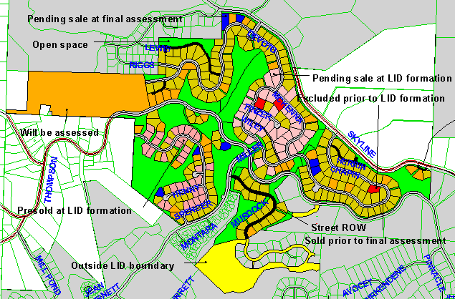4 | Sold Prior to Final Assessment | 8 | Replatted Parcel (not shown on map)

Exhibit A, Section 1 Map: Properties Excluded Prior to LID Formation

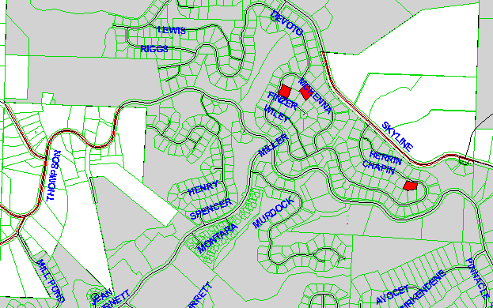

Exhibit A, Section 1 Property List: Properties Excluded Prior to LID Formation

 | State ID | Property Tax Number | City Lien Number | Legal Description | Lot | Actual Area | Assessed Area | Assessment | Recording | Total Billing
1 | 1N1W23DC 1800 | R291781180 | 109589 | Forest Hgts Estates No 2 | 108 | 15,484 | 0 | $ - | $ - | $ -
2 | 1N1W23DC 2100 | R291781240 | 109592 | Forest Hgts Estates No 2 | 111 | 14,453 | 0 | $ - | $ - | $ -
3 | 1N1W26AA 2300 | R291784340 | 124315 | FOREST HTS ESTATES NO 4 | 248 | 12,684 | 0 | $ - | $ - | $ -
 |  |  |  |  |  | 42,621 | 0 | $ - | $ - | $ -

Exhibit A, Section 2 Map: Properties Presold at LID Formation

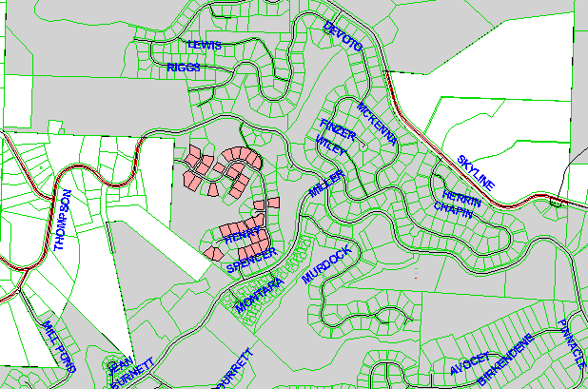

Exhibit A, Section 2 Property List: Properties Presold at LID Formation

 | State ID | Property Tax Number | City Lien Number | Legal Description | Lot | Actual Area | Assessed Area | Assessment | Recording | Total Billing
1 | 1N1W26BA 1800 | R291782220 |  | Forest Hgts Estates No 3 | 150 | 9,412 | 0 | $ - | $ - | $ -
2 | 1N1W26BA 1900 | R291782200 |  | Forest Hgts Estates No 3 | 149 | 9,378 | 0 | $ - | $ - | $ -
3 | 1N1W26BA 2200 | R291782140 |  | Forest Hgts Estates No 3 | 146 | 9,014 | 0 | $ - | $ - | $ -
4 | 1N1W26BA 2300 | R291782120 |  | Forest Hgts Estates No 3 | 145 | 8,787 | 0 | $ - | $ - | $ -
5 | 1N1W26BA 2500 | R291782260 |  | Forest Hgts Estates No 3 | 152 | 11,048 | 0 | $ - | $ - | $ -
6 | 1N1W26BA 2600 | R291782280 |  | Forest Hgts Estates No 3 | 153 | 10,243 | 0 | $ - | $ - | $ -
7 | 1N1W26BA 2800 | R291782320 |  | Forest Hgts Estates No 3 | 155 | 9,327 | 0 | $ - | $ - | $ -
8 | 1N1W26BA 3100 | R291782480 |  | Forest Hgts Estates No 3 | 163 | 7,213 | 0 | $ - | $ - | $ -
9 | 1N1W26BA 3200 | R291782460 |  | Forest Hgts Estates No 3 | 162 | 7,147 | 0 | $ - | $ - | $ -
10 | 1N1W26BA 3300 | R291782440 |  | Forest Hgts Estates No 3 | 161 | 6,972 | 0 | $ - | $ - | $ -
11 | 1N1W26BA 3500 | R291782400 |  | Forest Hgts Estates No 3 | 159 | 7,993 | 0 | $ - | $ - | $ -
12 | 1N1W26BA 3600 | R291782380 |  | Forest Hgts Estates No 3 | 158 | 8,081 | 0 | $ - | $ - | $ -
13 | 1N1W26BA 4000 | R291782080 |  | Forest Hgts Estates No 3 | 143 | 7,434 | 0 | $ - | $ - | $ -
14 | 1N1W26BA 4200 | R291782040 |  | Forest Hgts Estates No 3 | 141 | 8,436 | 0 | $ - | $ - | $ -
15 | 1N1W26BA 4300 | R291782020 |  | Forest Hgts Estates No 3 | 140 | 8,153 | 0 | $ - | $ - | $ -
16 | 1N1W26BA 4400 | R291782000 |  | Forest Hgts Estates No 3 | 139 | 8,866 | 0 | $ - | $ - | $ -
17 | 1N1W26BA 4500 | R291781980 |  | Forest Hgts Estates No 3 | 138 | 8,282 | 0 | $ - | $ - | $ -
18 | 1N1W26BA 4600 | R291781960 |  | Forest Hgts Estates No 3 | 137 | 7,648 | 0 | $ - | $ - | $ -
19 | 1N1W26BA 5100 | R291781860 |  | Forest Hgts Estates No 3 | 132 | 8,745 | 0 | $ - | $ - | $ -
20 | 1N1W26BA 6600 | R291783040 |  | Forest Hgts Estates No 3 | 191 | 7,842 | 0 | $ - | $ - | $ -
21 | 1N1W26BA 6700 | R291783020 |  | Forest Hgts Estates No 3 | 190 | 7,554 | 0 | $ - | $ - | $ -
22 | 1N1W26BA 6800 | R291783000 |  | Forest Hgts Estates No 3 | 189 | 7,490 | 0 | $ - | $ - | $ -
23 | 1N1W26BA 6900 | R291782980 |  | Forest Hgts Estates No 3 | 188 | 8,095 | 0 | $ - | $ - | $ -
24 | 1N1W26BA 7000 | R291782960 |  | Forest Hgts Estates No 3 | 187 | 7,889 | 0 | $ - | $ - | $ -
25 | 1N1W26BA 7100 | R291782940 |  | Forest Hgts Estates No 3 | 186 | 7,401 | 0 | $ - | $ - | $ -
26 | 1N1W26BA 7600 | R291782840 |  | Forest Hgts Estates No 3 | 181 | 8,624 | 0 | $ - | $ - | $ -
27 | 1N1W26BA 7700 | R291782820 |  | Forest Hgts Estates No 3 | 180 | 7,930 | 0 | $ - | $ - | $ -
28 | 1N1W26BA 8100 | R291782740 |  | Forest Hgts Estates No 3 | 176 | 8,317 | 0 | $ - | $ - | $ -
29 | 1N1W26BA 8200 | R291782720 |  | Forest Hgts Estates No 3 | 175 | 8,397 | 0 | $ - | $ - | $ -
30 | 1N1W26BA 8300 | R291782700 |  | Forest Hgts Estates No 3 | 174 | 7,569 | 0 | $ - | $ - | $ -
31 | 1N1W26BA 8400 | R291782680 |  | Forest Hgts Estates No 3 | 173 | 7,607 | 0 | $ - | $ - | $ -
32 | 1N1W26BA 8500 | R291782660 |  | Forest Hgts Estates No 3 | 172 | 9,499 | 0 | $ - | $ - | $ -
33 | 1N1W26BA 8900 | R291782580 |  | Forest Hgts Estates No 3 | 168 | 7,786 | 0 | $ - | $ - | $ -
 |  |  |  |  |  | 274,179 | 0 | $ - | $ - | $ -

Exhibit A, Section 3 Map: Properties Pending Sale at LID Formation

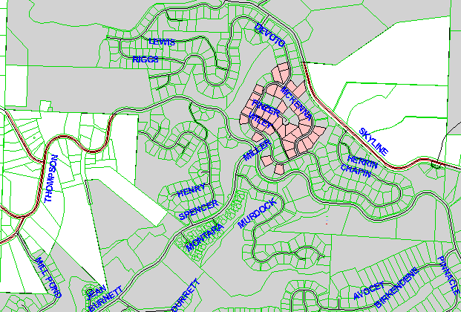

Exhibit A, Section 3 Property List: Properties Pending Sale at LID Formation

 | State ID | Property Tax Number | City Lien Number | Legal Description | Lot | Actual Area | Assessed Area | Assessment | Recording | Total Billing
1 | 1N1W23DC 1400 | R291781100 | 109585 | Forest Hgts Estates No 2 | 104 | 11,511 | 0 | $ - | $ - | $ -
2 | 1N1W23DC 1500 | R291781120 | 109586 | Forest Hgts Estates No 2 | 105 | 10,296 | 0 | $ - | $ - | $ -
3 | 1N1W23DC 1600 | R291781140 | 109587 | Forest Hgts Estates No 2 | 106 | 8,847 | 0 | $ - | $ - | $ -
4 | 1N1W23DC 1700 | R291781160 | 109588 | Forest Hgts Estates No 2 | 107 | 8,761 | 0 | $ - | $ - | $ -
5 | 1N1W23DC 1900 | R291781200 | 109590 | Forest Hgts Estates No 2 | 109 | 15,114 | 0 | $ - | $ - | $ -
6 | 1N1W23DC 2000 | R291781220 | 109591 | Forest Hgts Estates No 2 | 110 | 13,147 | 0 | $ - | $ - | $ -
7 | 1N1W23DC 2300 | R291781280 | 109594 | Forest Hgts Estates No 2 | 113 | 12,368 | 0 | $ - | $ - | $ -
8 | 1N1W23DC 2600 | R291781380 | 109599 | Forest Hgts Estates No 2 | 118 | 12,204 | 0 | $ - | $ - | $ -
9 | 1N1W23DC 2700 | R291781400 | 109600 | Forest Hgts Estates No 2 | 119 | 11,906 | 0 | $ - | $ - | $ -
10 | 1N1W23DC 2800 | R291781420 | 109601 | Forest Hgts Estates No 2 | 120 | 11,786 | 0 | $ - | $ - | $ -
11 | 1N1W23DC 2900 | R291781440 | 109602 | Forest Hgts Estates No 2 | 121 | 12,114 | 0 | $ - | $ - | $ -
12 | 1N1W23DC 3000 | R291780760 | 109568 | Forest Hgts Estates No 2 | 87 | 9,779 | 0 | $ - | $ - | $ -
13 | 1N1W23DC 3100 | R291780740 | 109567 | Forest Hgts Estates No 2 | 86 | 10,103 | 0 | $ - | $ - | $ -
14 | 1N1W23DC 3200 | R291780720 | 109566 | Forest Hgts Estates No 2 | 85 | 9,491 | 0 | $ - | $ - | $ -
15 | 1N1W23DC 3300 | R291780700 | 109565 | Forest Hgts Estates No 2 | 84 | 9,582 | 0 | $ - | $ - | $ -
16 | 1N1W23DC 3600 | R291780640 | 109562 | Forest Hgts Estates No 2 | 81 | 15,983 | 0 | $ - | $ - | $ -
17 | 1N1W23DC 3700 | R291780620 | 109561 | Forest Hgts Estates No 2 | 80 | 14,389 | 0 | $ - | $ - | $ -
18 | 1N1W23DC 3800 | R291780600 | 109560 | Forest Hgts Estates No 2 | 79 | 9,837 | 0 | $ - | $ - | $ -
19 | 1N1W23DC 700 | R291780520 | 109556 | Forest Hgts Estates No 2 | 75 | 10,602 | 0 | $ - | $ - | $ -
20 | 1N1W23DC 800 | R291780500 | 109555 | Forest Hgts Estates No 2 | 74 | 17,672 | 0 | $ - | $ - | $ -
21 | 1N1W26AB 1700 | R291780380 | 109549 | Forest Hgts Estates No 2 | 68 | 12,338 | 0 | $ - | $ - | $ -
22 | 1N1W26AB 1800 | R291780360 | 109548 | Forest Hgts Estates No 2 | 67 | 11,036 | 0 | $ - | $ - | $ -
23 | 1N1W26AB 1900 | R291780340 | 109547 | Forest Hgts Estates No 2 | 66 | 12,855 | 0 | $ - | $ - | $ -
24 | 1N1W26AB 2000 | R291780320 | 109546 | Forest Hgts Estates No 2 | 65 | 12,789 | 0 | $ - | $ - | $ -
25 | 1N1W26AB 2100 | R291781000 | 109580 | Forest Hgts Estates No 2 | 99 | 10,100 | 0 | $ - | $ - | $ -
26 | 1N1W26AB 2200 | R291781020 | 109581 | Forest Hgts Estates No 2 | 100 | 13,595 | 0 | $ - | $ - | $ -
27 | 1N1W26AB 2300 | R291781040 | 109582 | Forest Hgts Estates No 2 | 101 | 12,495 | 0 | $ - | $ - | $ -
28 | 1N1W26AB 2400 | R291781060 | 109583 | Forest Hgts Estates No 2 | 102 | 11,128 | 0 | $ - | $ - | $ -
29 | 1N1W26AB 2500 | R291781080 | 109584 | Forest Hgts Estates No 2 | 103 | 12,108 | 0 | $ - | $ - | $ -
30 | 1N1W26AB 2600 | R291781340 | 109597 | Forest Hgts Estates No 2 | 116 | 13,340 | 0 | $ - | $ - | $ -
31 | 1N1W26AB 2700 | R291781360 | 109598 | Forest Hgts Estates No 2 | 117 | 12,777 | 0 | $ - | $ - | $ -
32 | 1N1W26AB 2800 | R291780860 | 109573 | Forest Hgts Estates No 2 | 92 | 11,239 | 0 | $ - | $ - | $ -
33 | 1N1W26AB 2900 | R291780880 | 109574 | Forest Hgts Estates No 2 | 93 | 11,813 | 0 | $ - | $ - | $ -
34 | 1N1W26AB 3000 | R291780900 | 109575 | Forest Hgts Estates No 2 | 94 | 10,416 | 0 | $ - | $ - | $ -
35 | 1N1W26AB 3800 | R291780220 | 109541 | Forest Hgts Estates No 2 | 60 | 11,935 | 0 | $ - | $ - | $ -
36 | 1N1W26AB 4100 | R291780840 | 109572 | Forest Hgts Estates No 2 | 91 | 10,307 | 0 | $ - | $ - | $ -
37 | 1N1W26AB 4400 | R291780780 | 109569 | Forest Hgts Estates No 2 | 88 | 10,263 | 0 | $ - | $ - | $ -
38 | 1N1W26AB 5300 | R291780240 | 109542 | Forest Hgts Estates No 2 | 61 | 11,762 | 0 | $ - | $ - | $ -
 |  |  |  |  |  | 447,788 | 0 | $ - | $ - | $ -

Exhibit A, Section 4 Map: Properties Sold Prior to Final Assessment

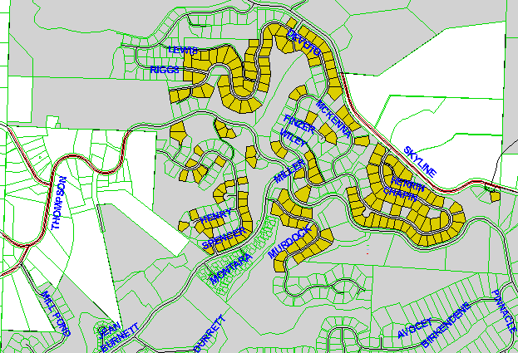

Exhibit A, Section 4 Property List: Properties Sold Prior to Final Assessment

 | State ID | Property Tax Number | City Lien Number | Legal Description | Lot | Actual Area | Assessed Area | Assessment | Recording | Total Billing
1 | 1N1W23CD 1000 | R291786660 | 124275 | FOREST HTS ESTATES NO 6 | 355 | 11,497 | 0 | $ - | $ - | $ -
2 | 1N1W23CD 1100 | R291786640 (P070926301) | 124274 | FOREST HTS ESTATES NO 6 | 354 | 13,420 | 0 | $ - | $ - | $ -
3 | 1N1W23CD 1200 | R291786620 | 124273 | FOREST HTS ESTATES NO 6 | 353 | 16,671 | 0 | $ - | $ - | $ -
4 | 1N1W23CD 1300 | R291786600 | 124272 | FOREST HTS ESTATES NO 6 | 352 | 16,407 | 0 | $ - | $ - | $ -
5 | 1N1W23CD 1400 | R291786580 | 124271 | FOREST HTS ESTATES NO 6 | 351 | 13,568 | 0 | $ - | $ - | $ -
6 | 1N1W23CD 1500 | R291786560 | 124270 | FOREST HTS ESTATES NO 6 | 350 | 9,066 | 0 | $ - | $ - | $ -
7 | 1N1W23CD 1600 | R291786540 | 124269 | FOREST HTS ESTATES NO 6 | 349 | 7,719 | 0 | $ - | $ - | $ -
8 | 1N1W23CD 1700 | R291786520 | 124268 | FOREST HTS ESTATES NO 6 | 348 | 16,454 | 0 | $ - | $ - | $ -
9 | 1N1W23CD 1800 | R291786500 | 124267 | FOREST HTS ESTATES NO 6 | 347 | 20,808 | 0 | $ - | $ - | $ -
10 | 1N1W23CD 200 | R291786820 | 124283 | FOREST HTS ESTATES NO 6 | 363 | 8,581 | 0 | $ - | $ - | $ -
11 | 1N1W23CD 2000 | R291786460 | 124265 | FOREST HTS ESTATES NO 6 | 345 | 10,701 | 0 | $ - | $ - | $ -
12 | 1N1W23CD 2100 | R291786480 | 124266 | FOREST HTS ESTATES NO 6 | 346 | 13,874 | 0 | $ - | $ - | $ -
13 | 1N1W23CD 2400 | R291786420 | 124263 | FOREST HTS ESTATES NO 6 | 343 | 10,781 | 0 | $ - | $ - | $ -
14 | 1N1W23CD 2500 | R291786440 | 124264 | FOREST HTS ESTATES NO 6 | 344 | 12,638 | 0 | $ - | $ - | $ -
15 | 1N1W23CD 300 | R291786800 | 124282 | FOREST HTS ESTATES NO 6 | 362 | 8,840 | 0 | $ - | $ - | $ -
16 | 1N1W23CD 3100 | R291786320 | 124258 | FOREST HTS ESTATES NO 6 | 338 | 12,316 | 0 | $ - | $ - | $ -
17 | 1N1W23CD 3200 | R291786300 | 124257 | FOREST HTS ESTATES NO 6 | 337 | 14,487 | 0 | $ - | $ - | $ -
18 | 1N1W23CD 3500 | R291786240 | 124254 | FOREST HTS ESTATES NO 6 | 334 | 12,755 | 0 | $ - | $ - | $ -
19 | 1N1W23CD 3600 | R291786220 | 124253 | FOREST HTS ESTATES NO 6 | 333 | 11,380 | 0 | $ - | $ - | $ -
20 | 1N1W23CD 3700 | R291786200 | 124252 | FOREST HTS ESTATES NO 6 | 332 | 13,929 | 0 | $ - | $ - | $ -
21 | 1N1W23CD 3800 | R291786180 | 124251 | FOREST HTS ESTATES NO 6 | 331 | 13,789 | 0 | $ - | $ - | $ -
22 | 1N1W23CD 3900 | R291786160 | 124250 | FOREST HTS ESTATES NO 6 | 330 | 14,102 | 0 | $ - | $ - | $ -
23 | 1N1W23CD 400 | R291786780 | 124281 | FOREST HTS ESTATES NO 6 | 361 | 8,700 | 0 | $ - | $ - | $ -
24 | 1N1W23CD 4000 | R291786140 | 124249 | FOREST HTS ESTATES NO 6 | 329 | 13,897 | 0 | $ - | $ - | $ -
25 | 1N1W23CD 500 | R291786760 | 124280 | FOREST HTS ESTATES NO 6 | 360 | 11,339 | 0 | $ - | $ - | $ -
26 | 1N1W23CD 600 | R291786740 | 124279 | FOREST HTS ESTATES NO 6 | 359 | 11,392 | 0 | $ - | $ - | $ -
27 | 1N1W23CD 700 | R291786720 | 124278 | FOREST HTS ESTATES NO 6 | 358 | 12,311 | 0 | $ - | $ - | $ -
28 | 1N1W23CD 800 | R291786700 | 124277 | FOREST HTS ESTATES NO 6 | 357 | 14,608 | 0 | $ - | $ - | $ -
29 | 1N1W23CD 900 | R291786680 | 124276 | FOREST HTS ESTATES NO 6 | 356 | 11,557 | 0 | $ - | $ - | $ -
30 | 1N1W23DC 1000 | R291780460 | 109553 | Forest Hgts Estates No 2 | 72 | 10,409 | 0 | $ - | $ - | $ -
31 | 1N1W23DC 1100 | R291780440 | 109552 | Forest Hgts Estates No 2 | 71 | 8,726 | 0 | $ - | $ - | $ -
32 | 1N1W23DC 1300 | R291780400 | 109550 | Forest Hgts Estates No 2 | 69 | 14,576 | 0 | $ - | $ - | $ -
33 | 1N1W23DC 2200 | R291781260 | 109593 | Forest Hgts Estates No 2 | 112 | 12,371 | 0 | $ - | $ - | $ -
34 | 1N1W23DC 2400 | R291781300 | 109595 | Forest Hgts Estates No 2 | 114 | 12,455 | 0 | $ - | $ - | $ -
35 | 1N1W23DC 2500 | R291781320 | 109596 | Forest Hgts Estates No 2 | 115 | 11,845 | 0 | $ - | $ - | $ -
36 | 1N1W23DC 300 | R291780580 | 109559 | Forest Hgts Estates No 2 | 78 | 10,276 | 0 | $ - | $ - | $ -
37 | 1N1W23DC 3400 | R291780680 | 109564 | Forest Hgts Estates No 2 | 83 | 9,902 | 0 | $ - | $ - | $ -
38 | 1N1W23DC 3500 | R291780660 | 109563 | Forest Hgts Estates No 2 | 82 | 8,896 | 0 | $ - | $ - | $ -
39 | 1N1W23DC 4200 | R291786100 | 124247 | FOREST HTS ESTATES NO 6 | 327 | 10,347 | 0 | $ - | $ - | $ -
40 | 1N1W23DC 4300 | R291786080 | 124246 | FOREST HTS ESTATES NO 6 | 326 | 11,199 | 0 | $ - | $ - | $ -
41 | 1N1W23DC 4400 | R291786060 | 124245 | FOREST HTS ESTATES NO 6 | 325 | 9,409 | 0 | $ - | $ - | $ -
42 | 1N1W23DC 4500 | R291786040 | 124244 | FOREST HTS ESTATES NO 6 | 324 | 10,427 | 0 | $ - | $ - | $ -
43 | 1N1W23DC 4600 | R291786020 | 124243 | FOREST HTS ESTATES NO 6 | 323 | 9,712 | 0 | $ - | $ - | $ -
44 | 1N1W23DC 4700 | R291786000 | 124242 | FOREST HTS ESTATES NO 6 | 322 | 9,182 | 0 | $ - | $ - | $ -
45 | 1N1W23DC 4800 | R291785980 | 124241 | FOREST HTS ESTATES NO 6 | 321 | 10,648 | 0 | $ - | $ - | $ -
46 | 1N1W23DC 4900 | R291785960 | 124240 | FOREST HTS ESTATES NO 6 | 320 | 11,651 | 0 | $ - | $ - | $ -
47 | 1N1W23DC 500 | R291780560 | 109558 | Forest Hgts Estates No 2 | 77 | 11,367 | 0 | $ - | $ - | $ -
48 | 1N1W23DC 5000 | R291785940 | 124239 | FOREST HTS ESTATES NO 6 | 319 | 10,883 | 0 | $ - | $ - | $ -
49 | 1N1W23DC 5100 | R291785920 | 124238 | FOREST HTS ESTATES NO 6 | 318 | 15,017 | 0 | $ - | $ - | $ -
50 | 1N1W23DC 5300 | R291785900 | 124237 | FOREST HTS ESTATES NO 6 | 317 | 12,102 | 0 | $ - | $ - | $ -
51 | 1N1W23DC 5400 | R291785880 | 124236 | FOREST HTS ESTATES NO 6 | 316 | 11,958 | 0 | $ - | $ - | $ -
52 | 1N1W23DC 5500 | R291785860 | 124235 | FOREST HTS ESTATES NO 6 | 315 | 9,532 | 0 | $ - | $ - | $ -
53 | 1N1W23DC 5600 | R291785840 | 124234 | FOREST HTS ESTATES NO 6 | 314 | 9,236 | 0 | $ - | $ - | $ -
54 | 1N1W23DC 5700 | R291785820 | 124233 | FOREST HTS ESTATES NO 6 | 313 | 10,888 | 0 | $ - | $ - | $ -
55 | 1N1W23DC 600 | R291780540 | 109557 | Forest Hgts Estates No 2 | 76 | 16,683 | 0 | $ - | $ - | $ -
56 | 1N1W23DC 6000 | R291787040 | 124294 | FOREST HTS ESTATES NO 6 | 374 | 9,721 | 0 | $ - | $ - | $ -
57 | 1N1W23DC 6100 | R291787020 | 124293 | FOREST HTS ESTATES NO 6 | 373 | 9,526 | 0 | $ - | $ - | $ -
58 | 1N1W23DC 6200 | R291787000 | 124292 | FOREST HTS ESTATES NO 6 | 372 | 9,762 | 0 | $ - | $ - | $ -
59 | 1N1W23DC 6300 | R291786980 | 124291 | FOREST HTS ESTATES NO 6 | 371 | 9,546 | 0 | $ - | $ - | $ -
60 | 1N1W23DC 6400 | R291786960 | 124290 | FOREST HTS ESTATES NO 6 | 370 | 9,045 | 0 | $ - | $ - | $ -
61 | 1N1W23DC 6500 | R291786940 | 124289 | FOREST HTS ESTATES NO 6 | 369 | 9,501 | 0 | $ - | $ - | $ -
62 | 1N1W23DC 6700 | R291786920 | 124288 | FOREST HTS ESTATES NO 6 | 368 | 8,501 | 0 | $ - | $ - | $ -
63 | 1N1W23DC 900 | R291780480 | 109554 | Forest Hgts Estates No 2 | 73 | 13,057 | 0 | $ - | $ - | $ -
64 | 1N1W26AA 1000 | R291784060 | 124341 | FOREST HTS ESTATES NO 4 | 234 | 11,764 | 0 | $ - | $ - | $ -
65 | 1N1W26AA 1200 | R291784040 | 124340 | FOREST HTS ESTATES NO 4 | 233 | 9,757 | 0 | $ - | $ - | $ -
66 | 1N1W26AA 1300 | R291784020 | 124339 | FOREST HTS ESTATES NO 4 | 232 | 10,824 | 0 | $ - | $ - | $ -
67 | 1N1W26AA 1400 | R291784000 | 124338 | FOREST HTS ESTATES NO 4 | 231 | 9,789 | 0 | $ - | $ - | $ -
68 | 1N1W26AA 1500 | R291783980 | 124337 | FOREST HTS ESTATES NO 4 | 230 | 11,250 | 0 | $ - | $ - | $ -
69 | 1N1W26AA 1600 | R291783960 | 124336 | FOREST HTS ESTATES NO 4 | 229 | 10,247 | 0 | $ - | $ - | $ -
70 | 1N1W26AA 1700 | R291783940 | 124335 | FOREST HTS ESTATES NO 4 | 228 | 13,619 | 0 | $ - | $ - | $ -
71 | 1N1W26AA 1800 | R291783920 | 124334 | FOREST HTS ESTATES NO 4 | 227 | 11,330 | 0 | $ - | $ - | $ -
72 | 1N1W26AA 1900 | R291783900 | 124333 | FOREST HTS ESTATES NO 4 | 226 | 10,518 | 0 | $ - | $ - | $ -
73 | 1N1W26AA 2100 | R291783860 | 124331 | FOREST HTS ESTATES NO 4 | 224 | 12,265 | 0 | $ - | $ - | $ -
74 | 1N1W26AA 2200 | R291784360 | 124316 | FOREST HTS ESTATES NO 4 | 249 | 14,314 | 0 | $ - | $ - | $ -
75 | 1N1W26AA 2400 | R291784320 | 124354 | FOREST HTS ESTATES NO 4 | 247 | 11,507 | 0 | $ - | $ - | $ -
76 | 1N1W26AA 2500 | R291784300 | 124353 | FOREST HTS ESTATES NO 4 | 246 | 10,613 | 0 | $ - | $ - | $ -
77 | 1N1W26AA 2600 | R291784280 | 124352 | FOREST HTS ESTATES NO 4 | 245 | 11,260 | 0 | $ - | $ - | $ -
78 | 1N1W26AA 2700 | R291784260 | 124351 | FOREST HTS ESTATES NO 4 | 244 | 11,999 | 0 | $ - | $ - | $ -
79 | 1N1W26AA 2800 | R291784240 | 124350 | FOREST HTS ESTATES NO 4 | 243 | 13,085 | 0 | $ - | $ - | $ -
80 | 1N1W26AA 3000 | R291784480 | 124322 | FOREST HTS ESTATES NO 4 | 255 | 12,316 | 0 | $ - | $ - | $ -
81 | 1N1W26AA 3200 | R291784440 | 124320 | FOREST HTS ESTATES NO 4 | 253 | 11,254 | 0 | $ - | $ - | $ -
82 | 1N1W26AA 3300 | R291784420 | 124319 | FOREST HTS ESTATES NO 4 | 252 | 11,852 | 0 | $ - | $ - | $ -
83 | 1N1W26AA 3400 | R291784400 | 124318 | FOREST HTS ESTATES NO 4 | 251 | 13,325 | 0 | $ - | $ - | $ -
84 | 1N1W26AA 3500 | R291784380 | 124317 | FOREST HTS ESTATES NO 4 | 250 | 12,576 | 0 | $ - | $ - | $ -
85 | 1N1W26AA 3600 | R291783840 | 124330 | FOREST HTS ESTATES NO 4 | 223 | 11,288 | 0 | $ - | $ - | $ -
86 | 1N1W26AA 3700 | R291783820 | 124314 | FOREST HTS ESTATES NO 4 | 222 | 11,133 | 0 | $ - | $ - | $ -
87 | 1N1W26AA 3800 | R291783800 | 124313 | FOREST HTS ESTATES NO 4 | 221 | 9,619 | 0 | $ - | $ - | $ -
88 | 1N1W26AA 3900 | R291783780 | 124312 | FOREST HTS ESTATES NO 4 | 220 | 8,474 | 0 | $ - | $ - | $ -
89 | 1N1W26AA 4000 | R291783760 | 124311 | FOREST HTS ESTATES NO 4 | 219 | 8,390 | 0 | $ - | $ - | $ -
90 | 1N1W26AA 4100 | R291783740 | 124310 | FOREST HTS ESTATES NO 4 | 218 | 8,357 | 0 | $ - | $ - | $ -
91 | 1N1W26AA 4200 | R291783720 | 124309 | FOREST HTS ESTATES NO 4 | 217 | 9,664 | 0 | $ - | $ - | $ -
92 | 1N1W26AA 4300 | R291783700 | 124308 | FOREST HTS ESTATES NO 4 | 216 | 9,179 | 0 | $ - | $ - | $ -
93 | 1N1W26AA 4400 | R291783680 | 124307 | FOREST HTS ESTATES NO 4 | 215 | 8,403 | 0 | $ - | $ - | $ -
94 | 1N1W26AA 4500 | R291783660 | 124306 | FOREST HTS ESTATES NO 4 | 214 | 8,215 | 0 | $ - | $ - | $ -
95 | 1N1W26AA 4600 | R291783640 | 124305 | FOREST HTS ESTATES NO 4 | 213 | 8,464 | 0 | $ - | $ - | $ -
96 | 1N1W26AA 4700 | R291783620 | 124304 | FOREST HTS ESTATES NO 4 | 212 | 8,213 | 0 | $ - | $ - | $ -
97 | 1N1W26AA 4800 | R291783600 | 124303 | FOREST HTS ESTATES NO 4 | 211 | 9,484 | 0 | $ - | $ - | $ -
98 | 1N1W26AA 600 | R291784660 | 124357 | FOREST HTS ESTATES NO 4 | 264 | 9,488 | 0 | $ - | $ - | $ -
99 | 1N1W26AA 800 | R291784100 | 124343 | FOREST HTS ESTATES NO 4 | 236 | 13,537 | 0 | $ - | $ - | $ -
100 | 1N1W26AA 900 | R291784080 | 124342 | FOREST HTS ESTATES NO 4 | 235 | 13,220 | 0 | $ - | $ - | $ -
101 | 1N1W26AB 1000 | R291784540 | 124325 | FOREST HTS ESTATES NO 4 | 258 | 11,759 | 0 | $ - | $ - | $ -
102 | 1N1W26AB 200 | R291784120 | 124344 | FOREST HTS ESTATES NO 4 | 237 | 12,179 | 0 | $ - | $ - | $ -
103 | 1N1W26AB 300 | R291784140 | 124345 | FOREST HTS ESTATES NO 4 | 238 | 12,259 | 0 | $ - | $ - | $ -
104 | 1N1W26AB 3200 | R291780920 | 109576 | Forest Hgts Estates No 2 | 95 | 8,059 | 0 | $ - | $ - | $ -
105 | 1N1W26AB 3300 | R291780940 | 109577 | Forest Hgts Estates No 2 | 96 | 7,573 | 0 | $ - | $ - | $ -
106 | 1N1W26AB 3400 | R291780960 | 109578 | Forest Hgts Estates No 2 | 97 | 10,551 | 0 | $ - | $ - | $ -
107 | 1N1W26AB 3500 | R291780980 (P070926350) | 109579 | Forest Hgts Estates No 2 | 98 | 11,541 | 0 | $ - | $ - | $ -
108 | 1N1W26AB 3600 | R291780070 |  |  |  | 1,426 | 0 | $ - | $ - | $ -
109 | 1N1W26AB 3700 | R961260820 |  |  |  | 22,651 | 0 | $ - | $ - | $ -
110 | 1N1W26AB 3900 | R291780200 | 109540 | Forest Hgts Estates No 2 | 59 | 9,793 | 0 | $ - | $ - | $ -
111 | 1N1W26AB 4200 | R291780820 | 109571 | Forest Hgts Estates No 2 | 90 | 9,288 | 0 | $ - | $ - | $ -
112 | 1N1W26AB 4300 | R291780800 | 109570 | Forest Hgts Estates No 2 | 89 | 11,238 | 0 | $ - | $ - | $ -
113 | 1N1W26AB 4800 | R291784760 | 124212 | FOREST HTS ESTATES NO 5 | 266 | 14,057 | 0 | $ - | $ - | $ -
114 | 1N1W26AB 4900 | R291784780 | 124213 | FOREST HTS ESTATES NO 5 | 267 | 12,377 | 0 | $ - | $ - | $ -
115 | 1N1W26AB 500 | R291784160 | 124346 | FOREST HTS ESTATES NO 4 | 239 | 11,765 | 0 | $ - | $ - | $ -
116 | 1N1W26AB 5000 | R291784800 | 124214 | FOREST HTS ESTATES NO 5 | 268 | 11,044 | 0 | $ - | $ - | $ -
117 | 1N1W26AB 5100 | R291784820 | 124215 | FOREST HTS ESTATES NO 5 | 269 | 12,694 | 0 | $ - | $ - | $ -
118 | 1N1W26AB 5900 | R291783460 | 124296 | FOREST HTS ESTATES NO 4 | 204 | 8,400 | 0 | $ - | $ - | $ -
119 | 1N1W26AB 600 | R291784180 | 124347 | FOREST HTS ESTATES NO 4 | 240 | 12,001 | 0 | $ - | $ - | $ -
120 | 1N1W26AB 6100 | R291783480 | 124297 | FOREST HTS ESTATES NO 4 | 205 | 8,746 | 0 | $ - | $ - | $ -
121 | 1N1W26AB 6200 | R291783500 | 124298 | FOREST HTS ESTATES NO 4 | 206 | 10,588 | 0 | $ - | $ - | $ -
122 | 1N1W26AB 6300 | R291783520 | 124299 | FOREST HTS ESTATES NO 4 | 207 | 10,403 | 0 | $ - | $ - | $ -
123 | 1N1W26AB 6400 | R291783540 | 124300 | FOREST HTS ESTATES NO 4 | 208 | 10,602 | 0 | $ - | $ - | $ -
124 | 1N1W26AB 6500 | R291783560 | 124301 | FOREST HTS ESTATES NO 4 | 209 | 10,928 | 0 | $ - | $ - | $ -
125 | 1N1W26AB 6600 | R291783580 | 124302 | FOREST HTS ESTATES NO 4 | 210 | 11,183 | 0 | $ - | $ - | $ -
126 | 1N1W26AB 700 | R291784200 | 124348 | FOREST HTS ESTATES NO 4 | 241 | 12,817 | 0 | $ - | $ - | $ -
127 | 1N1W26AB 7200 | R291784840 | 124216 | FOREST HTS ESTATES NO 5 | 270 | 13,755 | 0 | $ - | $ - | $ -
128 | 1N1W26AB 7300 | R291784860 | 124217 | FOREST HTS ESTATES NO 5 | 271 | 13,572 | 0 | $ - | $ - | $ -
129 | 1N1W26AB 7400 | R291784880 | 124218 | FOREST HTS ESTATES NO 5 | 272 | 9,549 | 0 | $ - | $ - | $ -
130 | 1N1W26AB 7500 | R291784900 | 124219 | FOREST HTS ESTATES NO 5 | 273 | 9,287 | 0 | $ - | $ - | $ -
131 | 1N1W26AB 7600 | R291784920 | 124220 | FOREST HTS ESTATES NO 5 | 274 | 9,620 | 0 | $ - | $ - | $ -
132 | 1N1W26AB 7700 | R291785500 | 124223 | FOREST HTS ESTATES NO 5 | 303 | 10,591 | 0 | $ - | $ - | $ -
133 | 1N1W26AB 7800 | R291785520 | 124224 | FOREST HTS ESTATES NO 5 | 304 | 10,675 | 0 | $ - | $ - | $ -
134 | 1N1W26AB 7900 | R291785540 | 124225 | FOREST HTS ESTATES NO 5 | 305 | 8,862 | 0 | $ - | $ - | $ -
135 | 1N1W26AB 800 | R291784220 | 124349 | FOREST HTS ESTATES NO 4 | 242 | 11,557 | 0 | $ - | $ - | $ -
136 | 1N1W26AB 8000 | R291785560 | 124226 | FOREST HTS ESTATES NO 5 | 306 | 8,905 | 0 | $ - | $ - | $ -
137 | 1N1W26AB 8100 | R291785580 | 124227 | FOREST HTS ESTATES NO 5 | 307 | 10,462 | 0 | $ - | $ - | $ -
138 | 1N1W26AB 8200 | R291785600 | 124228 | FOREST HTS ESTATES NO 5 | 308 | 9,598 | 0 | $ - | $ - | $ -
139 | 1N1W26AB 8300 | R291785620 | 124229 | FOREST HTS ESTATES NO 5 | 309 | 9,609 | 0 | $ - | $ - | $ -
140 | 1N1W26AB 8400 | R291785640 | 124230 | FOREST HTS ESTATES NO 5 | 310 | 9,701 | 0 | $ - | $ - | $ -
141 | 1N1W26AB 8500 | R291785660 | 124231 | FOREST HTS ESTATES NO 5 | 311 | 13,341 | 0 | $ - | $ - | $ -
142 | 1N1W26AB 900 | R291784520 | 124324 | FOREST HTS ESTATES NO 4 | 257 | 12,443 | 0 | $ - | $ - | $ -
143 | 1N1W26AC 1600 | R291785480 | 124222 | FOREST HTS ESTATES NO 5 | 302 | 13,409 | 0 | $ - | $ - | $ -
144 | 1N1W26BA 1000 | R291783240 | 110096 | Forest Hgts Estates No 3 | 201 | 8,945 | 0 | $ - | $ - | $ -
145 | 1N1W26BA 1100 | R291783260 | 110097 | Forest Hgts Estates No 3 | 202 | 8,973 | 0 | $ - | $ - | $ -
146 | 1N1W26BA 1400 | R291783280 | 110098 | Forest Hgts Estates No 3 | 203 | 13,781 | 0 | $ - | $ - | $ -
147 | 1N1W26BA 2000 | R291782180 | 110067 | Forest Hgts Estates No 3 | 148 | 15,049 | 0 | $ - | $ - | $ -
148 | 1N1W26BA 2700 | R291782300 | 110069 | Forest Hgts Estates No 3 | 154 | 9,068 | 0 | $ - | $ - | $ -
149 | 1N1W26BA 2900 | R291782340 | 110070 | Forest Hgts Estates No 3 | 156 | 10,202 | 0 | $ - | $ - | $ -
150 | 1N1W26BA 3400 | R291782420 | 110072 | Forest Hgts Estates No 3 | 160 | 8,414 | 0 | $ - | $ - | $ -
151 | 1N1W26BA 3800 | R291782360 | 110071 | Forest Hgts Estates No 3 | 157 | 8,025 | 0 | $ - | $ - | $ -
152 | 1N1W26BA 3900 | R291782100 | 110065 | Forest Hgts Estates No 3 | 144 | 7,278 | 0 | $ - | $ - | $ -
153 | 1N1W26BA 400 | R291783160 | 110092 | Forest Hgts Estates No 3 | 197 | 10,626 | 0 | $ - | $ - | $ -
154 | 1N1W26BA 4100 | R291782060 (P070926600) | 110064 | Forest Hgts Estates No 3 | 142 | 7,615 | 0 | $ - | $ - | $ -
155 | 1N1W26BA 500 | R291783180 | 110093 | Forest Hgts Estates No 3 | 198 | 12,011 | 0 | $ - | $ - | $ -
156 | 1N1W26BA 5000 | R291781880 | 110060 | Forest Hgts Estates No 3 | 133 | 7,875 | 0 | $ - | $ - | $ -
157 | 1N1W26BA 5200 | R291781840 | 110059 | Forest Hgts Estates No 3 | 131 | 8,000 | 0 | $ - | $ - | $ -
158 | 1N1W26BA 5300 | R291781820 | 110058 | Forest Hgts Estates No 3 | 130 | 8,064 | 0 | $ - | $ - | $ -
159 | 1N1W26BA 5400 | R291781800 | 110057 | Forest Hgts Estates No 3 | 129 | 7,972 | 0 | $ - | $ - | $ -
160 | 1N1W26BA 5500 | R291781780 | 110056 | Forest Hgts Estates No 3 | 128 | 9,179 | 0 | $ - | $ - | $ -
161 | 1N1W26BA 5600 | R291781760 | 110055 | Forest Hgts Estates No 3 | 127 | 9,678 | 0 | $ - | $ - | $ -
162 | 1N1W26BA 5700 | R291781740 | 110054 | Forest Hgts Estates No 3 | 126 | 9,165 | 0 | $ - | $ - | $ -
163 | 1N1W26BA 5800 | R291781720 | 110053 | Forest Hgts Estates No 3 | 125 | 8,899 | 0 | $ - | $ - | $ -
164 | 1N1W26BA 5900 | R291781700 | 110052 | Forest Hgts Estates No 3 | 124 | 8,520 | 0 | $ - | $ - | $ -
165 | 1N1W26BA 6000 | R291781680 | 110051 | Forest Hgts Estates No 3 | 123 | 8,259 | 0 | $ - | $ - | $ -
166 | 1N1W26BA 6100 | R291781660 | 110050 | Forest Hgts Estates No 3 | 122 | 8,474 | 0 | $ - | $ - | $ -
167 | 1N1W26BA 6200 | R291783120 | 110090 | Forest Hgts Estates No 3 | 195 | 8,804 | 0 | $ - | $ - | $ -
168 | 1N1W26BA 6500 | R291783060 | 110087 | Forest Hgts Estates No 3 | 192 | 7,998 | 0 | $ - | $ - | $ -
169 | 1N1W26BA 7200 | R291782920 | 110086 | Forest Hgts Estates No 3 | 185 | 7,339 | 0 | $ - | $ - | $ -
170 | 1N1W26BA 7300 | R291782900 | 110085 | Forest Hgts Estates No 3 | 184 | 7,685 | 0 | $ - | $ - | $ -
171 | 1N1W26BA 7400 | R291782880 | 110084 | Forest Hgts Estates No 3 | 183 | 7,833 | 0 | $ - | $ - | $ -
172 | 1N1W26BA 7500 | R291782860 | 110083 | Forest Hgts Estates No 3 | 182 | 9,071 | 0 | $ - | $ - | $ -
173 | 1N1W26BA 7800 | R291782800 | 110082 | Forest Hgts Estates No 3 | 179 | 8,705 | 0 | $ - | $ - | $ -
174 | 1N1W26BA 800 | R291783220 | 110095 | Forest Hgts Estates No 3 | 200 | 7,357 | 0 | $ - | $ - | $ -
175 | 1N1W26BA 8000 | R291782760 | 110080 | Forest Hgts Estates No 3 | 177 | 8,455 | 0 | $ - | $ - | $ -
176 | 1N1W26BA 8600 | R291782640 | 110079 | Forest Hgts Estates No 3 | 171 | 6,301 | 0 | $ - | $ - | $ -
177 | 1N1W26BA 8700 | R291782620 | 110078 | Forest Hgts Estates No 3 | 170 | 7,110 | 0 | $ - | $ - | $ -
178 | 1N1W26BA 8800 | R291782600 | 110077 | Forest Hgts Estates No 3 | 169 | 7,470 | 0 | $ - | $ - | $ -
179 | 1N1W26BA 9000 | R291782560 | 110076 | Forest Hgts Estates No 3 | 167 | 6,672 | 0 | $ - | $ - | $ -
 |  |  |  |  |  | 1,922,265 | 0 | $ - | $ - | $ -

Exhibit A, Section 5 Map: Properties Pending Sale at Final Assessment

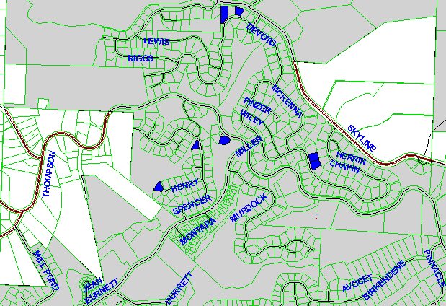

Exhibit A, Section 5 Property List: Properties Pending Sale at Final Assessment

 | State ID | Property Tax Number | City Lien Number | Legal Description | Lot | Actual Area | Assessed Area | Assessment | Recording | Total Billing
1 | 1N1W23DC 6900 | R291786880 | 124286 | FOREST HTS ESTATES NO 6 | 366 | 8,831 | 0 | $ - | $ - | $ -
2 | 1N1W23DC 7100 | R291786840 | 124284 | FOREST HTS ESTATES NO 6 | 364 | 16,735 | 0 | $ - | $ - | $ -
3 | 1N1W26AB 1100 | R291784560 (R291783370) | 124326 | FOREST HTS ESTATES NO 4 | 259 | 11,460 | 0 | $ - | $ - | $ -
4 | 1N1W26AB 1200 | R291784580 | 124327 | FOREST HTS ESTATES NO 4 | 260 | 10,784 | 0 | $ - | $ - | $ -
5 | 1N1W26BA 200 | R291783140 | 110091 | Forest Hgts Estates No 3 | 196 | 11,287 | 0 | $ - | $ - | $ -
6 | 1N1W26BA 7900 | R291782780 | 110081 | Forest Hgts Estates No 3 | 178 | 9,071 | 0 | $ - | $ - | $ -
7 | 1N1W26BA 9200 | R291782520 | 110074 | Forest Hgts Estates No 3 | 165 | 7,458 | 0 | $ - | $ - | $ -
 |  |  |  |  |  | 75,626 | 0 | $ - | $ - | $ -

Exhibit A, Section 6 Map: Properties Which are Open or Common Area

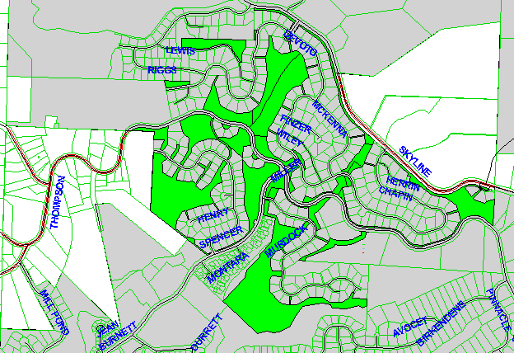

Exhibit A, Section 6 Property List: Properties Which are Open or Common Area

 | State ID | Property Tax Number | City Lien Number | Legal Description | Lot | Actual Area | Assessed Area | Assessment | Recording | Total Billing
1 | 1N1W23CD 100 | R291785690 |  |  |  | 74,465 | 0 | $ - | $ - | $ -
2 | 1N1W23CD 2200 | R291785760 |  |  |  | 15,959 | 0 | $ - | $ - | $ -
3 | 1N1W23CD 4100 | R291785680 |  |  |  | 85,306 | 0 | $ - | $ - | $ -
4 | 1N1W23DC 3900 | R291780010 |  |  |  | 183,975 | 0 | $ - | $ - | $ -
5 | 1N1W23DC 400 | R291780030 |  |  |  | 27,645 | 0 | $ - | $ - | $ -
6 | 1N1W23DC 4000 | R291785670 |  |  |  | 128,394 | 0 | $ - | $ - | $ -
7 | 1N1W23DC 5200 | R291785740 |  |  |  | 2,234 | 0 | $ - | $ - | $ -
8 | 1N1W23DC 5800 | R291785730 |  |  |  | 1,896 | 0 | $ - | $ - | $ -
9 | 1N1W23DC 6600 | R291785720 |  |  |  | 14,099 | 0 | $ - | $ - | $ -
10 | 1N1W23DC 7200 | R291785700 |  |  |  | 2,747 | 0 | $ - | $ - | $ -
11 | 1N1W23DC 7300 | R291785710 |  |  |  | 11,164 | 0 | $ - | $ - | $ -
12 | 1N1W26 300 | R291784730 |  |  |  | 514,461 | 0 | $ - | $ - | $ -
13 | 1N1W26AA 300 | R291783420 |  |  |  | 1,577 | 0 | $ - | $ - | $ -
14 | 1N1W26AA 700 | R291783366 |  |  |  | 152,087 | 0 | $ - | $ - | $ -
15 | 1N1W26AB 1400 | R291783400 |  |  |  | 7,993 | 0 | $ - | $ - | $ -
16 | 1N1W26AB 1600 | R291780040 |  |  |  | 31,589 | 0 | $ - | $ - | $ -
17 | 1N1W26AB 3100 | R291780090 |  |  |  | 6,937 | 0 | $ - | $ - | $ -
18 | 1N1W26AB 400 | R291783390 |  |  |  | 1,796 | 0 | $ - | $ - | $ -
19 | 1N1W26AB 4000 | R291780080 |  |  |  | 12,811 | 0 | $ - | $ - | $ -
20 | 1N1W26AB 4500 | R291780020 |  |  |  | 39,838 | 0 | $ - | $ - | $ -
21 | 1N1W26AB 4600 | R291784700 |  |  |  | 53,379 | 0 | $ - | $ - | $ -
22 | 1N1W26AB 4700 | R291784740 |  |  |  | 9,518 | 0 | $ - | $ - | $ -
23 | 1N1W26AB 5200 | R291780060 |  |  |  | 8,287 | 0 | $ - | $ - | $ -
24 | 1N1W26AB 5700 | R291780050 |  |  |  | 18,295 | 0 | $ - | $ - | $ -
25 | 1N1W26AB 5800 | R291783350 |  |  |  | 5,044 | 0 | $ - | $ - | $ -
26 | 1N1W26AB 6000 | R291783360 |  |  |  | 11,167 | 0 | $ - | $ - | $ -
27 | 1N1W26AB 6800 | R291784716 |  |  |  | 39,706 | 0 | $ - | $ - | $ -
28 | 1N1W26BA 100 | R291781460 |  |  |  | 137,685 | 0 | $ - | $ - | $ -
29 | 1N1W26BA 1200 | R291781580 |  |  |  | 10,538 | 0 | $ - | $ - | $ -
30 | 1N1W26BA 1300 | R291781500 |  |  |  | 99,680 | 0 | $ - | $ - | $ -
31 | 1N1W26BA 1500 | R291781520 |  |  |  | 33,512 | 0 | $ - | $ - | $ -
32 | 1N1W26BA 2400 | R291781600 |  |  |  | 5,347 | 0 | $ - | $ - | $ -
33 | 1N1W26BA 300 | R291781620 |  |  |  | 2,797 | 0 | $ - | $ - | $ -
34 | 1N1W26BA 3700 | R291781560 |  |  |  | 6,789 | 0 | $ - | $ - | $ -
35 | 1N1W26BA 600 | R291781480 |  |  |  | 49,343 | 0 | $ - | $ - | $ -
36 | 1N1W26BA 900 | R291781640 |  |  |  | 2,753 | 0 | $ - | $ - | $ -
37 | 1N1W26BA 9300 | R291781540 |  |  |  | 308,031 | 0 | $ - | $ - | $ -
 |  |  |  |  |  | 2,118,845 | 0 | $ - | $ - | $ -

Exhibit A, Section 7 Map: Properties are Street Right-of-Way

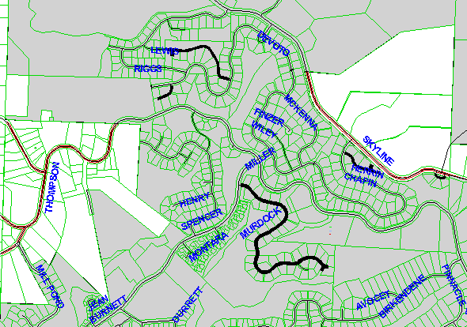

Exhibit A, Section 7 Property List: Properties Which are Street Right-of-Way

 | State ID | Property Tax Number | City Lien Number | Legal Description | Lot | Actual Area | Assessed Area | Assessment | Recording | Total Billing
1 | 1N1W23CD 2300 | R291785780 |  |  |  | 162 | 0 | $ - | $ - | $ -
2 | 1N1W23CD 2600 | R291785770 |  |  |  | 6,388 | 0 | $ - | $ - | $ -
3 | 1N1W23CD 4200 | R291785750 |  |  |  | 28,112 | 0 | $ - | $ - | $ -
4 | 1N1W23DC 200 | R291780100 |  |  |  | 40 | 0 | $ - | $ - | $ -
5 | 1N1W26AA 1100 |  |  |  |  | 15,291 | 0 | $ - | $ - | $ -
6 | 1N1W26AA 200 | R291783410 |  |  |  | 2,811 | 0 | $ - | $ - | $ -
7 | 1N1W26AB 1500 | R291780110 |  |  |  | 122 | 0 | $ - | $ - | $ -
8 | 1N1W26AB 8600 | R291784680 |  |  |  | 41,927 | 0 | $ - | $ - | $ -
9 | 1N1W26AC 1500 | R291784680 |  |  |  | 47,428 | 0 | $ - | $ - | $ -
 |  |  |  |  |  | 142,281 | 0 | $ - | $ - | $ -

Exhibit A, Section 8 Property List: Properties Which Have Been Replatted

No map provided; list of properties only.

 | State ID | Property Tax Number | City Lien Number | Legal Description | Lot | Actual Area | Assessed Area | Assessment | Recording | Total Billing
1 |  |  | 109603 | Westmont Block 2 | 1 | 0 | 0 | $ - | $ - | $ -
2 |  |  | 109604 | Westmont Block 2 | 2 | 0 | 0 | $ - | $ - | $ -
3 |  |  | 109605 | Westmont Block 2 | 3 | 0 | 0 | $ - | $ - | $ -
4 |  |  | 109606 | Westmont Block 2 | 4 | 0 | 0 | $ - | $ - | $ -
5 |  |  | 109607 | Westmont Block 2 | 5 | 0 | 0 | $ - | $ - | $ -
6 |  |  | 109608 | Westmont Block 2 | 6 | 0 | 0 | $ - | $ - | $ -
7 |  |  | 109609 | Westmont Block 3 | 3 | 0 | 0 | $ - | $ - | $ -
8 |  |  | 109610 | Westmont Block 3 | 4 | 0 | 0 | $ - | $ - | $ -
9 |  |  | 109611 | Westmont Block 3 | 5 | 0 | 0 | $ - | $ - | $ -
10 |  |  | 109612 | Westmont Block 3 | 6 | 0 | 0 | $ - | $ - | $ -
11 |  |  | 109613 | Westmont Block 3 | 7 | 0 | 0 | $ - | $ - | $ -
12 |  |  | 109614 | Westmont Block 3 | 8 | 0 | 0 | $ - | $ - | $ -
13 |  |  | 109615 | Westmont Block 3 | 9 | 0 | 0 | $ - | $ - | $ -
14 |  |  | 109616 | Westmont Block 3 | 10 | 0 | 0 | $ - | $ - | $ -
15 |  |  | 109617 | Westmont Block 5 | 1 | 0 | 0 | $ - | $ - | $ -
16 |  |  | 109618 | Westmont Block 5 | 2 | 0 | 0 | $ - | $ - | $ -
17 |  |  | 109619 | Westmont Block 5 | 3 | 0 | 0 | $ - | $ - | $ -
18 |  |  | 109620 | Westmont Block 5 | 4 | 0 | 0 | $ - | $ - | $ -
19 |  |  | 109621 | Westmont Block 6 | 1 | 0 | 0 | $ - | $ - | $ -
20 |  |  | 109622 | Westmont Block 6 | 2 | 0 | 0 | $ - | $ - | $ -
21 |  |  | 109623 | Westmont Block 6 | 3 | 0 | 0 | $ - | $ - | $ -
22 |  |  | 109624 | Westmont Block 6 | 4 | 0 | 0 | $ - | $ - | $ -
23 |  |  | 109625 | Westmont Block 6 | 5 | 0 | 0 | $ - | $ - | $ -
24 |  |  | 109626 | Sec 23 1N 1W TL 18 |  | 0 | 0 | $ - | $ - | $ -
25 |  |  | 109628 | Sec 26 1N 1W TL 3 |  | 0 | 0 | $ - | $ - | $ -
26 |  |  | 109629 | Sec 26 1N 1W TL 80 |  | 0 | 0 | $ - | $ - | $ -
27 |  |  | 109630 | Sec 26 1N 1W TL 104 |  | 0 | 0 | $ - | $ - | $ -
28 |  |  | 109631 | Sec 26 1N 1W TL 117 |  | 0 | 0 | $ - | $ - | $ -
 |  |  |  |  |  | 0 | 0 | $ - | $ - | $ -

