AGREEMENT FOR PROFESSIONAL, TECHNICAL, OR EXPERT SERVICES
CONTRACT NO. ___________
PORTLAND HARBOR INDUSTRIAL LANDS STUDY PHASE 2

This contract is between the City of Portland, acting by and through its Elected Officials, hereafter called "City," and E.D. Hovee & Company, hereafter called Contractor. The City's Project Manager for this contract Steve Kountz, Bureau of Planning.

Effective Date and Duration
This contract shall become effective on March 1, 2002 (or on the date at which every party has signed this contract, whichever is later.) This contract shall expire, unless otherwise terminated or extended, on October 31, 2002.

Statement of Work
(a) The statement of work is contained in EXHIBIT A attached hereto and by this reference made a part hereof.
(b) The delivery schedule for the work is identified in EXHIBIT A.

Consideration
(a) City agrees to pay Contractor a sum not to exceed $75,000 for accomplishment of the work.
(b) Interim payments shall be made to Contractor according to the schedule identified in EXHIBIT A.

Terms and conditions listed on pages 2 - 4.
===========================================================================================
CONTRACTOR DATA, CERTIFICATION, AND SIGNATURE

Name (please print):
Address:
Social Security #: _______________________________
Federal Tax ID #: _______________ State Tax ID #: _______________ Business License # _______________
Citizenship: Nonresident alien ____ Yes ____ No
Business Designation (check one): ____ Individual ____ Sole Proprietorship ____ Partnership ____ Corporation
____ Limited Liability Co (LLC) ____ Estate/Trust ____ Public Service Corp. ____ Government/Nonprofit

Payment information will be reported to the IRS under the name and taxpayer I.D. number provided above. Information must be provided prior to contract approval. Information not matching IRS records could subject you to 20 percent backup withholding.

I, the undersigned, agree to perform work outlined in this contract in accordance to the terms and conditions (listed on pages 2-4 and made part of this contract by reference) and the statement of work made part of this contract by reference; hereby certify under penalty of perjury that I/my business am not/is not in violation of any Oregon tax laws; hereby certify that my business is certified as an Equal Employment Opportunity Affirmative Action Employer as prescribed by Chapter 3.100 of Code of the City of Portland; and hereby certify I am an independent contractor as defined in ORS 670.600.

Approved by the Contractor: _______________________________________ _____________________
Signature/Title Date
==========================================================================================

CITY OF PORTLAND SIGNATURES

Approved by Mayor or Commissioner: _______________________________________________________ Elected Official or Delegate Date

Approved by Bureau Director: _______________________________________________________
Bureau Director Date

Approved by City Auditor: _______________________________________________________
City Auditor Date
Approved as to form
by City Attorney: _______________________________________________________
(Rev.07/00) Office of City Attorney Date

Page 1 of 4 Rev. 07/00
CITY OF PORTLAND
STANDARD CONTRACT PROVISIONS FOR
PROFESSIONAL, TECHNICAL & EXPERT SERVICES (MANDATORY PROVISIONS)

1. Access to Records
The Contractor shall maintain, and the City of Portland ("City") and its duly authorized representatives shall have access to the books, documents, papers, and records of the Contractor which are directly pertinent to the specific contract for the purpose of making audit, examination, excerpts, and transcripts for a period of three years after final payment. Copies of applicable records shall be made available upon request. Payment for cost of copies is reimbursable by the City.

2. Audits
(a) The City, either directly or through a designated representative, may conduct financial and performance audits of the billings and services specified in this agreement at any time in the course of the agreement and during the three (3) year period established by section 1, Access to Records. Audits will be conducted in accordance with generally accepted auditing standards as promulgated in Government Auditing Standards by the Comptroller General of the United States General Accounting Office.
(b) If an audit discloses that payments to the Contractor were in excess of the amount to which the Contractor was entitled, then the Contractor shall repay the amount of the excess to the City.
(c) If any audit shows performance of services is not efficient in accordance with Government Auditing Standards, or that the program is not effective in accordance with Government Auditing Standards, the City may pursue remedies provided under section 5, Early Termination of Agreement and section 7, Remedies.

3. Effective Date and Duration
The passage of the contract expiration date (as recorded on reverse side) shall not extinguish, prejudice, or limit either party's right to enforce this contract with respect to any default or defect in performance that has not been cured.

4. Funds
The City certifies that sufficient funds are available and authorized for expenditure to finance the cost of this contract.

5. Early Termination of Agreement
(a) The City and the Contractor, by mutual written agreement, may terminate this Agreement at any time.
(b) The City, on thirty (30) days written notice to the Contractor, may terminate this Agreement for any reason deemed appropriate in its sole discretion.
(c) Either the City or the Contractor may terminate this Agreement in the event of a breach of the Agreement by the other. Prior to such termination, however, the party seeking the termination shall give to the other party written notice of the breach and of the party's intent to terminate. If the party has not entirely cured the breach within fifteen (15) days of the notice, then the party giving the notice may terminate the Agreement at any time thereafter by giving a written notice of termination.

6. Payment on Early Termination
(a) In the event of termination under subsection 5(a) or 5(b), Early Termination of Agreement hereof, the City shall pay the Contractor for work performed in accordance with the Agreement prior to the termination date.
(b) In the event of termination under subsection 5(c), Early Termination of Agreement hereof, by the Contractor due to a breach by the City, then the City shall pay the Contractor as provided in subsection (a) of this section.
(c) In the event of termination under subsection 5(c), Early Termination of Agreement hereof, by the City due to a breach by the Contractor, then the City shall pay the Contractor as provided in subsection (a) of this section, subject to set off of excess costs, as provided for in section 7(a), Remedies.
(d) In the event of early termination all of the Contractor's work product will become and remain property of the City.

7. Remedies
(a) In the event of termination under subsection 5(c), Early Termination of Agreement, hereof, by the City due to a breach by the Contractor, then the City may complete the work either itself, by agreement with another contractor or by a combination thereof. In the event the cost of completing the work exceeds the remaining unpaid balance of the total compensation provided under this contract, then the Contractor shall pay to the City the amount of the reasonable excess.
(b) The remedies provided to the City under section 5, Early Termination of Agreement and section 7, Remedies for a breach by the Contractor shall not be exclusive. The City also shall be entitled to any other equitable and legal remedies that are available.
(c) In the event of breach of this Agreement by the City, then the Contractor's remedy shall be limited to termination of the Agreement and receipt of payment as provided in section 5(c), Early Termination of Agreement and section 6(b), Payment on Early Termination hereof.

Page 2 of 4 Rev. 07/00

8. Subcontracts and Assignment
Contractor shall not subcontract, assign or transfer any of the work scheduled under this agreement, without the prior written consent of the City. Notwithstanding City approval of a subcontractor, the Contractor shall remain obligated for full performance hereunder, and the City shall incur no obligation other than its obligations to the Contractor hereunder. The Contractor agrees that if subcontractors are employed in the performance of this Agreement, the Contractor and its subcontractors are subject to the requirements and sanctions of ORS Chapter 656, Workers’ Compensation.

9. Compliance with Applicable Law
In connection with its activities under this Agreement, Contractor shall comply with all applicable federal, state and local laws and regulations. Contractor shall complete Exhibit B, Independent Contractor/Workers’ Compensation Insurance Questionnaire, which is attached hereto and by this reference made a part hereof.

9a. Indemnity - Claims for Other than Professional Liability
Contractor shall defend, save, and hold harmless the City of Portland, its officers, agents, and employees, from all claims, suits, or actions of whatsoever nature, including intentional acts, resulting from or arising out of the activities of Contractor or its subcontractors, agents or employees under this agreement.

9b. Indemnity - Claims for Professional Liability
Contractor shall defend, save, and hold harmless the City of Portland, its officers, agents, and employees, from all claims, suits, or actions arising out of the professional negligent acts, errors or omissions of Contractor or its subcontractors and sub-consultants, agents or employees in performance of professional services under this agreement.

9c. Indemnity - Standard of Care
If Contractor's services involve engineering or consulting, the standard of care applicable to Contractor's service will be the degree of skill and diligence normally employed by professional engineers or consultants performing the same or similar services at the time such services are performed. Contractor will re-perform any services not meeting this standard without additional compensation.

10. Insurance
Exhibit C is hereby referenced and made a part of this contract.

11. Ownership of Work Product
All work products of the Contractor which result from this contract are the exclusive property of the City.

12. Nondiscrimination
Contractor agrees to comply with all applicable requirements of federal and state civil rights and rehabilitation statutes, rules, and regulations. Contractor also shall comply with the Americans With Disabilities Act of 1990 (Pub I. No. 101-336) including Title II of that Act, ORS 659.425, and all regulations and administrative rules established pursuant to those laws.

13. Successors in Interest
The provisions of this contract shall be binding upon and shall inure to the benefit of the parties hereto, and their respective successors and approved assigns.

14. Severability
The parties agree that if any term or provision of this contract is declared by a court of competent jurisdiction to be illegal or in conflict with any law, the validity of the remaining terms and provisions shall not be affected, and the rights and obligations of the parties shall be construed and enforced as if the contract did not contain the particular term or provision held to be invalid.

15. Waiver
The failure of the City to enforce any provision of this contract shall not constitute a waiver by the City of that or any other provision.

16. Errors
The Contractor shall perform such additional work as may be necessary to correct errors in the work required under this contract without undue delays and without additional cost.

17. Governing Law
The provisions of this contract shall be construed in accordance with the provisions of the laws of the State of Oregon. Any action or suits involving any question arising under this contract must be brought in the appropriate court in Multnomah County Oregon.

Page 3 of 4 Rev. 07/00

18. Amendments
(a) The City and the Contractor may amend this Agreement at any time only by written amendment executed by the City and the Contractor. Unless otherwise provided, if the original contract required an ordinance, any amendment that increases the amount of compensation payable to the Contractor must be approved by ordinance of the City Council. If the original contract did not require an ordinance, the commissioner-in-charge may approve an amendment increasing the amount of compensation, provided the total contract price does not exceed the formal bid threshold amount set annually by the City Auditor. The Project Manager may agree to and execute any other amendment on behalf of the City.
(b) Any change in the Scope of Contractor Services shall be deemed an amendment subject to subsection (a).

19. Business License
The Contractor shall obtain a City of Portland business license as required by PCC 7.02.030 prior to beginning work under this Agreement. The Contractor shall provide a business license number in the space provided on page one of this Agreement.

20. Prohibited Interest
(a) No City officer or employee during his or her tenure or for one year thereafter shall have any interest, direct or indirect, in this Agreement or the proceeds thereof.
(b) No City officer or employee who participated in the award of this Agreement shall be employed by the Contractor during the period of the Agreement.

21. Payment to Vendors and Subcontractors
The Contractor shall timely pay all suppliers, lessors and contractors providing it services, materials or equipment for carrying out its obligations under this Agreement. The Contractor shall not take or fail to take any action in a manner that causes the City or any materials that the Contractor provides hereunder to be subject to any claim or lien of any person without the City's prior written consent.

Merger Clause
THIS CONTRACT AND ATTACHED EXHIBITS CONSTITUTES THE ENTIRE AGREEMENT BETWEEN THE PARTIES. NO WAIVER, CONSENT, MODIFICATION, OR CHANGE OF TERMS OF THIS CONTRACT SHALL BIND EITHER PARTY UNLESS IN WRITING AND SIGNED BY BOTH PARTIES. SUCH WAIVER, CONSENT, MODIFICATION, OR CHANGE IF MADE, SHALL BE EFFECTIVE ONLY IN SPECIFIC INSTANCES AND FOR THE SPECIFIC PURPOSE GIVEN. THERE ARE NO UNDERSTANDINGS, AGREEMENTS, OR REPRESENTATIONS, ORAL OR WRITTEN, NOT SPECIFIED HEREIN REGARDING THIS CONTRACT. CONTRACTOR, BY THE SIGNATURE OF ITS AUTHORIZED REPRESENTATIVE, HEREBY ACKNOWLEDGES THAT HE OR SHE HAS READ THIS CONTRACT, UNDERSTANDS IT AND AGREES TO BE BOUND BY ITS TERMS AND CONDITIONS.

OPTIONAL PROVISIONS (selected by City Project Manager)

22. Arbitration: /___/ Not Applicable /_x_/ Applicable (consult with City Attorney’s Office before finalizing as applicable)
(a) Any dispute arising out of or in connection with this Agreement, which is not settled by mutual agreement of the Contractor and the City within sixty (60) days of notification in writing by either party, shall be submitted to an arbitrator mutually agreed upon by the parties. In the event the parties cannot agree on the arbitrator, then the arbitrator shall be appointed by the Presiding Judge (Civil) of the Circuit Court of the State of Oregon for the County of Multnomah. The arbitrator shall be selected within thirty (30) days from the expiration of the sixty (60) day period following notification of the dispute. The arbitration, and any litigation arising out of or in connection with this Agreement, shall be conducted in Portland, Oregon, shall be governed by the laws of the State of Oregon, and shall be as speedy as reasonably possible. The applicable arbitration rules for the Multnomah County courts shall apply unless the parties agree in writing to other rules. The arbitrator shall render a decision within forty-five (45) days of the first meeting with the Contractor and the City. Insofar as the Contractor and the City legally may do so, they agree to be bound by the decision of the arbitrator.
(b) Notwithstanding any dispute under this Agreement, whether before or during arbitration, the Contractor shall continue to perform its work pending resolution of a dispute, and the City shall make payments as required by the Agreement for undisputed portions of work.

23. Progress Reports: /___/ Applicable /_x__/ Not Applicable
The Contractor shall provide monthly progress reports to the Project Manager. If applicable, Exhibit A should list what information the Contractor must include in monthly progress reports.

24. Contractor's Personnel: /_x__/ Applicable /___/ Not Applicable
The Contractor shall assign the following personnel to do the work in the capacities designated: Eric Hovee and Paul Dennis at E.D. Hovee & Company; Donald Grigg, Margaret Johnson, and Odgen Beeman at Parsons Brinkerhoff; and John White and Corrinne Humphrey at The JD White Company, Inc.; each in the capacities designated in Exhibit A.

Page 4 of 4 Rev. 07/00

AGREEMENT FOR PROFESSIONAL, TECHNICAL, OR EXPERT SERVICES

EXHIBIT A

Statement of the Work
and
Payment Schedule

I. PROJECT OVERVIEW

The Portland Harbor Industrial Lands Study (PHILS) will assess the future land needs of industries in the Portland Harbor area, focusing on river-dependent, freight-related, and other concentrated industries in this area. The study is being prepared for the City of Portland Bureau of Planning, Portland Development Commission, Port of Portland, and others. It will assist the City in considering revisions to land use policies in the Portland Harbor industrial areas, including assessment of which lands should be reserved for river-dependent and river-related industry. That work is part of a comprehensive update of Portland’s Willamette Greenway Plan. The study will inform the Portland Development Commission’s work on industrial development strategies, supporting the update underway of Portland’s Economic Development Strategy. The study will assist the Port of Portland by informing strategic decisions on land use, development, and planning for marine facilities.

Related planning efforts will also benefit from the information collected in the study. It will inform the Portland Harbor Superfund Site project, as background research for harbor land use planning. It will also shed light on the land use and economic implications of major regional freight infrastructure projects under consideration, including maintenance dredging, channel deepening, and I-5 improvements.

The study consists of two phases that will be prepared simultaneously. Phase 1, which is currently being prepared by Bureau of Planning staff, is a contextual summary of industry patterns and trends in the study area based on published information and data. Phase 2, the subject of this contract, is an in-depth analysis of why firms and industries are in the study area and how much presence they will have in the future.

The study area consists generally of the industrially zoned districts along Portland Harbor, including the Guilds Lake, Linnton, Lower Albina, Swan Island, St. Johns, and Rivergate areas.

The final product of this contract will be a report of study findings and presentation of the report at two public or committee meetings.

II. PROFESSIONAL SERVICES REQUIRED

The selected consultant firm or team will perform the following tasks for this project. The selected firm or team shall be expected to work closely with affected bureau personnel to accomplish these goals.

A. Conduct interviews and other research.

1. Prepare a research methodology. The research strategy will focus on in-depth, open-ended interviews to support qualitative analysis of firm strategies, industry changes, and location needs and decisions. Review available secondary sources on firms, such as company histories and annual reports, prior to interviews. The contractor may propose and conduct surveys and other research as needed to support the required analysis. The methodology will consist of a description of research and analysis methods and the project schedule, including interview questions and participants and a detailed explanation of the approach to assess the future demand for industrial land to 2030.
2. Interview participants. Conduct 30 or more interviews of local industry leaders and experts. Select a representative range of river-dependent, freight-related, and concentrated industries in the study area, as identified by the City and described in phase 1, to interview. Select leading firms (including public agencies, such as the Port of Portland) or trade associations in each industry. Select interviewees that are knowledgeable of each firm’s or industry’s history, organization, and strategies.
3. Interview questions. The interview questions shall generally cover the following topics and others as needed to inform the analysis component of the study. For each firm interviewed, identify major suppliers, competitors, participation in trade associations, and customers, and specify whether each is located in the harbor study area, the metro region, or outside the region (such as depicted in Figure 1). Identify critical location attributes for the firm, including marine/rail/truck access, shipping berth length and depth, land area, special utility needs, proximity to suppliers or customers, and others. For multi-establishment firms, focus on activities occurring in the study area. Identify major changes in inter-firm relationships and location needs over the last decade and whether the changes resulted from industry, regional, or study area factors. As firm confidentiality allows, identify planned investments in new product lines, technologies, and facilities in the study area, the adequacy of land area for potential expansion, and the lifespan of existing facilities.

B. Analyze results.

1. Explain industry dynamics. Compile and analyze the interview and other research results. Aggregate or suppress information that respondents prefer to keep confidential. Present information on the trade relationships of firms, industries, and related combinations of industries in the study area. Synthesize findings on the significance of inter-firm relationships as a location advantage in the study area and region, what other factors attract firms to the area, how the industries in the study area are changing, and what factors are driving these changes. Explain whether the findings confirm or differ from the conclusions of phase 1.

2. Assess land use implications. Assess the potential of the industries studied for growth or decline in their demand for land in the study area (beyond their current ownership or lease area) to the year 2030, including river-dependent industrial uses as a specific category. Describe and quantify what components of that demand for land (e.g., by river-dependent industries and segments of freight industries and concentrated industries in the study area) need to be located in the study area, in order to avoid significant loss of productivity or meet other comparable criteria proposed by the contractor. Assess the availability of critical land and location attributes in the study area to accommodate expected growth. Predict how these critical attributes today are likely to change in the future. Use interview results and the information presented in phase 1 to inform this analysis.

3. Analyze land use sensitivity. Assess the sensitivity level of the demand for industrial land in the study area and the available land supply to the following variables: Portland Harbor Superfund Site, maintenance dredging costs, Columbia and Willamette River channel depth, study area infrastructure improvements (e.g., St. Johns Bridge rehabilitation), I-5 improvements, brownfield redevelopment costs, availability of industrial land in other locations, land competition from other expanding industries and uses in the study area, increased riverfront setback and bank treatment requirements, and increased public access to the riverfront.

4. Map industrial site quality. Develop and apply a grading scheme to a study area map. Identify which lands are the most, and which are the least, advantageous to accommodate expected expansion of each of the following, separately: river-dependent industry, freight-related industry, the concentrated industries in the study area, and industrial uses in general.

5. Frame policy questions. Identify key policy questions for the city and region to consider for maintaining a prosperous working harbor and adjacent industrial districts, based on the study findings.

C. Prepare deliverables.

1. Propose project methodology. Propose and present the interview and analysis methodology at two meetings, to be arranged by the City, for review and comments before proceeding. Revise the methodology as needed in response to comments. Timing: propose methodology within one month following execution of the contract.

2. Present research findings. Present a summary of the interview and research findings and anticipated directions for analysis at a meeting with City staff, for review and comments before proceeding with analysis. Timing: present research findings when completed.

3. Periodic meetings with City staff. Participate in periodic meetings with City staff as needed (at least one per month) to present findings, discuss significant questions that arise, and allow City staff to provide continued direction on approach as the study develops. Timing: set meeting schedule in project methodology.

4. Prepare report. Prepare a comprehensive report of the interview results, analysis, and findings, including an executive summary for a general audience. Provide the report and maps in paper and electronic format compatible with Bureau of Planning software (MS Word and Arcview). Present a draft of the report at a meeting with City staff for review and comments. Timing: submit draft report by June 24 and final report by July 15.

5. Present study findings. Present the project findings at two public or committee meetings for review and questions. Prepare the presentation for a non-technical audience. Timing: as needed, prior to November 15.

III. PAYMENT SCHEDULE

The City will pay the Contractor for professional services rendered and expenses incurred on work under the agreement. The total payment to the contractor for the work will not exceed $75,000. Fifteen 15 percent of that total amount will be withheld until receipt of the final report, and five percent will be withheld until completion of required presentations of study findings at two meetings.
Figure 1.
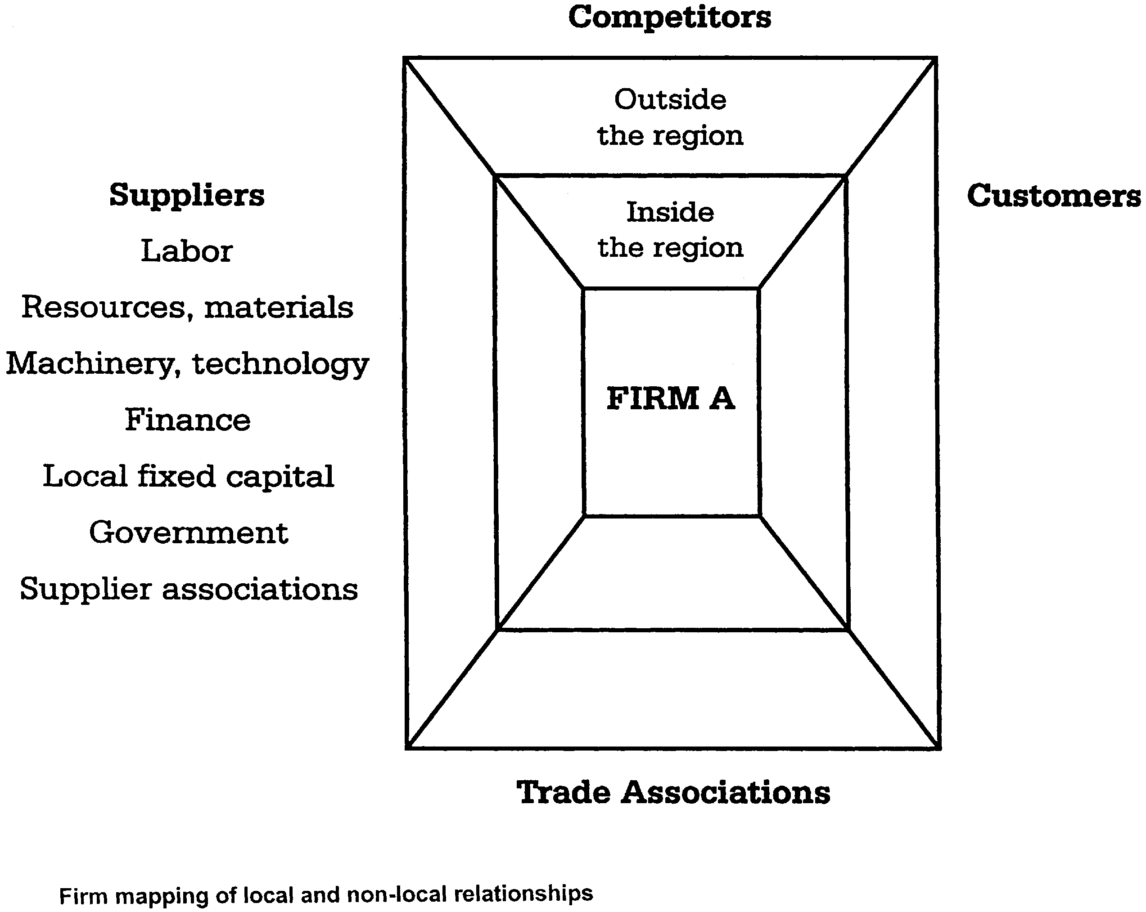

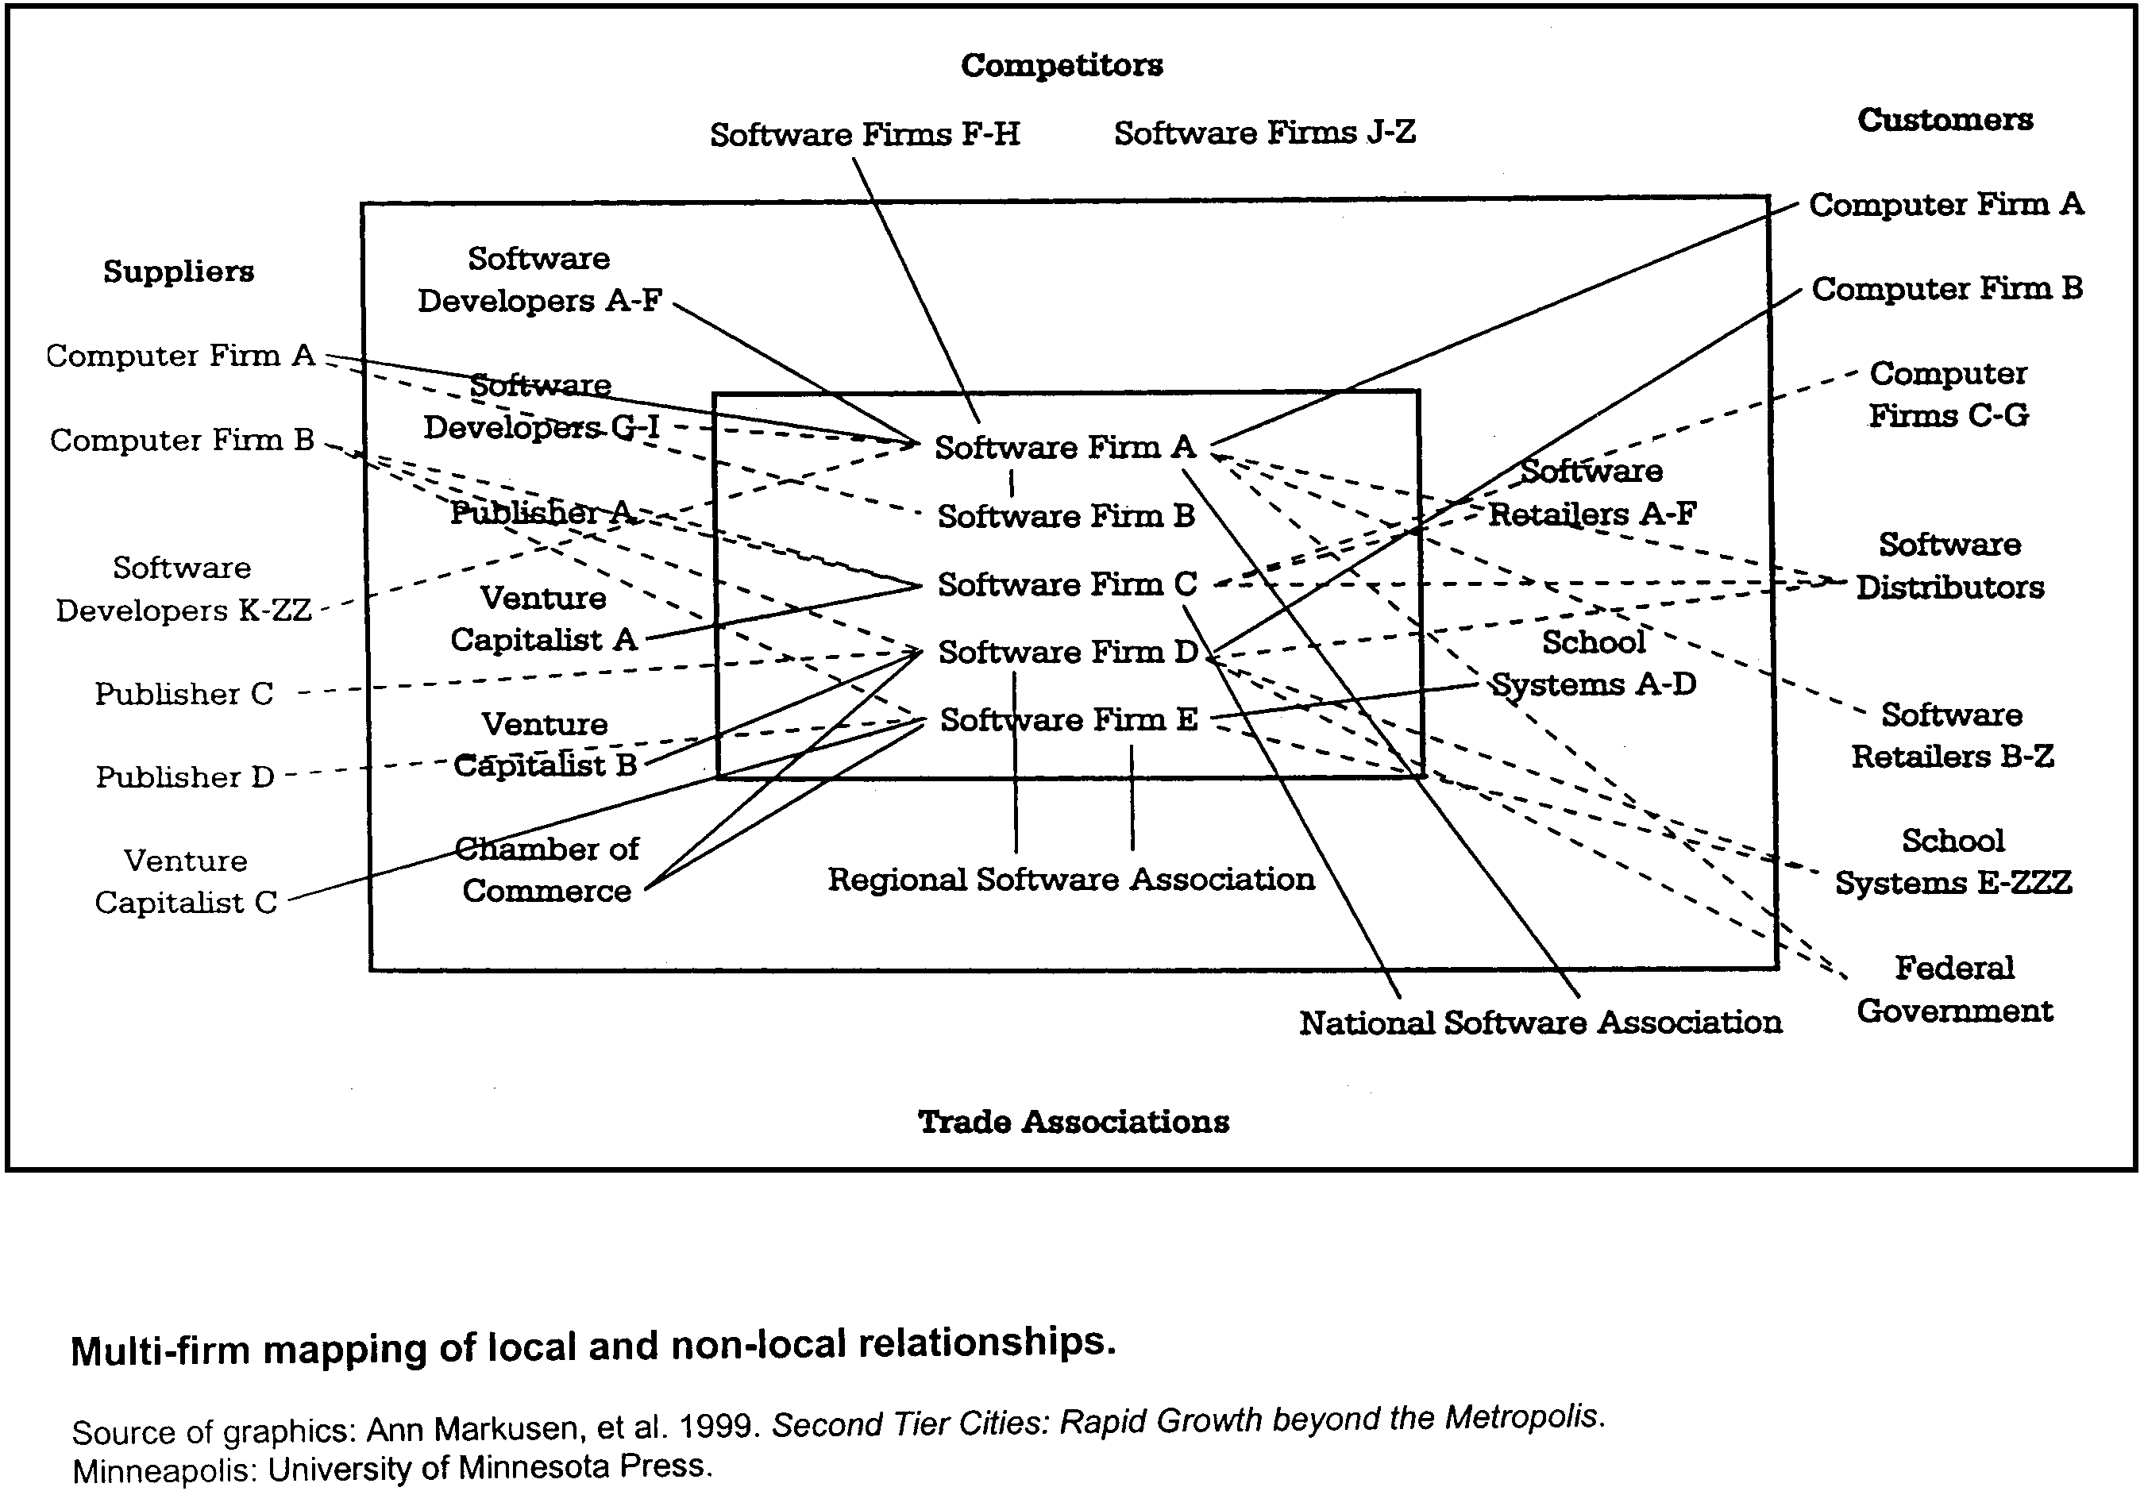

EXHIBIT A Rev. 07/00

EXHIBIT B

INDEPENDENT CONTRACTOR CERTIFICATION STATEMENT
SECTION A
CONTRACTOR CERTIFICATION I, undersigned, am authorized to act on behalf of entity designated below, hereby certify that entity has current Workers' Compensation Insurance.

Signature_________________________________ Date_________________________ Entity_______________________

If entity does not have Workers' Compensation Insurance, City Project Manager and Contractor complete the remainder of this form.

SECTION B
ORS 670.600 Independent contractor; standards. As used in various provisions of ORS Chapters 316, 656, 657, and 701, an individual or business entity that performs labor or services for remuneration shall be considered to perform the labor or services as an "independent contractor" if the standards of this section are met. The contracted work meets the following standards:

1. The individual or business entity providing the labor or services is free from direction and control over the means and manner of providing the labor or services, subject only to the right of the person for whom the labor or services are provided to specify the desired results;

2. The individual or business entity providing labor or services is responsible for obtaining all assumed business registrations or professional occupation licenses required by state law or local government ordinances for the individual or business entity to conduct the business;

3. The individual or business entity providing labor or services furnishes the tools or equipment necessary for performance of the contracted labor or services;

4. The individual or business entity providing labor or services has the authority to hire and fire employees to perform the labor or services;

5. Payment for the labor or services is made upon completion of the performance of specific portions of the project or is made on the basis of an annual or periodic retainer.

____________________________________________________________________ ____________________________
Project Manager Signature Date
_____________________________________________________________________________________________________________________
SECTION C

Independent contractor certifies he/she meets the following standards:

1. The individual or business entity providing labor or services is registered under ORS Chapter 701, if the individual or business entity provides labor or services for which such registration is required;

2. Federal and state income tax returns in the name of the business or a business Schedule C or form Schedule F as part of the personal income tax return were filed for the previous year if the individual or business entity performed labor or services as an independent contractor in the previous year; and

3. The individual or business entity represents to the public that the labor or services are to be provided by an independently established business. Except when an individual or business entity files a Schedule F as part of the personal income tax returns and the individual or business entity performs farm labor or services that are reportable on Schedule C, an individual or business entity is considered to be engaged in an independently established business when four or more of the following circumstances exist. Contractor check four or more of the following:

_____ A. The labor or services are primarily carried out at a location that is separate from the residence of an individual who performs the labor or services, or are primarily carried out in a specific portion of the residence, which portion is set aside as the location of the business;

_____ B. Commercial advertising or business cards as is customary in operating similar businesses are purchased for the business, or the individual or business entity has a trade association membership;

_____ C. Telephone listing and service are used for the business that is separate from the personal residence listing and service used by an individual who performs the labor or services;

_____ D. Labor or services are performed only pursuant to written contracts;

_____ E. Labor or services are performed for two or more different persons within a period of one year; or

_____ F. The individual or business entity assumes financial responsibility for defective workmanship or for service not provided as evidenced by the ownership of performance bonds, warranties, errors and omission insurance or liability insurance relating to the labor or services to be provided.

____________________________________________________________________ ____________________________
Contractor Signature Date

EXHIBIT B Rev. 07/00
EXHIBIT C

INSURANCE (The Project Manager must answer and initial 2, 3, and 4 below).

During the term of this contract Contractor shall maintain in force at its own expense, each insurance noted below:

1. Workers Compensation insurance in compliance with ORS 656.017, which requires subject employers to provide Oregon workers' compensation coverage for all their subject workers (contractors with one or more employees, unless exempt under ORS 656.027).

2. __x_ Required and attached or Waived by City Attorney :_______

General Liability insurance with a combined single limit of not less than $500,000 each occurrence for Bodily Injury and Property Damage. It shall include contractual liability coverage for the indemnity provided under this contract, and shall provide that City of Portland, and its agents, officers, and employees are Additional Insured but only with respect to the Contractor's services to be provided under this Contract:

3. __x_ Required and attached or Waived by City Attorney : _______
Automobile Liability insurance with a combined single limit of not less than $500,000 each occurrence for Bodily Injury and Property Damage, including coverage for owned, hired, or nonowned vehicles, as applicable:

4. ____ Required and attached or Waived by City Attorney : __x__

Professional Liability insurance with a combined single limit of not less than $1,000,000 each claim, incident, or occurrence. This is to cover damages caused by error, omission or negligent acts related to the professional services to be provided under this contract.

5. On all types of insurance. There shall be no cancellation, material change, reduction of limits, or intent not to renew the insurance coverage(s) without 30-days written notice from the Contractor or its insurer(s) to the City.

6. Certificates of insurance. As evidence of the insurance coverages required by this contract, the Contractor shall furnish acceptable insurance certificates to the City at the time contractor returns signed contracts. The certificate will specify all of the parties who are Additional Insured and will include the 30-day cancellation clause that provides that the insurance shall not terminate or be cancelled without 30 days written notice first being given to the City Auditor. Insuring companies or entities are subject to City acceptance. If requested, complete policy copies shall be provided to the City. The Contractor shall be financially responsible for all pertinent deductibles, self-insured retentions, and/or self-insurance.

