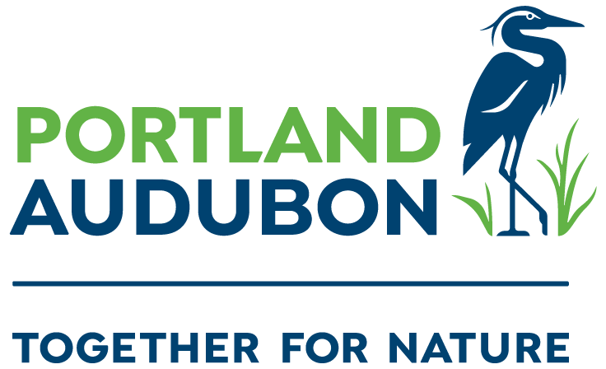
To: Portland Design Commission
From: Portland Audubon
Re: LU 20-102914, Alamo Manhattan Blocks

Chair Livingston and Commissioners,

We would like to submit comments following the applicant’s presentation on Thursday March 5, 2020. To begin, we are quite frustrated with the applicant’s attempt at avoiding compliance of the Central City 2035 Plan. The Central City Plan sets forth a vision for how the Central City and South Waterfront would become more vibrant, innovative, sustainable and resilient, and represents years of community engagement; which included numerous stakeholder advisory committees, countless open houses, many comment periods and extensive staff time. The plan ensures that new development will be a net-benefit to the community and natural resources. By pulling its previous development plan, and re-submitting through a previous application that was ‘vested’ before the code was updated, the applicant and the proposed development risks taking a step back, and shirks its obligations to uphold our community’s future vision, especially in regards to protecting and enhancing our natural resources along the river. We understand that the Design Commission may not have discretion to hold the applicant to the updated code given their development plans are now vested in the previous iteration of the code, but we urge the Commission to hold the applicant to all possible standards that the code allows. This is especially important in regards to how you judge “baseline” vs. an “enhanced” greenway design, or how you consider granting FAR bonuses and timing of greenway installation.

Our primary goal is to ensure that the greenway portion of this project builds and improves upon the existing greenway that exists to the north at South Waterfront. This is especially relevant when looking through the lens of natural resource enhancement, increased public access, and improvement of the public realm. We would like to see these improvements to the greenway portion of the development proposal;

- Take the Urban Forestry Division’s suggestions regarding substituting larger form trees into the plan, of species selected from the Portland Plant List. Also, require a greater density of native trees to be planted.
- Increase native vegetation throughout the greenway to create more diverse structure, and increase the overall habitat diversity.
- We urge the Commission to require the applicant to move the buildings farther from the greenways edge to ensure that the private development areas do not encroach into the setback, and that delineation of the public and private realm is clearer.
- If a FAR bonus is considered, it must be concurrent on the applicant meeting the requirements of an “enhanced greenway design”, in which the width and natural resource quality of the greenway is increased from the current proposal.
  - FAR bonus should be contingent on the “enhanced greenway design” elements being installed first.
- Lighting in the greenway should be minimized. Lights that are placed in the greenway should be required to be warm light LED lamps (below 3,000K) that are fully shielded and aimed downward to reduce sky glow and to minimize light trespass into the Willamette River and adjacent riparian habitat.

Again, while we understand that the Design Commission may not have discretion to hold the applicant to the updated Central City Plan code, we urge the Commission to hold the applicant to all possible standards that the applicable code allows.

Micah Meskel
Activist Program Manager

Mary Coolidge
BirdSafe Campaign Coordinator

Bob Sallinger
Conservation Director

