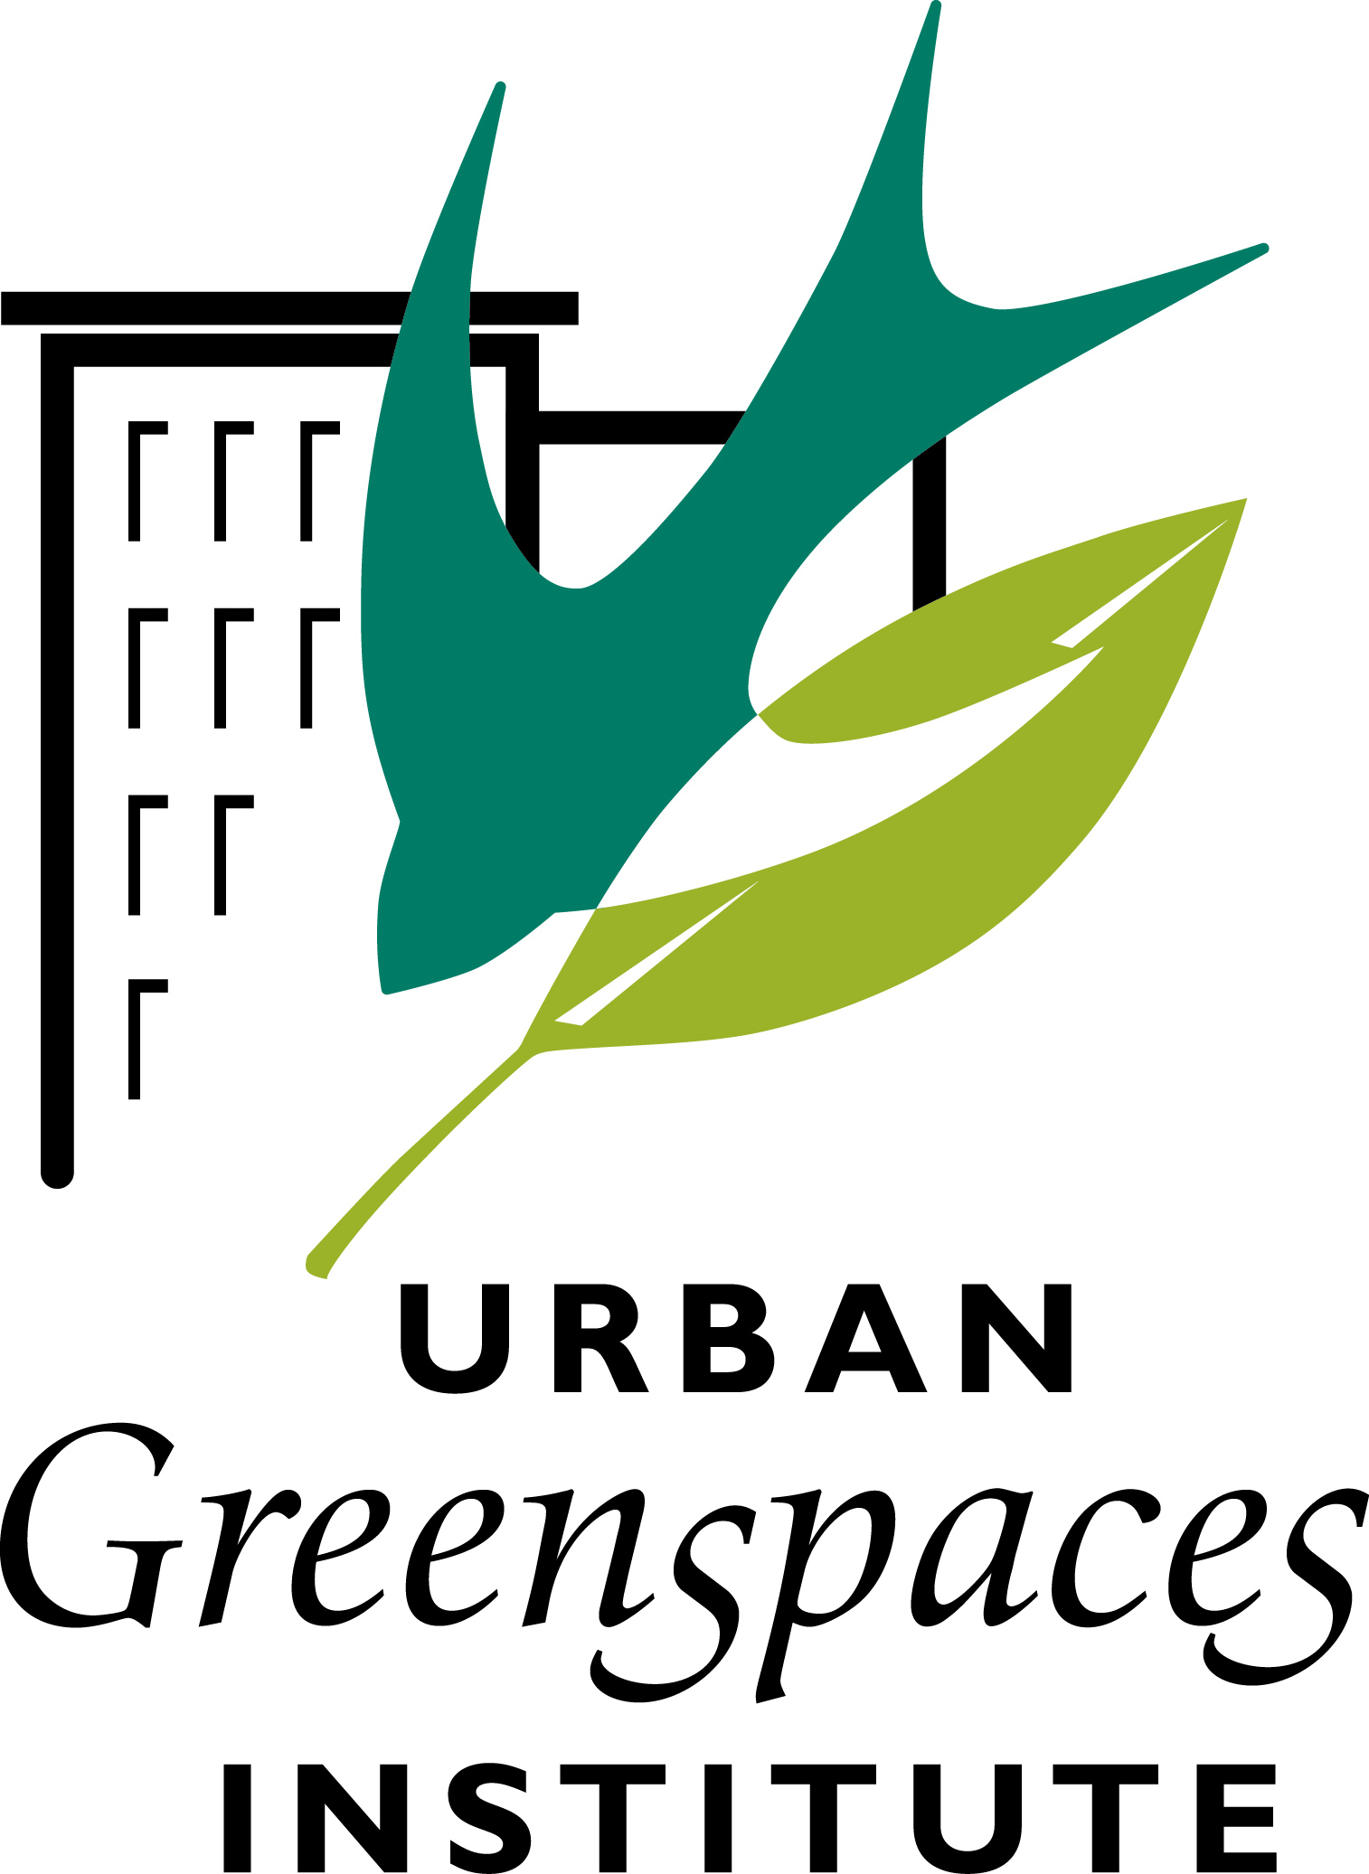 March 10, 2020
In Livable Cities is Preservation of the Wild
P.O. Box 6903 l Portland, OR 97228-6903 l 503.319.7155 l www.urbangreenspaces.org
STAFF
Ted Labbe
Executive Director

Mike Houck
Urban Naturalist

OFFICERS
MJ Cody
Chair

Mike Faha
Vice-Chair

Bob Wilson
Secretary-Treasurer

BOARD
Daniela Brod
Steffeni Mendoza Gray
Mel Huie
Tom Liptan
Kelly Punteney
Nadja Quiroz
Jim Rapp
Ruth Roth
Judy Bluehorse Skelton

To: Portland Design Commission
From: Mike Houck
Re: Additional Comments, LU 20-102914, Alamo Manhattan

Chair Livingston and Commissioners,

I am writing to follow up on last week’s Design Commission discussions following testimony and applicant presentation. During Commission deliberations and number of topics were covered that I would like to comment on and ask that you give my comments serious consideration when making your decisions regarding this project.

First, I want to reiterate my comments about the Greenway. Our primary interest is that the applicant, at a minimum, creates a Greenway design that is equal in quality and performance to that of the Greenway to the north at South Waterfront. The Greenway is not an “amenity.” It’s an essential element of the city’s infrastructure and a resource of regional significance.

There was discussion among Commissioners what might constitute a “base-line” Greenway vs an “enhanced” Greenway. Brett Horner from PP&R was asked what the parks bureau would consider elements of an “enhanced” Greenway. Among items listed was installation of a dock. We would oppose consideration of a dock based on concerns expressed by city staff, other agencies, and stakeholders regarding the proliferation of docks in the lower Willamette River. That section of the river is in the river’s thalweg (line of fastest flow or deepest water along a river's course), which is why the concrete wall is in the position it is in. Based on my conversations with those familiar with the river’s hydrology there is very high potential that a dock would pose a significant risk to the large woody debris installation the applicant has agreed to as well as other in-water habitat issues.

As to other items brought up by PP&R and the Commissioners we would strongly support adding significantly more vegetation and moving the buildings farther from the Greenway’s edge. By whatever means, moving buildings, creation of bioswales as at South Waterfront, and elevating units, the applicant needs to create more obvious delineation of the public and private realms.

With regard to vegetation we were pleased that the applicant agreed to respond positively to the city’s Urban Forestry Division with regard to substituting larger form trees, use of species listed by Forestry, and the addition of at least 10 more trees in Subarea 2. This would constitute “base-line” Greenway design. We also agree with Commissioner Santner’s recommendation to beef up the shrub layer with larger form shrubs to create a “layering” effect from larger form trees to multiple layers of shrubs and ground cover that would be more diverse in diversity of species and form. Plants should be selected from the 2004 Greenway Plan and/or the City of Portland’s plant list, https://beta.portland.gov/bps/environ-planning/portland-plant-list.

FAR Bonus: We are still adamantly opposed to issuance of FAR bonus based on the applicant’s proposed additional “public space.” Both from the applicants graphics and interactions between the applicant’s team and Commissioners our take away was the project as proposed does not approach the level of “public benefit” that would warrant the generous bonus of additional 125 feet of height. The bonus should be tied to significant enhanced Greenway design that would include more trees and shrubs native to the Willamette River riparian zone and additional width added to the Greenway by moving the buildings farther from the Greenway’s edge. Without those requirements the Design Commission would be “giving away the store” with little to no public benefit.

Enhanced Greenway Timing: During exchanges between Commissioner and applicant it was suggested the Commission might approve the height bonus contingent on the applicant’s initially installing a “base line” Greenway design and commit to an “enhanced” design at some point in the future. We would oppose such an arrangement. If the bonus is granted based on an “enhanced” Greenway and additional public benefit the design should be installed up front, not at an uncertain future date.

Concrete Retaining Wall: The applicant’s decision to leave the retaining wall in place will create, as noted during Commission deliberations, a public nuisance. The wall is considered in such disrepair that failure is likely in the near term. We understand the city cannot force the applicant to remove the wall but we would argue that and “enhanced” Greenway might include removal of this unsafe structure or reinforcing it to remove the public safety hazard.

Pilings: We continue to request the applicant be required to remove all of the pilings.

Respectfully,
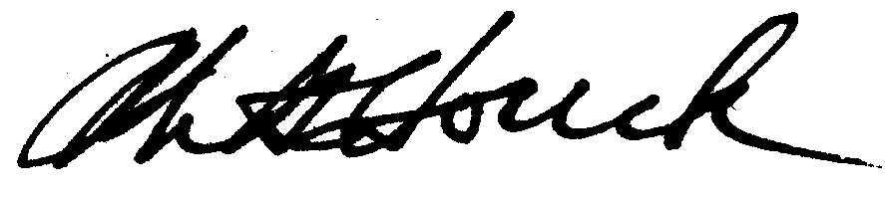
Mike Houck

