June 25, 2020

Board of Directors
Prosper Portland
222 NW 5th Ave.
Portland OR 97209

I am following up on earlier testimony I sent to the Prosper Portland board urging Prosper Portland to continue working with the Alamo Manhattan project and city bureaus to bring additional funds to the table from the North Macadam TIF funds that might enhance the Alamo Manhattan project, particularly on the Willamette Greenway. We greatly appreciate the continued engagement by Prosper Portland with city bureaus and Alamo Manhattan representatives.

While the Alamo Manhattan project has improved through the Design Commission hearings and many of our concerns have been taken into new design proposals, much remains to be done on the Willamette Greenway to truly “enhance” the area riverward of the Greenway. We continue to support all of the South Portland Neighborhood’s requests, including: Increased tree and shrub plantings and ensuring that bonus greenway setbacks are clearly welcoming and usable by the public.

We feel the following are also essential to an “enhanced” Greenway:

1). Removal of all of the pilings, including those remaining at South Waterfront and in front of the Old Spaghetti Factory.

2). Additional in-water large woody debris

3). Most importantly, removal of the dilapidated cement wall which will become a dangerous, attractive nuisance that will result in expensive remediation in the future, is essential. We requested this in our feedback to the Alamo Manhattan consultants and were told it would be too expensive. We are hopeful that “enhancement” funding would allow wall removal, laying back of the bank, and significantly improving the bank habitat through soil bioengineered restoration.

Respectfully,
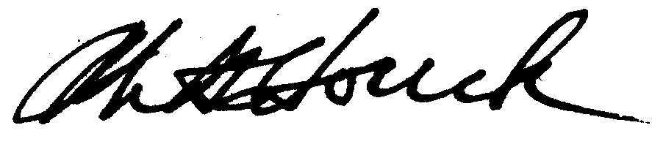
Mike Houck
cc Jeanne Galick, South Portland Neighborhood; Michael Harrison, OHSU;

Michael Jordan, Bureau of Environmental Services; Adena Long, PP&R

