March 10, 2020

To: Portland Design Commission
From: Jeanne Galick
Re: LU 20-102914, Alamo Manhattan comments

Chair Livingston and Commissioners,

Please consider these follow-up comments on both the topics raised at the hearing and commission discussion.

Most troubling is the use of the greenway bonus. Where is it? Tucked into corners and up against the buildings. It neither functions nor appears public. It may increase the greenway technically but not usefully. It is a misuse of the bonus and should be denied.
Their plan doesn’t meet minimum standards, let alone rising to the benchmark of “better enhance the natural, scenic, historic, economic, recreational, public access, fish and wildlife habitat and stormwater management qualities.”

Adding insult to injury, the applicant has turned down additional funding from both Prosper Portland and Portland Parks to enhance the greenway.

There was some discussion as to what enhancement means. The Greenway Master Plan vividly demonstrates the city’s vision for this stretch. Just to the north, where the plan has been implemented, it includes; riparian restoration of the bank; a very deep setback after the bank has been laid back (100 feet or more); native plants and trees; physical differences in elevation between private and public buildings; building articulation with 2-4 story structures facing the greenway; commissioned artwork, rather then found objects. Examples below.

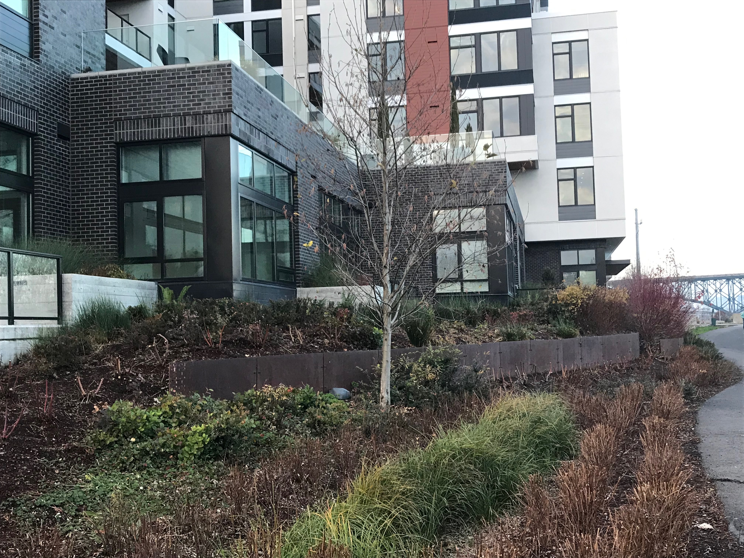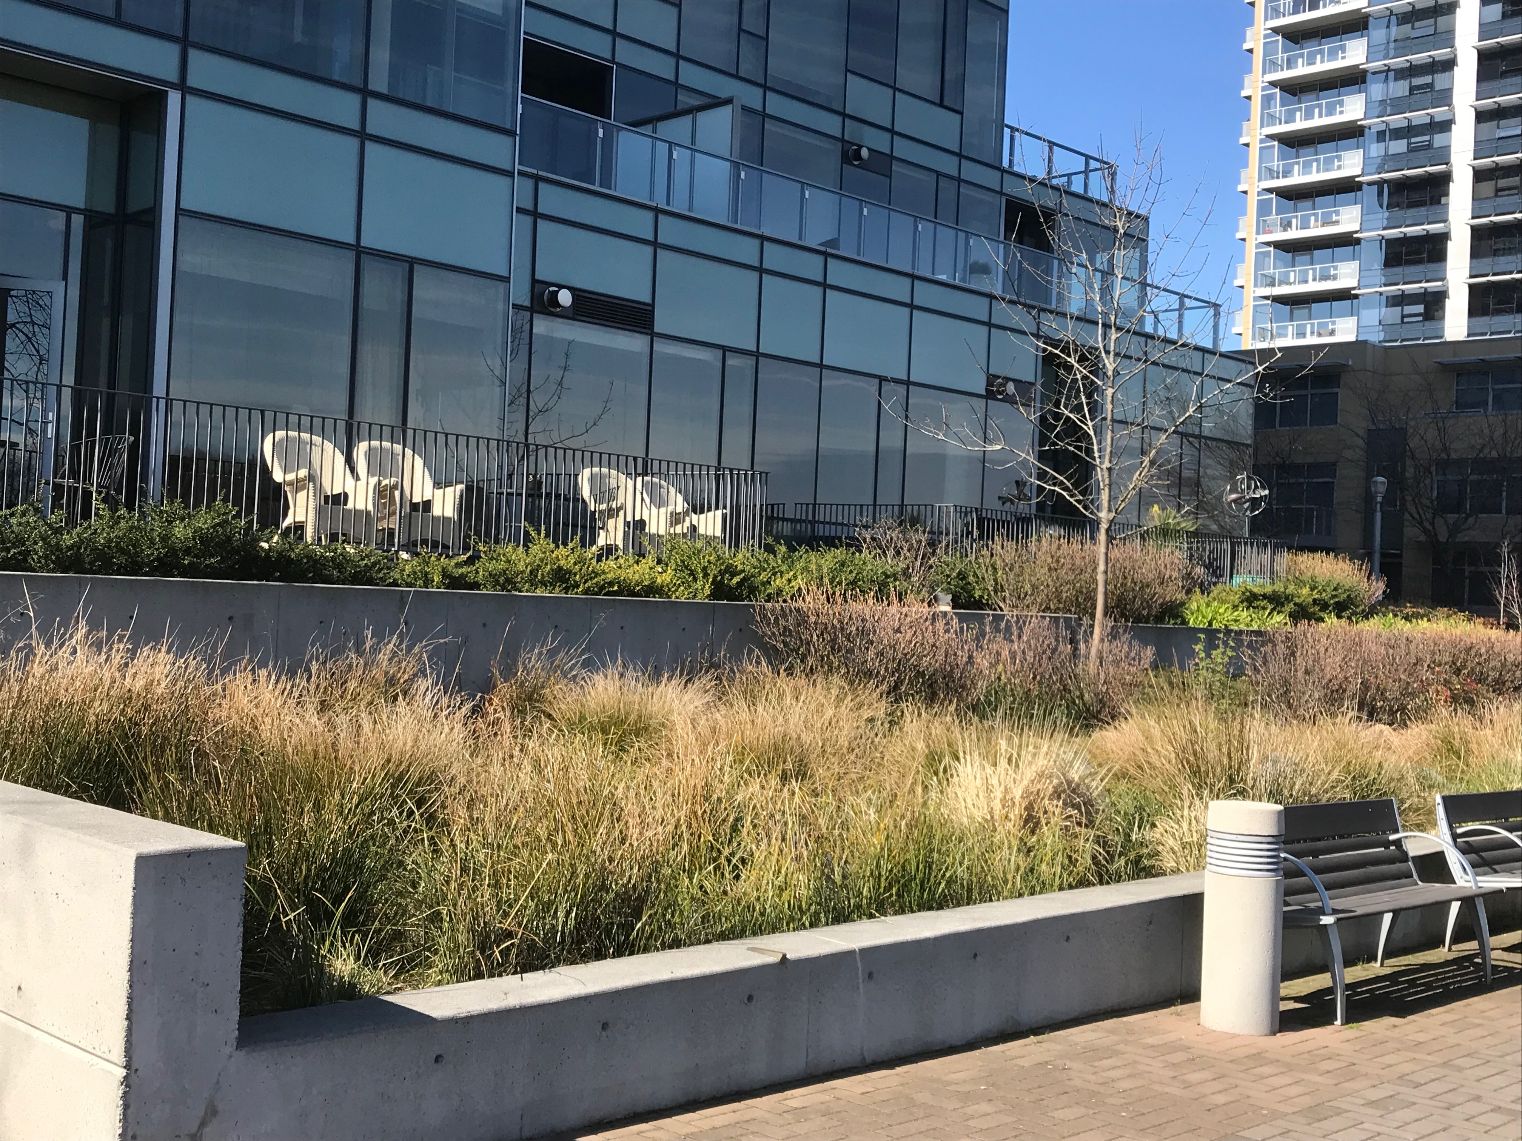

The greenway is a regional recreation and transportation corridor. With this link, the Sellwood Bridge will be connected to downtown. With the substantial increase in both public users and new residents, a wider greenway is necessary.

Timing. There was some discussion about installing a basic greenway now and enhancing it later. Please do not go forward with such a compromise. Who will ensure or enforce this to happen? On what timeline? My neighborhood’s experience is greenway enforcement is non-existent. The city is reluctant to cite violations or enforce compliance. This soft “solution” is tantamount to ensuring it will never happen.

The decision to submit under an earlier code to avoid environmental conditions compounded with using the greenway bonus in a way that benefits their property rather than the public is reason enough to hold this applicant to the full intent and substance of each design standard.

Jeanne Galick
7005 SW Virginia Ave
Portland, OR 97219

