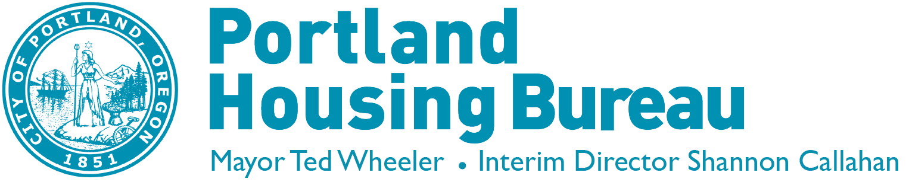
Fair Housing Advocacy Committee

March13th, 2018
3:00 pm- 5:00 pm
Steel/Bridge
421 SW 6th, Suite 500
Portland, OR 97203

March Agenda

AGENDA TOPIC | LEAD | ACTION | TIME
Call to Order, Roll Call, Minutes | Jason Trombley | Approve | 3:00 – 3:05
Public Testimony | Jason Trombley | - | 3:05 – 3:10
Standing Updates
Approve Meeting Notes | Kim McCarty | Approve | 3:10 – 3:15
Regular Agenda
Review the Proclamation | Kim McCarty | Approve | 3:15 -4:00
Finalize 50th Anniversary – speakers for listening session | Kim McCarty | Approve | 4:00– 4:30
Review Fair Housing Assessment 2nd Draft | Kim McCarty | Review | 4:30 – 5:00

Materials for all meetings will be posted on the Housing Bureau’s website: www.portlandoregon.gov/phb/74581

Call-In: Conference line: 1-866-670-8282, passcode 10232602 then press # key

Upcoming Public Meetings: February 13, 2018, and monthly, second Tuesday of the month 3 pm- 5 pm
Accessibility: To help ensure equal access to City programs, services and activities, the City of Portland will reasonably modify policies/procedures and provide auxiliary aids/services to persons with disabilities. Call 3 days in advance to request special assistance for ADA accessibility. 503-823-2375, TTY, 503-823-6868.
Language Services: To help ensure equal access to City programs, services and activities, the City of Portland will reasonably provide translation services with at least 48 hours advance notice. 503-823-2375, TTY 503-823-6868. Traducción o interpretación | Chuyển Ngữ hoặc Phiên Dịch | 翻译或传译 | Письменный или устный перевод | Traducere sau Interpretare | Письмовий або усний переклад | 翻訳または通訳 | Turjumida ama Fasiraadda | ການແປພາສາ ຫຼື ການອະທິບາຍ | الترجمة التحريرية أو الشفهية

www.portlandoregon.gov/phb

