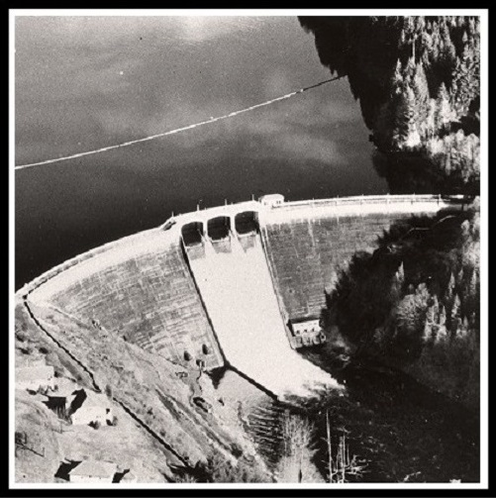

Celebrating 90 Years

**Bull Run Dam 1**

**2019 marks the 90-year anniversary of the completion of Bull Run Storage Dam 1. The three-year project, which cost nearly 3 million dollars, was set in motion to meet the needs of a growing city. According to *Water: Portland’s Precious Heritage*, “Contemporary projection of Portland’s growth envisioned a city as large as two million people by 1970. In order to meet requirements of growth over long periods, Kaiser [Lawrence Kaiser, Superintendent of the Water Bureau] knew that reliance on stopgap measures would ensure the water systems eventual failure.” A project was set in motion to address the growing population’s need for additional water. Building the dam was the first step in the process. Dam 1 is a gravity arch dam which is 200 ft. high from the bedrock and contains 220,000 cubic yards of concrete. The Bull Run Watershed has been the source of Portland’s water supply since 1895. The City continues to rely heavily on the water supply stored in the reservoir behind Dam 1.**

**City of Portland (OR) Archives, *Water: Portland's Precious Heritage*, 9600-02, 1983.**